

MANAGING PUBLIC SECTOR BUDGETS
PART TWO
Professional Development Course Book
Presented by Mark Priadko

IPAA Personal Membership
Become part of the IPAA SA Personal Member community and access an extensive range of benefits, opportunities and support for your career.

Personal Membership Will…

Get you future ready
We will improve your career as we educate and inform you of what’s to come in the future of the profession and build your skill set to ensure you are ready for it.
Build your capability
We will build your current capability to ensure you perform at the best of your ability and get you ready to face every new challenge throughout your career.
Champion you
We will champion your successes and voice them to the sector.
Build your networks
We will build your networks and connect you to like-minded people, people facing the same challenges as you and people who can help you to gain influence and penetrate the vast public sector.
Connect you
We will connect you with ideas from across the country through our National body and State jurisdictions.
Support you
We will provide you with tangible support throughout your career.

More benefits
- Extensive discounts on IPAA SA training, courses, forums and events.
- Access to exclusive member opportunities, such as our mentorship program and networking sessions.
- Receive resources and learning opportunities relevant to your career level.
- Receive a membership certificate for your CV and use of the MIPAA post nominal.
- Unlimited digital access to the Australian Journal of Public Administration.
- Receive a training voucher to the value of your membership.
- Have your say in IPAA SA governance.

How to join?
Joining is as easy as visiting our website: www.sa.ipaa.org.au/membership. Navigate to the Membership section and select the membership type most applicable to you and fill in your details online. Membership fees are generally tax-deductible.

If you have any questions about membership, contact us on 8212 7555 or email membership@sa.ipaa.org.au
.

Table of Contents

Budgeting – top-down and ground-up 4
Budget management (at the cost centre level) 5
Develop a zero-based budget or activity-based budget for my cost centre or project 5
Adapt to being issued a top-down budget, that is lower than my zero-based budget 6
Cash flowing the approved budget 11
Exercise control over transactions 15
Compliance with rules and policies 16
Compliance with Authorisations (Delegations) 16
Monitoring performance against budget during the year 18
Adapting to unfavourable variations that occur during the year 24
Seek approval to change our budget 27
Summary of budgeting, reporting and monitoring 33
Appendix 1: SA Government hierarchy of legislation to procedure 34
Appendix 2: Project reporting example 44
Appendix 3: Costing 50
Appendix 4 - Better Practice Techniques for Budgeting 52
Appendix 5: Financial clarity at work – The Scientists 57

What was my most significant learning from session 1?

What relevant issues have arisen since session 1?

What questions have arisen since session 1?

 | Year 1  $'000 | Year 2  $'000 | Year 3  $'000 | Year 4  $'000 | Year 5  $'000
Revenue
Where possible - specify
Expenses
Where possible - specify
Net operating result
Capital expenditure
Net lending/borrowing
Expenditure Authority

Conclusion
Rather than focus on whether a budget is right or wrong, it is more productive to focus on the quality of the estimates. The quality of estimates can be observed in at least three ways:
- Rigour – the extent of activity and cost drivers and detail in the assumptions made are indicators of quality.
- Substantiation – the extent to which assumptions can be checked or verified to reliable sources (e.g. wages to EB agreements).
- Transparency – the observable trail from cost driver, through assumption to dollars

Developing a Budget

1. Identify different revenues & expense activities

2. Develop assumptions in priority order
3. Convert into dollars and inflate
List of transactions
# of units & $ per unit
Table showing financial impact

Introduction and initial discussion
Finance as an expression of strategy
Understand costs and revenue – zero based budgeting
Adapt to a top-down budget (including savings)
Cash flow (or phase) your budget
Exercise control over transactions
Monitor your performance against budget
Adapt to budget variations
Seek approval to change your budget
I am more confident in my ability to manage my budget and to work with finance staff in my department.
Terminology
Financial Management Basics

Budgeting – top-down and ground-up

Whole of government budgeting - Top-down view of budgeting
From the previous session, we can conclude that the whole of government budgeting is not only an incremental process, it is also very much a top-down process or approach to budgeting.

Cost centre or project – ground-up budgeting
Earlier we developed a zero/activity-based budget. This started the process of ground-up budgeting.
We will work with our zero/activity-based budget and will look at how we manage our budget in an environment where the amount we are provided from a top-down budgeting process differs from the budget constructed from the ground up.

Focus is on financial sustainability and affordability
Focus is on need and the resources necessary to deliver services
Whole of Government/Department approaches are ‘top-down’
Project, team and unit approach is ‘ground-up’
A process with interaction and iteration between the two is necessary to make ends meet

Budget management (at the cost centre level)
Managing a budget at a cost centre level involves being able to:
- Develop a zero-based budget or activity-based budget for a cost centre or project
- adapt to being issued a top-down budget, that is lower than a zero/activity-based budget
- cash flowing the approved budget
- exercise control over transactions
- monitoring performance against budget during the year
- adapting to unfavourable variations that occur during the year
- seek approval to change our budget - developing a business case or budget bid to influence the top-down budget.

Develop a zero-based budget or activity-based budget for my cost centre or project
The development of a zero-based budget was covered in the previous section.

Adapt to being issued a top-down budget, that is lower than my zero-based budget
It will often be the case that the budget we are allocated is less than our ideal zero/activity-based budget. This demands that we can adapt to deliver services within the budget that we have been allocated. At this point, we revisit the activities and assumptions that we developed as part of our zero-based budgeting exercise to examine where we need to scale back from the zero/activity-based budget that we developed.
An example of a budget allocated to run our 20 houses is below.
The table below shows the difference between our zero-based budget and the budget allocated to us.

DISCUSSION
Discuss in small groups, what type of action you might take to adapt to this allocated budget.

List as many options as you can for adapting to the top-down budget.

Options for revising our case study budget include:
- Staffing mix – change the mix of staff to have some case managers at ASO4 and some case managers at ASO3
- Efficiencies - reduce the staffing requirement to increase the caseload per case manager
- Procurement – seek to use purchasing power to get reduced prices for groceries or for house maintenance
- Nice to have vs must have – seek to identify aspects of the budget that are not obligatory and scale them back or eliminate them
- Seek alternate sources of funding/revenue – options for this include:
  - Contributions from the families being resettled
  - Contributions from local councils (e.g. rate relief) that benefit from having workers resettle in their area
  - Contributions from the employers that benefit from the program
- Scale the program back – reduce the number of houses to fit the program within the budget
- Re-profile expenditure by delaying the start of the program – the top-down budget reduced the program to $9.9 million over five years, a reduction of $1.8 million over five years. We could aim to save $1.8 million by starting the program later in the first year, reducing first-year costs down from $2.2 million to $0.4 million.
- Outsource the program to a third party by seeking tenders to deliver within the financial parameters given
- Share costs with other programs operating in the regions (e.g. office accommodation or program management)
- Seek assistance from volunteers
- Reduce the size of families that qualify for the program
- Vacancy management - allow gaps between tenants in our houses to reduce household expenses. This will reduce the overall number of families resettled.
Review your business model
Another approach is to review our business model in response to the lower budget.

Focus on Inputs
Focussing on inputs will usually look at methods of cost control:
- Understand the mix of our inputs (types of costs).
- Reduce unnecessary costs – those costs that are not delivering value.
- Can we share inputs with others to share costs (e.g. staff and space)?
- Look at how we are procuring inputs – are we getting value for money in how we buy goods and services from the market?
- Are inputs fully utilised?

Focus on How (activity)
Our focus on activity is usually a question of efficiency. Questions that probe efficiency include:
- Are we converting inputs into outputs as efficiently as possible?
- Have we arranged our processes properly?
- Is there any evidence of waste (this may also touch on utilisation) that we can eliminate?
- Increase utilisation – look at how we are deploying staff and assets to assess the extent to which they are utilised. If an asset is underutilised, are we able to find ways of increasing utilisation or should we scale back our usage to find cheaper alternatives?
- Have we benchmarked our performance with others to assess our efficiency and identify better ways of doing things?
Our “how” includes:
- Looking at different delivery channels like online vs. face-to-face delivery or the extent of self-service required by clients
- Opportunities to outsource work by having it performed by external providers under contract rather than by staff.

Focus on Outputs (Products and Services)
A focus on outputs will require looking into opportunities to change the delivery of products and services with questions like:
- Are there products or services we should scale down or eliminate?
- Are there products or services we should scale up to increase our operating surpluses?
- Can we provide products and services to beneficiaries who will pay more?
- Are there other products and services that we can provide?

Focus on Who is Involved
This may warrant looking at questions of the extent to which we insource or outsource different goods and services:
- Are there other funding sources we can find (e.g. benefactors, grant providers)?
- Are there new customers/markets that we can seek out to increase revenue?
- Do we understand the margins on the work we do for different market segments?

Business Model Transformation
There will be cases where our response can be to work incrementally on each aspect of our business model to address cost overruns or revenue shortfalls. However, the accumulated effect of savings requirements may ultimately require us to rethink our business model.
In some cases, where market and financial pressures are great, organisations have decided to review the entire business model to the extent that it transformed the way the business or the industry works (e.g. UPS, online newspapers, or the music industry).
Notes
Introduction and initial discussion
Finance as an expression of strategy
Understand costs and revenue – zero based budgeting
Adapt to a top-down budget (including savings)
Cash flow (or phase) your budget
Exercise control over transactions
Monitor your performance against budget
Adapt to budget variations
Seek approval to change your budget
I am more confident in my ability to manage my budget and to work with finance staff in my department.
Terminology
Financial Management Basics

Cash flowing the approved budget
Now that we have an approved budget, we will be required to estimate the timing of expenditure. The shortcut method for this is to estimate monthly costs at 1/12th of annual costs. However, doing this will result in monthly variance when some costs occur quarterly or even annually.
We want to estimate cash flows well for two reasons:
- Liquidity and viability – to ensure our organisation can plan for the cash balances and working capital it needs throughout the year. Estimating cash flows will help identify when the timing of revenue and expenses may be out of sync leading to working capital being run down. This can enable the organisation to plan to defer expenses or, if possible, bring forward revenue/funding.
- Enable variance reporting – to ensure that we predict revenue and expenses as best as possible so that reported variances reveal useful information. If revenue and expenses are poorly phased, they will reduce the ability of variation reporting to reveal good information about how our organisation is tracking.
Therefore, where possible, we should identify costs where timing is less regular than monthly and allocate budgets for these costs to the months where the expenses are expected to be incurred.
- Identify transactions/activities that occur:
  - Each month
  - quarterly
  - annually
  - irregularly
- breakdown the budget into these components
- ensure the breakdown matches the total budget for each line.

Getting cash flows right
Working with a client having difficulty managing the finances of a team, it became apparent that one of the causes was poor phasing or cash-flowing of expenses.
The client, an education business, had set aside a budget for casual staff to supplement their core teaching staff during the year. They had been allocated a budget for the casual staff.
However, the budget was phased across the year to be spent each month. Based on a $420,000 budget for casual staff, it was estimated they would spend $35,000 per month.
Casual staff were hired in semester one March, April, May and June, and in semester two, hired in August, September and October. That is, they were required for seven months of the year. The spending in each of these months can be estimated at $60,000 per month.
Once the year was underway, the cash flow of $35,000 per month masked material variances in the spending on casual staff. Actual monthly spending was $80,000.
The chart below is an attempt to demonstrate the impact on year-to-date variance. The chart contains three pieces of data:
- The monthly cash flow of $35,000 per month is shown as the black line
- Actual monthly expenditure of $80,000 per month is shown as the grey bar
- The year-to-date variation accumulating is shown as the red bar.
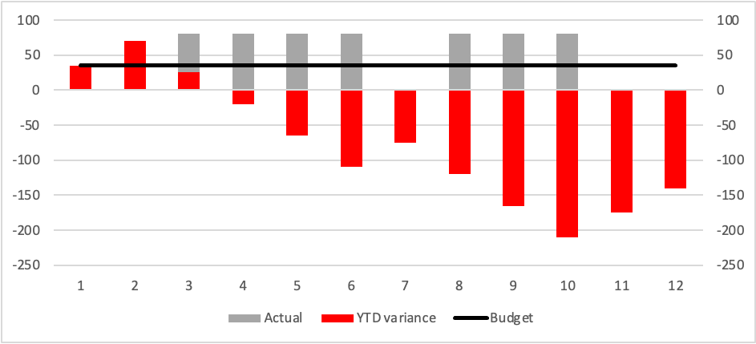

As a result of the 12-month cash flow, the year-to-date variance starts positive for months one, two and three. Only in month four did a negative year-to-date variance appear drawing some initial attention to it but not yet triggering any concern. In month five, the year-to-date variance triggered a review. Only then was it revealed to the corporate team that the team had hired more casual staff than budget and contracts had been locked in for these staff until the end of month 10.
The cash-flow approach compromised the quality of reporting and masked some poor financial decision-making.

Cash flowing our budget will result in us producing a table that looks something like the one on the next page.

Discussion
What are some of the factors that will determine the cash flow of our budget?

Handout – revised budget and cash flow

Introduction and initial discussion
Finance as an expression of strategy
Understand costs and revenue – zero based budgeting
Adapt to a top-down budget (including savings)
Cash flow (or phase) your budget
Exercise control over transactions
Monitor your performance against budget
Adapt to budget variations
Seek approval to change your budget
I am more confident in my ability to manage my budget and to work with finance staff in my department.
Terminology
Financial Management Basics

Exercise control over transactions
The primary purposes for financial controls over transactions are to achieve:
- Efficiency
- compliance with policies and procedures
- Exercising authorities (delegations).

Efficiency
Efficiency occurs when costs per output or costs per level of activity can be reduced to the lowest level possible while maintaining reasonable standards of quality or effectiveness of the service.
Critical to efficiency in the delivery of services are:
- Cost per unit of activity
- Cost per case
- Cost per call for call centres.
Budget owners should consider efficiency in at least two ways:
- Buying wisely (efficiency in procurement)
- Efficient use of resources
- Benchmarking.

Buying wisely
Efficiency can be achieved by purchasing goods and services in ways that minimise the cost per good or service purchased. Examples of how purchasing can contribute to efficiency include:
- Purchasing items from preferred vendors and/or established catalogues
- Undertaking purchasing on a large scale to become a volume buyer in the marketplace
- Using tender and contract processes to seek out the best cost and quality outcomes
- Managing inventories to ensure not too much or too little is being purchased (avoid panic purchases that can tend to be more costly).

Efficient use of resources
Efficient use of resources is the day-to-day practice of avoiding waste in our use of staff time, supplies, equipment and other consumables.
Examples:
- Don’t staff to peak workloads
- Don’t consistently use agency or casual staff for ongoing work
- Employ flexible staffing arrangements to manage unpredictable work
- Ensure highly paid staff are not doing work that could be done by lesser paid staff
- Monitor overtime to assess whether alternate methods (like employing casual staff) can be more cost-effective in managing work with variable demand
- Observe the extent of waste that is occurring in your area (volumes of rubbish, unused or expired inventory)
- Query whether more expensive items (e.g. more expensive or “brand” products) are achieving better quality outcomes

Benchmarking
Where possible, Budget owners should seek out benchmarking information to compare the delivery of services. Reasonable benchmarks include the history of the service itself, comparisons with similar services within South Australia and comparisons with similar services in other states or jurisdictions. These benchmarks can provide a guide to what could be deemed a reasonable level of efficiency for a particular service.

Compliance with rules and policies
As required by the Treasurer’s Instructions, each Department has finance policies and procedures that provide very specific requirements and guidance primarily related to how the organisation accounts for and reports its financial performance, financial position and financial transactions.
Requirements of an individual arising from compliance with Government requirements like:
- Treasurer’s Instructions
- DPC Circulars.
More details on these are provided in Appendix 2.

Compliance with Authorisations (Delegations)
As a Manager, your position will have delegated to it authorities for you to act on behalf of the Government to purchase goods and services, to enter into contracts and to authorise payments.
Authorisations (delegations) form an essential part of all financial management environments and systems. How an organisation delegates authority is fundamental to how it controls its ability to incur expenditure, enter contracts and make payments.
There is a range of authorities created by Government legislation and delegated to staff across health. These include:
- Financial authorisation
- Procurement/Purchasing authorisation
- Approval to enter into contracts.
All these authorities are to be carried out within the budget targets of an organisation. Authority delegated to a position is not authority to exceed the financial limits allocated to the Budget owner. Each of the financial and procurement authorisations explained below is separate and cumulative.
Authorisations for Departments are usually maintained online.

Introduction and initial discussion
Finance as an expression of strategy
Understand costs and revenue – zero based budgeting
Adapt to a top-down budget (including savings)
Cash flow (or phase) your budget
Exercise control over transactions
Monitor your performance against budget
Adapt to budget variations
Seek approval to change your budget
I am more confident in my ability to manage my budget and to work with finance staff in my department.
Terminology
Financial Management Basics

Monitoring performance against budget during the year
The next component to managing a budget is to monitor performance during the year. This means receiving financial statements and reports that show the progress of expenditure against the budget. Monitoring budget performance may also require us to receive information relating to activity levels that are important to understanding our progress.

Reading financial statements
Financial statements can be very intimidating for people with a non-financial background. Confronted by many numbers without having the more important numbers distinguished from the less important numbers. Financial statements also contain terminology and language that is foreign which can make reading financial statements difficult.
Distinguish two types of reading.
- Reading for comprehension - what we do when we read text in books or reports. We read from left to right across the page and line by line down the page to understand the meaning.
- Reading for destination-when we read maps, we seek out specific points on the page. When reading financial statements, we read for destinations seeking out specific numbers and variations. If we try and read financial statements for comprehension, we risk drowning ourselves in numbers.
The following are three steps to assist a reader of financial statements in understanding or asking questions about financial statements.
- Where and what is the bottom line – and what are the keys to its derivation?
This will focus on attention what the main takeaway point of the statements is. Is it showing we are on or off target? This is a fundamental starting point for reading further. In some cases, if the reader is satisfied that the bottom line is OK, only limited further analysis may be required. Beware! A reasonable bottom line can mask adverse trends – see step 3. If the bottom line is not OK, further insight into what is driving the bottom line is required.
- Focus on the big numbers
When there are many numbers in financial statements, it can be hard to know where to look next. When in doubt, after having found the bottom line, find the big numbers in the report. This will ensure you are focussing on the most important financial issues, that is, those areas where the highest revenues and expenses are incurred. This step is about prioritising where you look but should not limit where you look.
- Identify trends
It can be a trap to look at data for one month or one period at a time. Looking at data across time can help identify patterns that are emerging and give you early warning on when problems may emerge. While the bottom line may be OK, key transactions underneath it may be moving adversely (certain expense lines growing rapidly or revenues slowing down) in a way that suggests the bottom line may deteriorate.
These three steps are designed to get you started but may not determine where you should finish. For variance reports, our goal is to understand the variances at the target level and then focus on large variances that explain the ‘bottom-line’ result.

Understanding and explaining variances
A manager with finance responsibilities is accountable not only for understanding and implementing actions to remedy variations but also for explaining reasons for variations and related remedies to their line manager. Our understanding, explanation and remedies for variances should be evidence-based. Increases in expenses will arise from at least one of the following sources:
- Activity
- Complexity
- Price/cost growth/reduction
- Unbudgeted expenditure
- Timing – delayed invoice or budget phasing error
- Errors
Increases in expenses attributed to each of these categories can be supported by evidence.
Understanding, explaining and remedying variances is more straightforward if you have done “ground-up” budgeting. Ground-up budgeting enables a budget owner to understand the cost, activity and acuity drivers of their budget in advance.

ACTIVITY
Monitor the budget for our program using the statements below:
How are the finances of this cost centre going?

What is going well?

What is not going well?

What extra information do we need?

Introduction and initial discussion
Finance as an expression of strategy
Understand costs and revenue – zero based budgeting
Adapt to a top-down budget (including savings)
Cash flow (or phase) your budget
Exercise control over transactions
Monitor your performance against budget
Adapt to budget variations
Seek approval to change your budget
I am more confident in my ability to manage my budget and to work with finance staff in my department.
Terminology
Financial Management Basics

Adapting to unfavourable variations that occur during the year
It is one thing to receive financial information regarding a budget, it is another to have to do something about it by adapting to unfavourable variations that occur during the year. This will demand that we understand these variations in more detail.
As a result of looking at reports relating to our division/section or project, we may determine that steps need to be taken to more carefully monitor and track revenue and expenditure. It can be difficult to know where to start in understanding how relevant revenue and expenditure can be controlled.
Following are six steps that will help to move beyond reading financial statements to trying to do something about the financial situation we find.
- Seek information on a transaction-by-transaction basis –transactions report
To do this requires information on a transaction basis. Information is available in most organisations at the transactional level.
- Identify material transactions that are driving your variances (this follows from the previous section). Satisfy yourself that these transactions were necessary and correct. In addition, select a small number of material transactions and satisfy yourself that the related revenue or expenses were necessary and correct.
- Distinguish controllable expenses from uncontrollable expenses. Not all expenditure or revenue can be controlled by a cost centre or project manager. Some expenses will occur regardless of any actions that can be taken by the manager. It is important to understand which transactions fit into this category. You can then look at your cost centre reports from the perspective of controllable expenses versus uncontrollable expenses.
- Seek evidence and documentation to support variances in expenses. This can take the form of an email, invoice, contract or service-level agreement. The purpose of the documentation is to confirm the nature of the transactions and the degree of control you as a cost centre or project manager have over the expenses. Where the expense relates to a fixed cross charge – establish documentation over the nature of the charge, its likely amount and timing.
- Project forward as to how remaining material expenses will be incurred – satisfy yourself in advance that there will be some checks and balances in place to ensure the best value for money.
- Identify actions that can be taken to manage. Examples of steps that can be taken are:
  - Vary levels or quality of service
  - Make policy decisions to vary the method of service
  - Remove or defer discretionary expenditure
  - Identify possible sources of revenue
  - Review the business model
  - Alert your finance officer of your financial situation and the measures you are taking to address it.
There will be circumstances when expenses have increased above our budget bid due to cost blowouts, lack of control, or additional demand imposed upon us by management or customers. How do we handle these circumstances where we are expected to manage a budget yet all the assumptions underlying a budget are changing?
It is at this point that the quality of our budget will either help us all hinder us. A high-quality budget will help us. A poor quality budget will hinder us.
If we are operating to a budget that is poorly specified, that lacks rigour and that lacks transparency it will be very difficult for us to know where remedial action can be taken when reality gets out of line with our budget. By having a budget well specified and our assumptions clear it is easier for us to identify the impacts that can arise from having to adjust elements of our budget down.
Recalling our budget for fuel, it assumed families would use 30 litres per week for $1.50 per litre. The weekly usage equates to around 140 litres per month per family.
The transactions report shows variations arising from additional vehicle usage (activity), higher fuel prices (cost pressure) and vehicle services. The latter has been costed to this line while the budget for vehicle services is assigned to a separate budget line (an error).
3. Understand and monitor relevant transactions
2. Identify key variances and trends
1. Bottom line & big numbers
Examine transactional detail
Summarised analysis & priorities
Reading financial statements

Introduction and initial discussion
Finance as an expression of strategy
Understand costs and revenue – zero based budgeting
Adapt to a top-down budget (including savings)
Cash flow (or phase) your budget
Exercise control over transactions
Monitor your performance against budget
Adapt to budget variations
Seek approval to change your budget
I am more confident in my ability to manage my budget and to work with finance staff in my department.
Terminology
Financial Management Basics

Seek approval to change our budget
In addition to attempting to deal with either a budget that is short of our ideal or in dealing with unfavourable variations during the year, we could aim to seek approval to increase our budget to the level we need to deliver a viable service.
It is possible to get approval to change your budget. However, in all cases, this demands that early warning of these circumstances is given to your agency's finance or budget section.
In cases where expenditure authority is the only target likely to be exceeded (and offset by increased revenue - eg due to a successful grant program), an agency needs to inform Treasury and Finance of the need to change the expenditure authority target. Where there is a legitimate case, Treasury and Finance will facilitate approval of an adjustment to the agency budget. Such approval is typically straightforward. Once this has been facilitated, the agency can continue with its programs in the knowledge that it is now within revised targets.
The example above is typically undertaken at the corporate level and requires a phone call or email to the finance or budget section of your agency who will in turn contact Treasury and Finance. In addition, the finance sections of agencies will work with their agency colleagues to generate supporting documentation and to draft a budget system journal to submit to Treasury and Finance to update the budget targets.
In cases where the net operating balance and net lending targets are likely to be breached, your finance officers need to be informed. Where a likely breach of budget targets cannot be managed internally, Chief Executives and Ministers will make a submission to Cabinet to seek approval for an adjustment in the key budget targets.
An important step in managing the breach of budget targets is early warning to your agency's finance or budget section and in turn to Treasury and Finance.

Following is an example of an approval process that followed in some government agencies.

Example of an approval process for a budget variation
Is the proposed expenditure within the current budget and forward estimates of the division?
YES
NO
Proceed (subject to delegations)
Can the division reschedule expenditure within its current budget and forward estimates?
YES -
Inform corporate
NO – documentation to Finance required
Can the dept reschedule expenditure within its current budget and forward estimates?
YES, with CE approval
NO – budget bid or Cabinet submission required
Can the Government reschedule expenditure within its current budget and forward estimates? – requires budget or cabinet submission (submission requires CE approval)
NO
Proposed expenditure is denied
CE approved submission or bid
Cabinet approval?
YES
NO

This might ultimately require that we develop a business case or budget bid to influence the whole of government budget process.

Complete information necessary for additional government expenditure authority
This could include completing:
- A Cabinet submission
- A budget bid.

Cabinet submission
In some cases, bids for additional money from the Government are sought through a Cabinet submission.
Cabinet submissions are used in circumstances where there is urgency required in response from the government. Examples will include funding bids for disaster relief or to meet unexpected peaks in demands for essential services.
As a rule, other bids for funding should be considered in the budget process to enable the range of bids for funding to be considered together.
In these cases, the document used for your budget bid will be in the format of a Cabinet submission.
A template for a Cabinet submission is available on the SA Govt intranet.
The section in the submission where estimates of costs and revenue go is in the economic, financial and budgetary implications.
In this section, it is recommended that the following table be included to ensure the financial and budgetary implications of the initiative are transparent to the Cabinet. As outlined before, the figures to be included in this table will relate to the increment in the existing budget, not to the total budget for our program.
 | Year 1  $'000 | Year 2  $'000 | Year 3  $'000 | Year 4  $'000 | Year 5  $'000
Revenue
Expenses
Net operating result
Capital expenditure
Net lending/borrowing
Expenditure Authority

.

PROFORMA BUDGET BID (based on the format used in previous years by Treasury and Finance)

Title

Description

Financial Impacts ($'000s)

 | Year 1 | Year 2 | Year 3 | Year 4 | Year 5 | Ongoing
Impact on general government net operating result
Impact on general government net lending
Impact on expenditure authority

Links
State Strategic Plan link

Agency programs and objectives

Impacts on:
Legislation Required

Regional Impact

Benchmarking

Implications if Funding is not provided

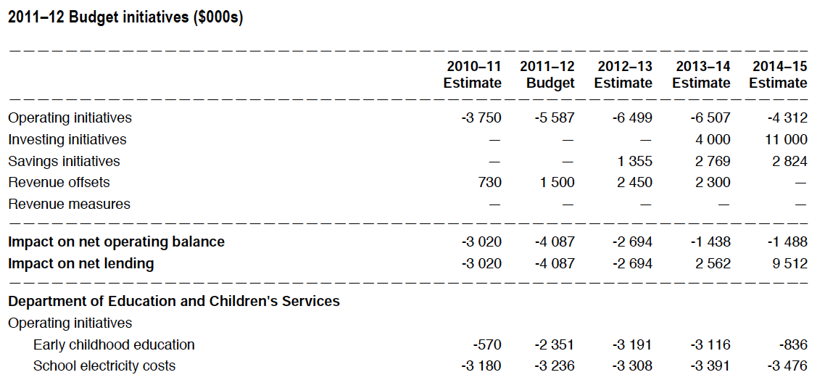
Budget Measure - Cost Pressure example

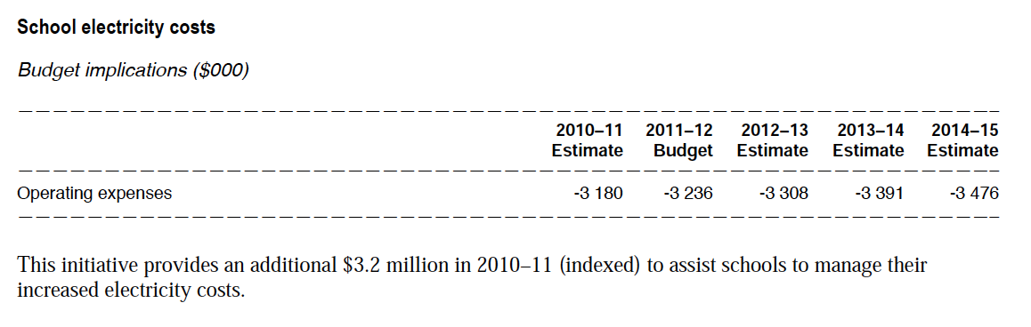

Budget Measure – Increasing Capacity Example
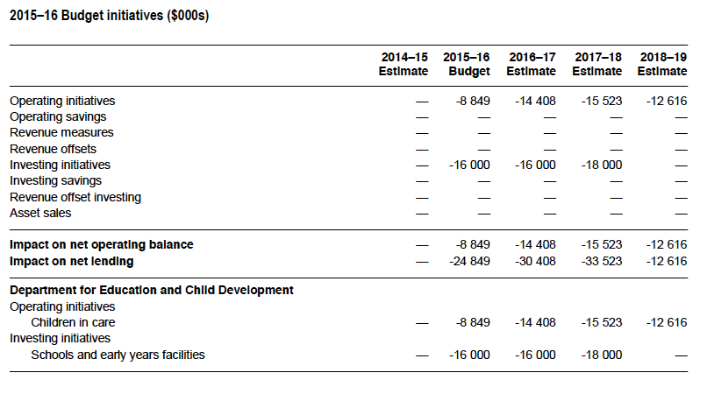

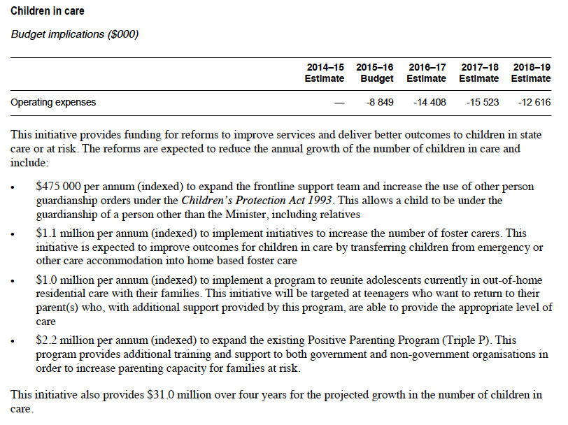

Summary of budgeting, reporting and monitoring

We have followed a process of building (budgets), exploring (financial statements) and drilling (transactional information).

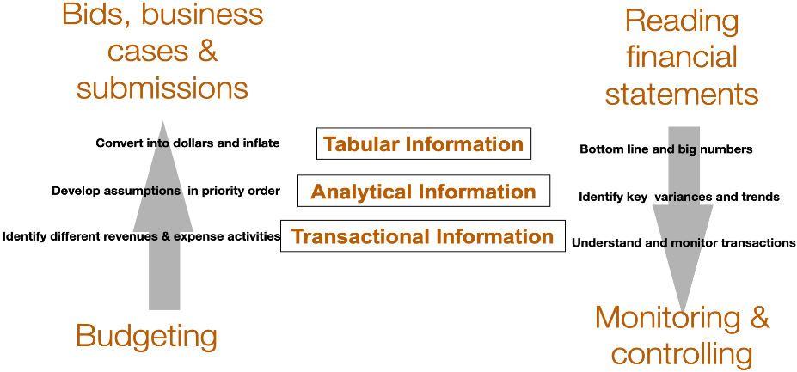

Reflection and discussion
What has been my most important learning from this session?

Why?

Appendix 1: SA Government hierarchy of legislation to procedure

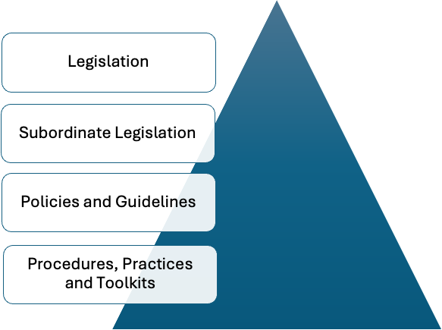
Establish frameworks - Low levels of prescription
Add greater levels of detail with increasing levels of prescription
Detailed with high levels of guidance and prescription
Detailed with high levels of guidance and prescription

Legislation
Accountability for public money in South Australia is driven by the Public Finance and Audit Act. This act dictates that all public money be received into the Consolidated Account and that the release of the money from the Consolidated Account be approved by Parliament.
Parliament approves the release of money from the Consolidated Account annually with the approval of the supply bill and the appropriation bill. In some cases, standing (or ongoing) appropriation from the Consolidated Account is approved under other legislation (e.g. payments for the Auditor General and the Commissioner of Police).
Responsibility for the Public Finance and Audit Act and the operation of the Consolidated Account resides with the Treasurer.
The Public Finance and Audit Act allows circumstances where public money can be received directly by a department and used by the department. The Act also makes provision for the Treasurer to establish deposit accounts for departmental operations. The accounts receive appropriations from the Consolidated Account.
The Administrative Arrangements Act establishes Ministers as bodies corporate (that is legal entities that can contract). All assets and liabilities of the crown are vested in these bodies corporate. Ministers are the legal stewards of state assets and liabilities.
In some cases, some specific legislation has been established to monitor specific industry funds. Examples include the Botanic Gardens, the Highways Fund, and the Emergency Services Levy Fund. However, in these cases, the management of public money must still be carried out in compliance with the requirements of the Public Finance and Audit Act and with the financial targets established in the budget process and approved by the Cabinet.
All the financial activities of public authorities (both controlled and administered) are conducted through the public accounts. Only the Treasurer can approve the use of public monies outside the public accounts. All revenue generated from non-state sources by the use of public sector assets and the work of public sector employees is deemed public money.
Further, any borrowing of money on behalf of the state is either undertaken by the Treasurer or by a limited number of authorised government entities (e.g. SAFA) only with the Treasurer's approval.
Legislation relevant to our finances and our delegations
- The Public Finance and Audit Act
- The annual Appropriation Act
- Agency specific legislation.
Other relevant articles of legislation and principles include the Freedom of Information Act.
This legislation gives members of the public a legal right to request access to the majority of documents held by Government agencies, Government Ministers, Local Councils or Universities (only a patient can access their patient health records through FOI)
The objects of the FOI Act are:
“Consistent with the principle of the Executive Government's responsibility to Parliament—
- To promote openness in government and accountability of Ministers of the Crown and other government agencies and thereby to enhance respect for the law and further the good government of the State.
- To facilitate more effective participation by members of the public in the processes involved in the making and administration of laws and policies.”

Authorisations
Parliament (appropriation act)
Governor (administrative arrangements Act
Conditions/Limits include:
-Budget papers
-Deposit account
-Treasurer's instructions (TI8)
As per gazettal
Ministers
Approval to spend public money
Ability to enter into contracts
Vest public assets and liabilities
Chief Executives
Departmental officers – also see the code of conduct
TI8 – Minister grants a standing authority to incur expenditure to the CE
Minister grants authority for the CE to enter contracts on his/her behalf
Departmental financial authorisations:
Expenditure authorisation, disposal authorisation, authority to enter contracts
Policies include
- Treasurer's instructions
- Accounting policy framework
- DPC circulars
- Cabinet directions (e.g. carryover, savings policy)

Subordinate legislation
“Subordinate legislation, also known as delegated legislation, is law made by the executive branch of government with the authorisation of Parliament. Subordinate legislation includes regulations, rules, by-laws, certain policies, proclamations and notices. These laws are made under an Act of Parliament.”
Source: www.legislation.sa.gov.au
In South Australia, the Public Finance and Audit Act s41 enables the Treasurer to issue instructions for application across the public sector. These are known as Treasurer’s Instructions. These instructions, while not specified in the Public Finance and Audit Act take the form of subordinate legislation.
The financial policies and practices of agencies are designed to align with the requirements of the legislation and the Treasurer’s Instructions.

Treasurer’s Instructions
Treasurers Instruction | Objective(s)
1 – Interpretation & Application | To provide guidance on the interpretation and application of the instructions
2 - Financial Management | To specify certain procedures in relation to financial management, and to require each public authority to develop, implement, document and maintain policies, procedures, systems and internal controls to assist Chief Executives with their financial management responsibilities.
3 - Appropriation | to require the Chief Executive of each public authority to institute appropriate controls in respect of money appropriated by Parliament for the public purposes of the State.
5 – Debt recovery and write offs | To require the Chief Executive of each public authority to ensure that the authority establishes and implements policies for the management of debt recovery that aim to recover all amounts owing to the authority and to prescribe the circumstances under which a debt may be written off or waived by a public authority
6 – Statutory Accounts and Banking | To set out requirements for the establishment and operation of:  (a) deposit accounts, special deposit accounts and the Consolidated Account under the Public Finance and Audit Act 1987 (the statutory accounts); and  (b) bank accounts and merchant facilities.
7 – Corporate Governance | To allow the Treasurer to appoint a Treasurer's representative to attend board meetings of a designated public authority where there is no power to appoint a representative in the specific governing legislation of the designated public corporation; and  to prescribe the procedures to be followed in relation to public sector employees acting as Treasurer's representatives on the boards of designated public authorities; and  to prescribe the role and responsibilities of the Chair of the board in relation to the Representative.

Treasurers Instruction | Objective(s)
8 – Financial Authorisations | To establish a governance regime to apply to all public authorities such that prior approval is required, by a person authorised pursuant to these instructions, before the public authority can:  (a) incur expenditure through contractual arrangements, including purchases; and  (b) enter into an agreement with the potential to lead to expenditure; and  (c) make a payment or disbursement.
9 – Payroll deductions | To establish requirements for the making of deductions from salaries and wages.
10 – Engagement of Legal Practitioners | To require public authorities to seek the advice of the Crown Solicitor before engaging a legal practitioner other than the Crown Solicitor.  To require public authorities to obtain a certificate from the Crown Solicitor in respect of the purchase of land.
11 – Payment of Creditors’ Accounts | To prescribe the policy for the payment of creditors’ accounts by public authorities including, where required under the Late Payment of Government Debts (Interest) Act 2013, the payment of interest on overdue accounts.  To require public authorities to report account payment performance information to the Department of Treasury and Finance.  To enable public authorities to charge other public authorities’ interest on overdue accounts.  To prohibit payment for goods not received and services not rendered.
12 – Government Purchase Cards | To prescribe a policy for the control and use of government purchase and stored value cards.
13 – Expenditure incurred by Ministers and ministerial staff | To specify requirements for the documentation of expenditure incurred by Ministers and Ministerial Officers.  To specify a policy for the use of purchase and other credit cards by Ministers and Ministerial Officers.  To prohibit the purchase of alcohol by Ministers and Ministerial Officers.
14 – Ex Gratia payments | To specify the requirements for the approval of ex gratia payments by public authorities.
15 – Grant funding | To establish appropriate accountability on the part of non-South Australian Government entities that receive a grant(s) from an administrative unit(s)
17 – Public Sector initiatives | The object of these instructions is to ensure that public sector initiatives are:  justified; and  subject to the appropriate approvals before they proceed
18 – Procurement | To promote good governance, contract management, transparency and record keeping by public authorities in the course of planning and undertaking procurements which create liabilities or potential liabilities for expenditure by public authorities; and  To promote compliance with whole-of-government procurement policies; and  To provide for reporting to the Department of Treasury and Finance about procurements by public authorities; and  To make Chief Executives of public authorities responsible for procurements by the public authority and for determining public authority-specific procurement arrangements.
19 – Budgetary Control and Reporting | To set out the responsibility of each public authority for the discharge of financial accountability in respect of that authority and the maintenance of accounting and other financial records to permit the Treasurer to comply with statutory and other reporting requirements.
20 – Guarantees and Indemnities | To ensure the Government’s exposure to guarantees or indemnities given by public authorities is appropriately monitored and managed.  To require each public authority to maintain a register of guarantees and indemnities given by it.
22 – Tax Equivalent Payments | To specify the requirements for the calculation, and manner of payment, of tax equivalent payments.
23 – Management of Foreign Currency Exposures | To prescribe a policy for the appropriate management of foreign currency exposures incurred by public authorities.
25 – Taxation Policies | To outline procedures for the preparation of Commonwealth and State taxation returns and Commonwealth private taxation rulings.  To require certain prior approvals before a private taxation ruling is lodged with the Australian Taxation Office or legal counsel is engaged to pursue a taxation matter/disagreement with the Australian Taxation Office.
28 – Financial Management Compliance Program | To require each public authority to develop, implement, document and maintain a robust and transparent financial management compliance program

If budgeted, who has the authority to contract and approve expenditure?
For the majority of Government initiatives, the authority to enter into contracts and approve expenditure for the budget resides with Ministers. Ministers are proclaimed as bodies corporate with the authority to enter into contracts with suppliers and to approve the spending of government money. This authority is then delegated to department Chief Executives to undertake this work on behalf of Ministers. The delegations from Ministers to Chief Executives are written and specific.
Limits for these delegations are provided by Treasurer’s Instructions 8.
Section 5 of TI 8 includes:
In any dealing to which these instructions apply a Chief Executive must ensure compliance with the public authority's enabling legislation.
No dealing to which these instructions apply may be approved unless—
- (a) the expenditure is necessary for the conduct of the public authority, and the requirements of the Public Finance and Audit Act 1987 and any other relevant Act or instruction have been observed in all respects; and
- (b) the Chief Executive has a reasonable expectation that sufficient financial resources will be available to meet commitments as they fall due.
Section 6 of TI 8: relates to Contracts and states:
Unless the public authority's enabling legislation has alternative specific arrangements that are inconsistent with this instruction, a contract, including for the purchase of goods and services, can only be executed if approved as follows:
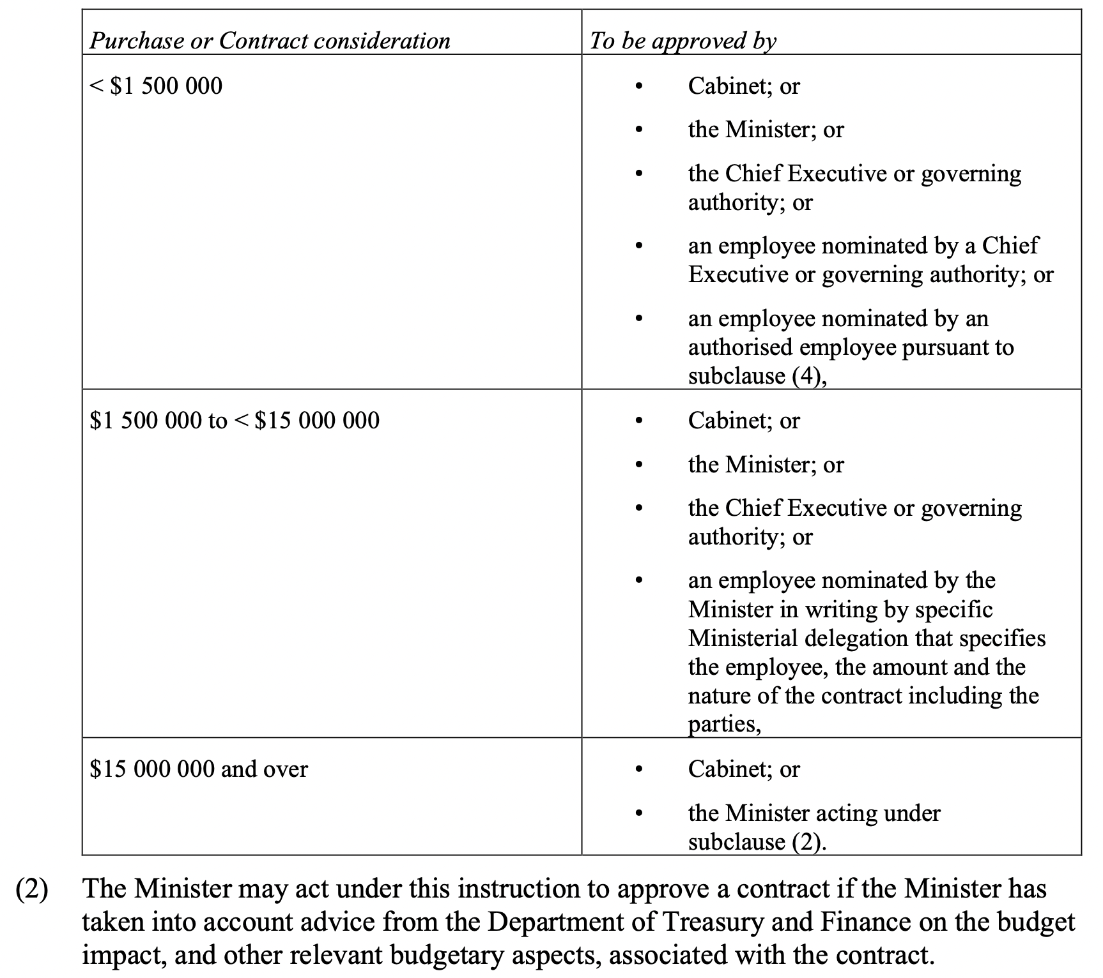

Is it value for money – have processes been followed?
Value for money for expenditure on supplies and services is achieved through following procurement policies and processes. Treasurer’s Instruction 18 establishes arrangements for procurement in agencies. The objects of TI 18 are:
To promote good governance, contract management, transparency and record keeping by public authorities in the course of planning and undertaking procurements which create liabilities or potential liabilities for expenditure by public authorities; and
To promote compliance with whole-of-government procurement policies; and
To provide for reporting to the Department of Treasury and Finance about procurements by public authorities; and
To make Chief Executives of public authorities responsible for procurements by the public authority and for determining public authority-specific procurement arrangements.
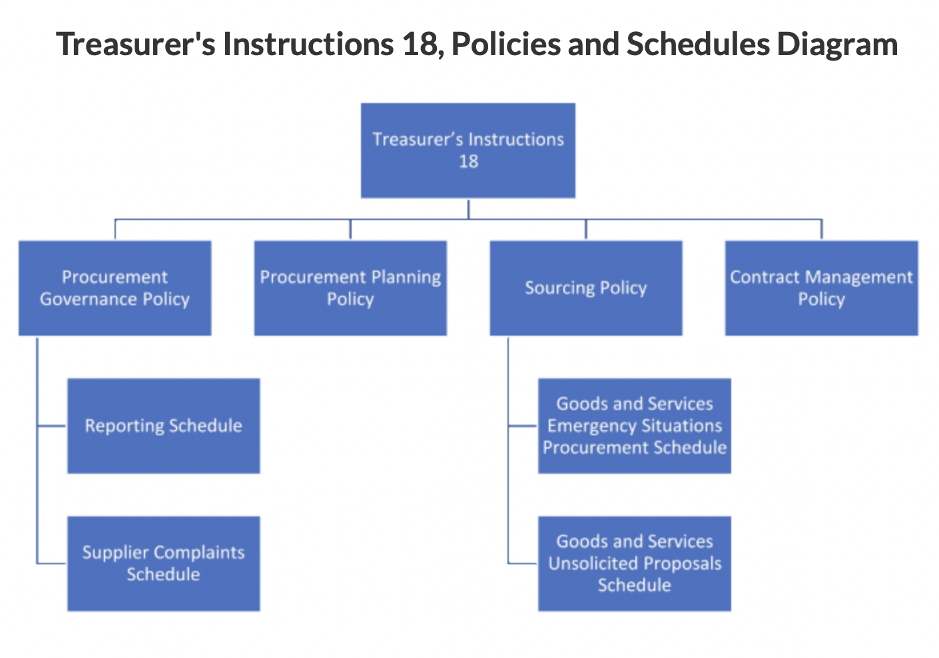
Procurement Governance Policy – is divided into 5 Parts:
Part 1: Key Procurement Principles – Value for money, creating South Australian jobs, increasing apprentices and trainees, stimulating innovation and new business and achieving environmentally sensitive, low-carbon, socially just outcomes
Part 2: Procurement Governance
Part 3: Public Authority Procurement Frameworks
Part 4: Procurement Activity Planning and Reporting
Part 5: Procurement Policy and Process
Each part contains key information about the across-government approach to procurement.

Procurement and contract management processes are classified as either:
- Transactional – low-risk procurements/contracts with a value up to and including $55,000.
- Routine – generally low/medium risk procurements/contracts valued above $55,000.
- Complex – generally medium risk and higher value (valued above $550,000) procurements/contracts.
- Strategic – generally high-value, high-risk procurements/contracts with a high complexity; but some lower-value procurements or contracts may be strategic for reasons other than price.
The distinctions dictate procedures to be followed for each category. For example, the market approach will align with the process outlined in the following table.
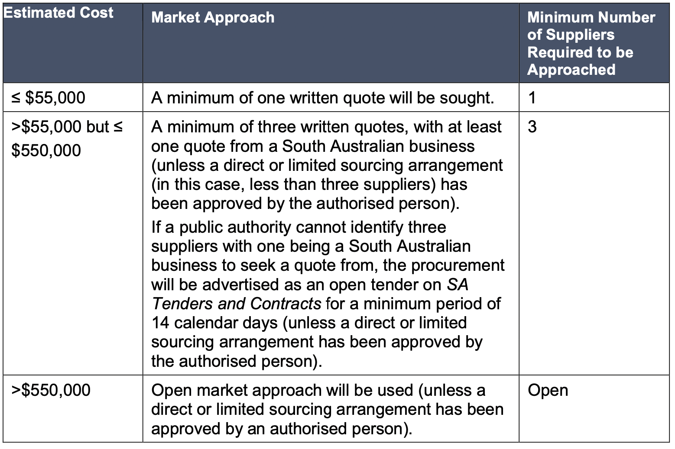
Procurement Planning Policy - outlines the requirements to plan a procurement process (i.e. acquisition strategy) on behalf of the South Australian Government (‘government’).
Policy requirements are to be applied to all procurements for goods and services, including construction projects valued at up to $165,000.
Sourcing Policy - outlines the requirements for approaching the market to source goods and services, including construction projects valued up to $165,000, on behalf of the South Australian Government (‘government’).
Contract Management Policy - outlines the requirements for South Australian public authorities (‘public authorities’) to undertake effective contract management practices to achieve value for money.

An example of summarised procurement processes is shown in the following diagram
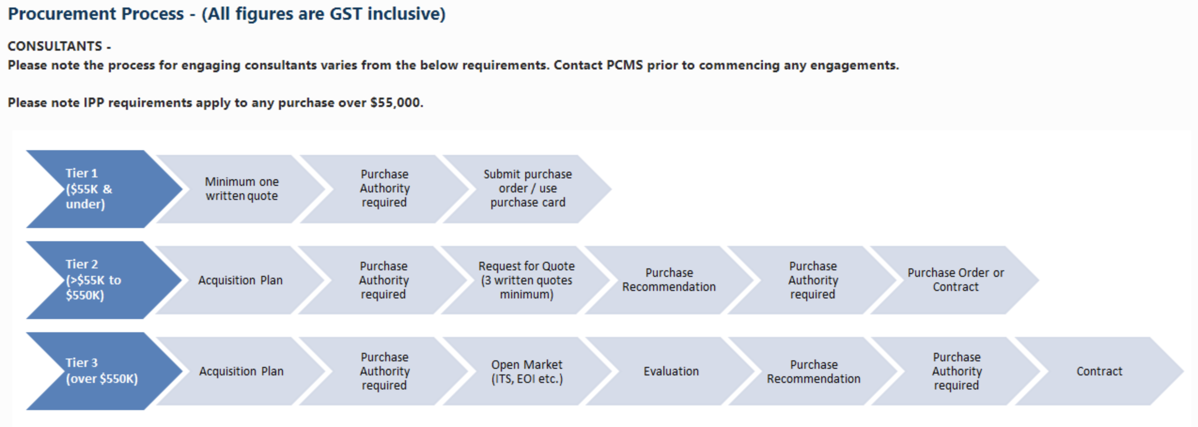

Budget approvals

For a new initiative? – Treasurer’s Instruction 17
The object of these instructions is to ensure that public sector initiatives are—
(a) justified; and
(b) subject to the appropriate approvals before they proceed.
public sector initiatives means —
(a) a new plan, project or program proposed by a public authority to achieve a particular outcome; or
(b) a substantial change in an existing plan, project or program being undertaken by a public authority.
New initiatives require a justification statement. They can be approved within the agency up to a value of $15,000,000 if the agency has (or is reasonably expected to have) sufficient financial resources available to meet the estimated cost of the public sector initiative. For initiatives of a value above $15,000,000, the approval of the Minister or Cabinet is required and when sought, should include written advice from Treasury and Finance on the budget impact.

Appendix 2: Project reporting example
Consider a project with a total budget of $16.7 million over 18 months. The expenditure profile of the project is summarised below.
We receive regular monthly reports for our project. Below is an example of a basic financial report for our project as of month 6.

What can we conclude from this report?

What other information do we need?

The initial report received is reasonable for an operational group or team that provides regular and predictable services across a year. This report may not be as useful for a project.
For our project, year-to-date variance appears reasonable but needs to be viewed considering the progress of the project in meeting its milestones.
For projects, low variances or underspending against budget by time can be indicative of delays in the project. The delays in the project can result in costs associated with stages being greater than anticipated. For our project, we can track the costs by stage to see if stages are taking longer and costing more. This reporting by stage is an important early warning system for the financials of a project experiencing delays.
At the six-month mark, it was initially hoped that the first three stages of the project would be completed:
- Procure and plan
- Configure the system and test
- Configure sites.
However, at the end of six months, only the first two stages have been completed. The under-expenditure on the original report is symptomatic of delays.
An additional report for us is to track expenditure by stage. Such a report is presented below.
This report shows that the costs of each of the stages completed to date have been more than the budget for each stage.
Now what is our view of how the project is going?

Earned value management
Earned value management (EVM) is a project management methodology that integrates schedule, costs, and scope to measure project performance.
Three core concepts to earned value analysis:
- Planned Value (PV) – is the approved budget assigned to scheduled work. It defines the physical work that should have been accomplished at the reporting date.
- Earned Value (EV) – is a measure of work performed at the reporting date expressed in terms of the budget approved for that work.
- Actual Cost (AC) – is the cost incurred for the work performed on an activity during the time period up to the report date. It is the amount of money spent in accomplishing the work that the EV measured.
The relationship between PV, EV, and AC is shown in the diagram below.
 |  | Expenses
 |  | Budget | Actual
Work/Activity | Scheduled | Planned Value
Work/Activity | Performed | Earned Value | Actual Cost

We can apply these concepts to our project. As at the six-month point:
- The planned value for our project can be calculated from the approved project value. The planned value (excluding contingencies) is $7.333 million.
- The earned value for our project is the budgeted cost for the first two stages. The earned value (excluding contingencies) is $5.290 million.
- The actual cost for our project is the inception to date cost - $7.313 million.

Earned Value Variance Analysis
Based on these figures, we can undertake, some Earned value variance analysis. Two basic measures include:
- Schedule variance and
- Cost Variance.

Schedule Variance (SV)
Scheduled Variance = Earned Value – Planned Value
Schedule variance is a measure of the divergence from the initial planned schedule. A negative SV indicates that the project is behind schedule, a positive SV indicates the project is ahead of schedule and zero means that we are exactly on schedule.
If positive – the project is ahead of schedule. If negative, the project is behind schedule.

Cost Variance (CV)
Cost Variance = Earned Value – Actual Cost
Cost variance is a measure of the divergence from the initial planned budget. A negative CV indicates that we are over budget for the work done to date, a positive CV indicates that we are under budget for the work done to date and zero means that we are exactly on budget.
The table below presents this analysis for our project.

The report shows:
- a schedule variance of -28.0 % - the project is well behind schedule
- a cost variance of -35.4% - the cost to complete stages to date is higher than the budget.
This can occur with projects that incur delays but where staff costs cannot be reduced and as a result have costs incurred that do not link to activity outcomes for the project.
Earned value analysis can be presented in graphical form.

Estimate at completion
A report that compares the approved revenue and expense budget for the project with our best updated estimate of revenue and expenses that we think will occur once the project is completed. The comparison between the approved budget and the revised estimate produces variances.
Our estimated cost at completion is based on:
- actual costs up to the end of the current month
- our best estimates of the cost and timing of costs for the remaining months.
An example of the estimate at completion report for our conference is shown below.
The estimate at completion can also be presented on a graph.
The analysis for this project suggests that if remain months go according to the original plan, the project will be completed two months late with an unfavourable variance of $2.0 million and without additional funding will run out of money before the end of month 18.

Appendix 3: Costing

Costing Definitions
Understanding costs and the ability to control the cost of operations is an integral part of good financial management. This section will review some common definitions of costing.
Total costs = direct costs + indirect costs

Total costs = fixed costs + variable costs

Cost type | Definition | Circumstances for use
Total costs | Direct costs plus indirect costs  OR  Fixed costs plus variable costs | - Where the service is long term and reliant on related systems and databases.
Direct costs | Costs that can be specifically attributed to the delivery of a service/project. | - Assessing sustainability over the medium term.  - Evaluating the cost of delivering material but non-core services.
Indirect costs | Costs over and above direct costs that are necessary to deliver the service in the long term. | - Longer term view and whole view of costs.
Full cost | When you consider total costs and add the cost of capital as a margin. | - Assessing sustainability over the longer-term view.  - Evaluating the cost of delivering core services.
Variable costs | Costs that grow or shrink as activity grows or shrinks. | - To understand the extent of flexibility a business has in pricing.
Fixed costs | Costs that do not grow or shrink as activity grows or shrinks. | - To understand the extent of flexibility a business has in pricing.
Average costs | The cost per unit when total costs are attributed across each unit of production. | - Usually applied in calculating prices per unit.
Marginal costs | Additional costs of providing an additional unit of service or collecting an additional $ of revenue. | - Assessing short term sustainability.  - Adding a small revenue item to the collection base.

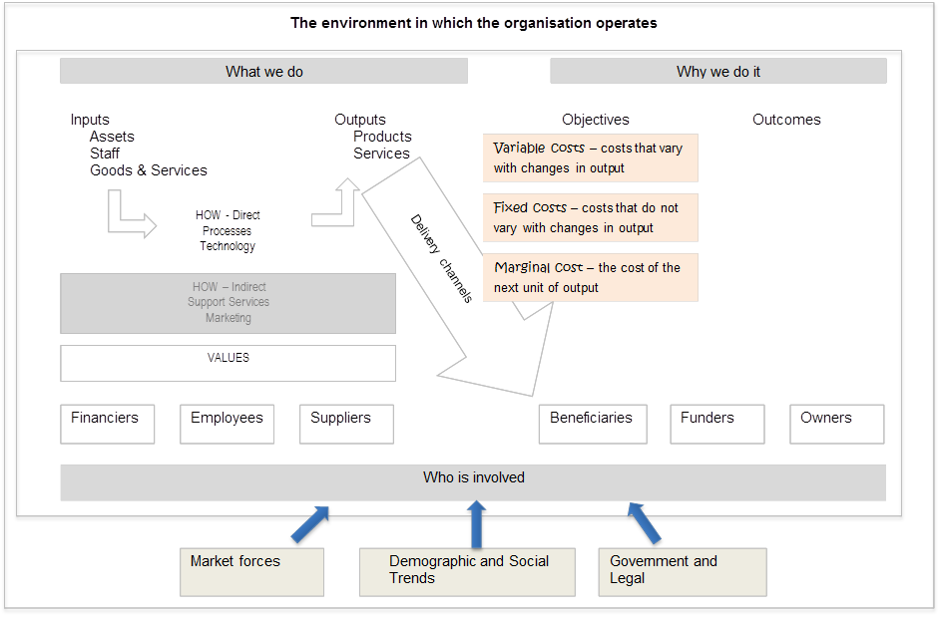
Goods & Services
Employee expenses
Cost of Capital
Revenue from sales
Grants & subsidies
Return of Capital
Direct Costs
Indirect Costs

Appendix 4 - Better Practice Techniques for Budgeting

Excerpt from the former Treasury and Finance Financial Management Framework
There are numerous better practice techniques for effectively and efficiently budgeting for desired outputs within a department. The information listed below is presented by technique and rationale to aid departments in the development of their budgets.
Technique 1: Publish a comprehensive budget calendar that specifies when budget tasks are to be completed and that identifies timelines for those tasks.
Rationale: Managers need to be aware of when key budget tasks, events, and decisions will occur so they have an opportunity to plan and participate in the process. The preparation of a calendar helps ensure that all aspects of the budget process have been considered and that adequate time has been provided.
Technique 2: Prepare general policy guidelines and budget preparation instructions for each budget cycle.
Rationale: Budget guidelines and instructions help ensure that the budget is prepared in a manner consistent with Government policies and the desires of management and the legislative body. Instructions are necessary so that all participants know what is expected, thereby minimising misunderstanding and extra work.
Technique 3: Develop mechanisms and assign responsibilities to provide for overall coordination of the preparation and review of the budget.
Rationale: The complete budget process involves many levels, departments and individuals in a Government, as well as a number of distinct processes and disparate groups of stakeholders. Coordination is needed to ensure that processes move forward as planned to prevent confusion and misinformation and to ensure appropriate stakeholders are involved.
Technique 4: Develop and implement a set of procedures that facilitate the review, discussion, modification, and adoption of a proposed budget. This review process should include a representation from all functional areas within the department so a balanced and consensus-building approach is used during the deliberation and evaluation of funding priorities.
Rationale: Appropriate procedures are needed to resolve conflicts, promote acceptance of the proposed budget by stakeholders, and assist in the timely adoption of the budget.
Technique 5: Provide opportunities in the budget process for obtaining stakeholder input.
Rationale: By definition, stakeholders are affected by a Government’s resource allocation plans and service and program decisions. Stakeholders should have clearly defined opportunities to provide input. This helps ensure that stakeholder priorities are identified and enhances stakeholder support for the approved budget.

Technique 6: Develop a financial planning process that assesses the long-term financial implications of current and proposed policies. Programs, and assumptions that develop appropriate strategies to achieve its goals. Sufficient forecasting budgeting tools should be employed to understand the impacts of funding a service or services under varying ‘what-if’ scenarios.
Rationale: Financial planning expands a department’s awareness of options, potential problems, and opportunities. The long-term revenue, expenditure, and service implications of continuing or ending existing programs or adding new programs, services, and debt can be identified. The financial planning process helps shape decisions and permits necessary and corrective action to be taken before problems become more severe.
Technique 7: Prepare multi-year projections of revenues and other resources.
Rationale: The projection of revenues and other resources is critical to understanding the level of funding available for services and capital acquisition. Projections for future budget periods help determine the likelihood that services can be sustained and highlight future financial issues to be addressed. Preparing revenue projections also enhances a department’s understanding of revenue sensitivity to changes in assumptions and controllable factors.
Technique 8: Maintain an in-depth understanding of major revenues.
Rationale: A large, unexpected variance in a major revenue source is usually a major problem, but even a relatively small variance in a major revenue source can have a significant impact. The better the ability of a department to predict these changes or at least their direction, the less disruptive these changes will be. In addition, improved estimation of these revenues will enhance the confidence of stakeholders in the overall revenue projection.
Technique 9: Evaluate and understand the effect of potential changes to revenue source rates and bases.
Rationale: Changes in rates and fees of revenue sources and revenue bases may be made by a Government for a variety of reasons (for example, to increase or decrease revenue) or may happen outside of the control of a department and its government. Understanding the effects of such changes, in terms of expected revenue collections or other impacts, in advance of the changes will increase understanding about the outcome, enhance decision making and provide a better opportunity to plan for the changes.
Technique 10: Periodically estimate the impacts and potential foregone revenue as a result of policies that exempt from payment, provide discounts and credits, or otherwise favour particular categories of taxpayers or service users.
Rationale: A periodic review of current or proposed exemptions and fees is necessary to verify their desirability, their potential benefits and costs, and the extent to which they benefit certain taxpayers or service users more than others.
Technique 11: Develop a process for achieving consensus on the forecast of revenues used to estimate available resources for a budget.
Rationale: Developing consensus on the revenue forecast is more likely to remove the forecast from ongoing disputes and keep the budget process on track. The process of achieving consensus helps ensure a critical review of assumptions underlying the forecast.
Technique 12: Prepare and maintain a revenue manual that documents revenue sources and factors relevant to present and projected future levels of those revenues.
Rationale: The documentation of revenue sources promotes a better understanding of a Government’s resources. Revenue documentation is also important as an administrative function since budget operations often experience fairly frequent staff turnover.
Technique 13: Prepare multi-year projections of expenditures for each fund and for existing and proposed new programs.
Rationale: Senior management should understand the monetary impact of budget decisions made in ‘year 1’ relative to other years to assess the sustainability of funding certain programs within the department. In addition, the impacts of legislation on certain funding should be recognised.
Technique 14: Evaluate revenue and expenditure options together and consider the implications for other financial indicators before making specific choices with regard to the proposed budget.
Rationale: Senior management should understand the financial implications of revenue and spending options being considered, including the ability of the department to sustain programs and services in the long run.
Technique 15: Employ an industry-recognised budgeting approach (incremental budgeting, zero-based budgeting, or activity-based budgeting)
Rationale: There are several types of budgeting tools and techniques within the management accounting framework. Each budgeting technique has its own unique set of advantages and disadvantages, and each is more suited to certain circumstances than others.

Incremental Budgeting
Incremental budgeting is the most traditional style of budgeting used. However, with the growing focus on outputs and outcomes, departments will require a broader range of budgetary tools. Under the new arrangements, agencies will need to establish budgets and monitor performance against such budgets, which focus on the full costs of particular outputs rather than merely compliance with cash-based input targets (that is, Consolidated Account appropriations).
Incremental budgeting involves the rolling over of the previous year’s budget into the current year after having made incremental adjustments to reflect changing activity levels, responsibilities or objectives. This has the effect of embedding inefficiencies and can lead to allocation of spending to areas where money has been spent, rather than where it should be spent.
Given the need to adopt a more strategic approach to planning, including the assessment of alternative service delivery options, department budgetary processes may need to incorporate elements of budgetary tools that examine more fundamentally the activities in which an agency engages. Such tools include zero and activity-based budgeting.

Zero-based Budgeting
The use of zero-based budgeting disregards the precedent of the previous period’s budget and requires all costs to be justified each period. This process involves examining the objectives of the organisation, determining options as to how they might be achieved, and then evaluating each option.
The benefits of such analysis are clear, and effective use of such a procedure should result in a more efficient and effective allocation of resources. However, the costs of conducting this process may be restrictive in some agencies.
Activity-based Budgeting (better practice)
Activity-based budgeting represents current better practice in financial management. Activity-based budgeting is based on a premise similar to zero-based budgeting, in that all costs must be justified each period. However, when activity-based information is available a more accurate picture of the costs incurred by agencies’ activities can be determined. This in turn leads to more effective management decisions. Activity-based budgeting involves:
- Identifying the major functional outputs and processes within the organisation (for example, production, finance, marketing)
- Identifying the constituent activities that make up the major functional processes (for example, accounts payable, accounts receivable, payroll)
- Identifying the cost drivers and resource consumption levels for each activity
- Determining the contribution level of each activity to the organisation’s objectives; and
- Establishing performance measures to evaluate each activity against budget.
Technique 16: Use budgeting system software that contains strong analytical and functional capabilities.
Rationale: A department’s criteria for a robust budgeting software tool should be driven by the budgeting process requirements and the associated analysis and reporting requirements set by the government or agency. Other evaluation criteria can be used to more fully evaluate the many software vendors who maintain budgeting software products.
Technique 17: Develop a capital infrastructure plan that identifies its priorities and time frame for undertaking capital projects and provides a financing plan for those projects.
Rationale: The cost of desired capital projects will sometimes substantially exceed available funds in most departments. The development of a capital infrastructure plan provides a framework for prioritising projects and identifying funding needs and sources.
Technique 18: Prepare and present a recommended comprehensive program and financial plan (the “budget”) for review by stakeholders and consideration for adoption by the executive.
Rationale: A complete plan is necessary to allow stakeholders to judge how well all of the different aspects of the plan fit together and whether there is an appropriate balance of resources and assigned uses.
Technique 19: Include a description of key program and financial policies, plans, and goals in its budget documents.
Rationale: Identification of key program and financial policies, plans, and goals assists stakeholders in determining the appropriateness of a department’s direction and allows stakeholders to develop their own opinions as to whether the department’s programs and decisions conform to or are likely to achieve those policies, plans, and goals.
Technique 20: Highlight key budget issues and decisions in the deliberation process.
Rationale: Identification of key issues and decisions focuses attention on the most critical areas, improves the likelihood that an appropriate level of deliberation will occur regarding decisions in these areas, supports the notion of government accountability to stakeholders, and promotes trust.
Technique 21: Outline in the budget document the short-term and long-term financial plan of the department.
Rationale: Stakeholders need to have the financial plan of the department clearly identified to make the best budgetary decisions.
Technique 22: Provide the reader with budget documents referring to the operation of programs, services and organisational structures to provide the programs.
Rationale: information concerning programs and the organisational structure supporting those programs provides context for the proposed allocation of resources in the budget. This information is necessary to make reasoned decisions about the use of resources and to make clear the direction of the department’s programs.
Technique 23: Prepare a summary of both the proposed and final budget.
Rationale: Most managers do not want to take the time to read and understand the details of a budget. A concise summary of key issues, choices, and financial trends is therefore needed to inform and direct the reader to the appropriate location for additional information.
Technique 24: Provide clear and comprehensible budget documents and related materials to stakeholders.
Rationale: The budget is the guide that determines the direction of the department. It is arguably the single most important document routinely prepared by departments. To be usable, it not only must contain the appropriate information but must also be prepared in a manner that is clear and comprehensible.
Technique 25: Adopt a budget that meets all statutory requirements before the beginning of the fiscal year.
Rationale: The timely adoption of a budget permits the department to proceed with implementing programs and services that further the achievement of goals.

Appendix 5: Financial clarity at work – The Scientists
I was asked to help a team of scientists who had been asked to deliver their services with less money. They were part of a government department and had been given a savings target from the Government.
There is a range of scientific services that operate across State and Federal Governments. In the State Government examples include pathology and radiology services within the Health and Human Services Department, Forensic sciences within the Justice Portfolio, and food, plant and biosecurity services within the environment and primary industries sectors. In the federal government, examples include the CSIRO, the Bureau of Meteorology and aspects of customs.
The initial reaction from the scientists was that they could not achieve their savings targets through efficiencies. Improving their services was an ongoing task and they were continually finding ways to deliver their services more efficiently.
They were confused by the allocation of a savings target without regard for the services they delivered. They had not been consulted on the amount of savings or their implications. My assistance was sought to help them work through this task. In the first instance, I made it clear to them, that all parts of government have savings targets allocated to them. It is a reasonable thing for the leaders of an organisation to expect ongoing improvement and efficiencies as well as the government making decisions to reallocate money due to changing demographics or economic realities like lower taxation income.
My first piece of advice is not to get caught up on why they had been allocated savings or the politics of their savings target. Our goal was to achieve a line of sight between the financial parameters of their business and the service parameters of their business so the implications of the savings targets would be clear to them, to their department and the Government. I wanted to understand the full cost for the delivery of their services and the relationship between these costs, the revenues of the business and the activity of the business.
We started by viewing their business as a series of functions or services. Most businesses do this naturally and the result of this can be seen from organisational structures.
All organisations of any size can be distilled down into two functions:
- Function One: Produces and Delivers the outputs of the business (e.g. Laboratory services, tests, freight to deliver)
- Function Two: Supports function one (e.g. Finance, HR, ICT)
The first function incurs direct costs and the second function incurs indirect costs. The second function is often described as an overhead. Both functions are necessary in any business.
We started by understanding the structure of their business and how the finances were allocated across the various functions of your business. It was important to be able to have both a historical view of their finances by function and to have a forward-looking view of their finances by function. The second area is often not that well understood.
I wanted to develop a representation or a financial exhibit of their overall business showing the revenues and expenses of each function.
We developed an initial financial graphic of the business that looked as follows:
The graphic showed the total expenses for the business as the sum of the expenses across each team (from left to right) and the sum of expenses across the different categories of expenses (from top to bottom).
The scientists had structured their business and their finances in this way and we were able to construct this above table quite easily.
To get a better line of sight, we needed to understand the full cost of delivering the services from each of the teams. To do this, we need to allocate or attribute the corporate costs across each of the teams. Attributing ICT expenses can be done by identifying the ICT requirement of each team (number of computers, machines or data usage from each team). Other corporate costs are often attributed to teams based on the number of FTEs in each team as a % of the total of the four service delivery teams. I wanted to develop a second financial exhibit that looked like that below.
We now had a display of the total expenses associated with each team in the business.
My next request for an improved line of sight was to include some measures of activity or output for each of the teams. For the scientists, the measures of activity could have included:
- The number of tests performed
- reports produced
- cases managed
- investigations conducted.
The scientists did have measures of their activity, although they were nervous about how well these captured some of the subtleties of their work. For instance, those who performed tests would comment that they had simple tests and more complex tests. They should not be counted as the same. We could address this by establishing the concept of a standard test and then estimating that complex tests were the equivalent of three standard tests. Now we could combine the different tests into one meaningful measure of the number of standard tests performed. This activity data can be included in our graphic and can be used to calculate an average cost per item. This is shown in the graphic over the page.

We are now establishing a line of sight between the expenses of the business and the activity of the business. With this line of sight, the scientists were now able to demonstrate the impact of the budget savings on their activity levels. A reduction in the budget for team one will translate into that team performing fewer tests or managing fewer cases which will likely impact the waiting time for tests or cases.
Another benefit of this line of sight is that the scientists have developed parameters for their business that can be benchmarked. As a minimum, they can benchmark their current and future performance against their past performance. They can also benchmark their performance against that of other enterprises to find and identify opportunities for improvement or to identify where they have achieved high standards of efficiency or effectiveness. The main benefit of external benchmarking is that it acts as a trigger to evaluate performance and to find ways to improve, from the examples of comparable businesses.
The scientists modelled these impacts and provided a submission back to the Government to demonstrate the impact of the budget reductions. They modelled the impact on the number of tests performed and estimated the increased waiting times arising from the reduced activity. There are functions of government where the speed and waiting times for scientific tests will impact other services. Examples will include the speed of pathology tests in moving patients through hospitals, and DNA tests in progressing police investigations and court trials.
An example of the outcome of this work is provided in the following graphic.

This final graphic provides a line of sight between expenses and their relationship with activity and their relationship with a performance indicator like waiting times.
In the case of the scientists, the Government received their submission and feedback from other agencies was such that they wanted to avoid the impact of increased waiting times in one of the services. The increase in waiting times in other services was not ideal but deemed tolerable.
The Government then reinstated some of the savings requirements, seeking to quarantine some key functions from the impact of savings.
The example shows the value of having a line of sight between finances, activity and outcomes and increases the financial clarity for the business. The example also shows business model clarity and financial clarity at work. In this case, the financial clarity served as a defence against budget cuts for one team in the business. For other teams in the business, the financial clarity serves to help manage expectations about service levels, demonstrating that the savings would impact on service volumes and waiting times.

Conclusion
Financial Clarity is a keystone requirement of public administration. It enables internal management and decision making and it enables external decision making with respect to funding and expectations.
Be prepared to answer two questions:
- Do I know what resources I need to do what is expected of me?
- Do I know what I can deliver with the resources I have been provided?

