MANAGING PUBLIC SECTOR BUDGETS
Professional Development Course Book
Presented by Mark Priadko

IPAA Personal Membership
Become part of the IPAA SA Personal Member community and access an extensive range of benefits, opportunities and support for your career.

Personal Membership Will…

Get you future ready
We will improve your career as we educate and inform you of what’s to come in the future of the profession and build your skill set to ensure you are ready for it.
Build your capability
We will build your current capability to ensure you perform at the best of your ability and get you ready to face every new challenge throughout your career.
Champion you
We will champion your successes and voice them to the sector.

Build your networks
We will build your networks and connect you to like-minded people, people facing the same challenges as you and people who can help you to gain influence and penetrate the vast public sector.
Connect you
We will connect you with ideas from across the country through our National body and State jurisdictions.
Support you
We will provide you with tangible support throughout your career.

More benefits
- Extensive discounts on IPAA SA training, courses, forums and events.
- Access to exclusive member opportunities, such as our mentorship program and networking sessions.
- Receive resources and learning opportunities relevant to your career level.
- Receive a membership certificate for your CV and use of the MIPAA post nominal.
- Unlimited digital access to the Australian Journal of Public Administration.
- Receive a training voucher to the value of your membership.
- Have your say in IPAA SA governance.

How to join?
Joining is as easy as visiting our website: www.sa.ipaa.org.au/membership. Navigate to the Membership section and select the membership type most applicable to you and fill in your details online. Membership fees are generally tax-deductible.

If you have any questions about membership, contact us on 8212 7555 or email membership@sa.ipaa.org.au
.

Learning objectives:
- Introduction to financial management basics
- Understand functions and types of budgets
- Understand government budgeting processes
- Get practical insight into managing and controlling budgets.

Self-evaluation
My proficiency in managing budgets and financial plans is:
 | 1 | 2 | 3 | 4 | 5 | 6 | 7 | 8 | 9 | 10
 | Low |  |  |  |  |  |  |  |  | High

List of what I need to know to move up one point on this scale.
- .......................................................................................
- .......................................................................................
- .......................................................................................
- .......................................................................................

These course notes are designed to support the presentation of information in the module. They are based on the knowledge and experience of Mark Priadko. These notes are not designed to present comprehensive documentation of the nature of financial management or public sector finances. References are provided for those who wish to investigate matters in more detail.

Table of contents

Introduction 6
Transaction processes 8
Organising principles of finance (how we account for what we do) 11
Reporting - Management Accounting vs Financial Accounting 17
Accounting concepts and terminology 20
Understand the system we are part of – Public Finances 26
Public finances differ from private finances 26
Public finance terminology 27
Financing the business – relationship with funders 27
In public finances – legislation and the budget are central 27
Is it in the Budget? 30
The budget process 31
Carryovers 35
Finances: An expression of strategy 38
What is our business model? 38
Components of a Business Model 39
Projects vs Operations 41
Approaches to projecting and budgeting 44
Managing Budgets and Financial Plans 48
Understand your costs & revenues – Zero-based & activity-based budgeting 49
Adapt to being issued a top-down budget, that is lower than my zero-based budget 57
Cash flowing (phasing) the approved budget 63
Exercise control over transactions 67
Is it value for money – have processes been followed? 69
Monitoring performance against budget during the year 72
Adapting to unfavourable variations that occur during the year 76
Seek approval to change our budget 80
Summary of budgeting, reporting and monitoring 83
Appendix 1: Financial management expectations 84
Appendix 2: Understand the fungibility of public money 88
Appendix 3: Accounting and Budget Terminology 91
Appendix 4: Costing Terminology 96
Appendix 5: Project Estimating and Reporting 99
Appendix 6: Different Approaches to estimating and projecting 111
Appendix 7: Treasurer’s Instructions – List 114

Introduction and initial discussion
Finance as an expression of strategy
Understand costs and revenue – zero-based budgeting
Adapt to a top-down budget (including savings)
Cash flow (or phase) your budget
Exercise control over transactions
Monitor your performance against budget
Adapt to budget variations
Seek approval to change your budget
I am more confident in my ability to manage my budget and to work with finance staff in my department
Public Finance – the system we are part of
Organising principles of finance

Case Study
Several parts of government are involved in temporary or transitional housing programs. Examples include housing for staff, housing for children in care, housing to assist with hospital discharges, and housing to support workers in regional areas. We will consider managing a budget for such a program.
If we were to run a transitional housing program, what are some inputs we would need?

What are some choices that could be made about how we acquire or procure these inputs?

What would be some key cost drivers and parameters that we need to establish in order to develop a budget?

What are some examples of the outputs of such a program?

Introduction
It is my view that there are five components to good financial management:
- Establishing the financial bottom line(s) (financial targets)
- Do you know where you are? (reporting)
- Are you confident in your future viability? (estimating & projecting)
- Are decisions rigorous and transparent? (budget bidding & allocation)
- Do you have adequate control over transactions? (control & assurance)
Targets
Funding it
Controlling it
Knowing it
Planning it
What is your financial bottom line(s)? Establishing financial targets
Do you know where your finances are now? Good financial reporting
Are you confident in your financial future? Good projecting and estimating
Are the financial implications of decisions rigorous and transparent? Good budget allocation & bids/business cases
Do you have assurance that transactions and records are right? Good financial controls

The basics apply to any household, business or government. While they sound basic, it cannot be presumed that all are done well.
Very often there is an emphasis on the reporting, control and planning (budgeting) components. However, the establishment of appropriate financial targets and transparency in decisions, if not done well, will undermine the benefits of doing the other components well.
The quality of financial management will be related to how well each of the five steps is carried out.

The accounting process (transactions to reporting)
The accounting process is a series of activities that begins with a transaction and ends with the production of reports and the closing of the books at the end of the accounting period.
Targeting it
Funding it
Controlling it
Knowing it
Planning it
What is your financial bottom line(s)? Establishing financial targets
Do you know where your finances are now? Good financial reporting
Are you confident in your financial future? Good projecting and estimating
Are the financial implications of decisions rigorous and transparent? Good budget allocation & bids/business cases
Do you have assurance that transactions and records are right? Good financial controls
Money
Transactions
Prepare the general ledger
Preliminary reporting & forecasting
Publish reports
Closing the books
Budget process
The budget process is the process through which organisations establish their budget and forward estimates for both the entire organisation and for the project and units within it.

Targeting it
Funding it
Controlling it
Knowing it
Planning it
What is your financial bottom line(s)? Establishing financial targets
Do you know where your finances are now? Good financial reporting
Are you confident in your financial future? Good projecting and estimating
Are the financial implications of decisions rigorous and transparent? Good budget allocation & bids/business cases
Do you have assurance that transactions and records are right? Good financial controls
Money
Budget submission for approval
Prioritise & negotiate proposals
Identify changes & proposals
Consolidate estimates
Project & estimate
The budget process is a process that establishes the parameters of financial sustainability for the year(s) ahead and involves bringing together projections and forecasts from across the business.

Transaction processes
Transactions are everyday events where goods and services are purchased, change hands and are paid for.
There is a range of transactions that occur within businesses. Hiring and paying staff, purchasing goods and services, purchasing and constructing assets, selling goods and services and making goods.
Transactions can be shown to follow a cycle. Examples are presented in the diagram below.

Commonly listed inputs or ingredients to a business include:
- Staff
- Property and plant like - Office accommodation
- Training for staff
- Office supplies
- Vehicles
- Specialist contractors
- Professional services (e.g. legal)
- Equipment – computers, printers
- Software and applications
- Consumables.
Choices for how we acquire or procure these inputs
- Own vs lease – we could choose to own buildings or vehicles or we could choose to lease them.
- Operate vs commission – we could choose to deliver services or operate a facility ourselves or we could choose to commission others to deliver the services.
- Staff vs contract – we could choose to directly employ staff to deliver services or we could choose to contract with others to provide the services when we need them.
These choices will define our business model.
Each of these choices has implications for how we account for what we do.
Outputs are what we deliver to clients and on behalf of the government. Outputs are what the government purchases when it provides budget funding.
The nature of outputs is scope-defining. For our program, our outputs could be:
- The provision of the housing. The extent of resourcing that we need will depend on what is needed to manage and maintain the houses.
- The provision of housing and the provision of case management services to residents. This could increase the scope of staffing to include case managers
- The provision of housing and care services to residents (e.g. nursing, social work). The extent of staffing will increase and will now depend on the intensity of care required for the residents. Intensity of care/support is a key factor in determining funding in hospitals, aged care, child protection, prisons and education.
We will revisit this example throughout the day to see what is needed to manage the budget for this work.
The management of a budget depends on the context in which it occurs.
Three matters of context relevant to our ability to manage a budget:
- Understanding how finances are organised – organising principles of financial management (how we account for what we do)
- System context - The financial system you are part of (the design of public finances)
- Business context - The business model chosen to deliver your services

Introduction and initial discussion
Finance as an expression of strategy
Understand costs and revenue – zero-based budgeting
Adapt to a top-down budget (including savings)
Cash flow (or phase) your budget
Exercise control over transactions
Monitor your performance against budget
Adapt to budget variations
Seek approval to change your budget
I am more confident in my ability to manage my budget and to work with finance staff in my department
Public Finance – the system we are part of
Organising principles of finance

Organising principles of finance (how we account for what we do)
Financial information is created through the recording of business transactions. A transaction is an agreement between two parties (a buyer and a seller) to exchange goods or services. Organisations capture and record each and every financial transaction they undertake. Transactions may be for sales, purchasing or assets with each transaction assigned coding to distinguish between the types of financial information being recorded.
Transactions are recorded by entering the data into a ledger, which acts as a central database for an organisation. For financial reporting, the General Ledger becomes a primary source of the truth. The general ledger represents census data of every transaction that occurs in an entity and is subject to audit each year.
Transactions are recorded in financial systems or databases. In some cases, each type of transaction is recorded in its own system (e.g. payroll, asset register, purchasing, or sales ledger). Data is then transferred from these systems into a central ledger, known as the general ledger. In some organisations, one integrated system is used to capture all this data. These systems are known as enterprise resource platform (ERP) systems. Examples of ERP systems are SAP, PeopleSoft, Oracle, and Masterpiece.
The accounts are the sum of all transactions for a business. Transactions occur in a range of systems and are consolidated together for the whole business in the general ledger.
General ledger (Masterpiece/Oracle)
Revenue systems
Sales & debtors
Purchasing systems
(e.g. Basware)
Purchases, accounts payable
Payroll/HR systems
(e.g. Chris 21 & workforce central)
Salaries and leave o/s
Asset register
Values, depreciation, WIP
Budget management & reporting system
Budget inputs & variation to budget reporting

The reporting process requires that the reporting period is closed in each of these source systems and in the general ledger putting an end to transactions for that period.
Transactions are recorded with codes – cost centre codes and account codes. These codes make up what is known as the chart of accounts. All transactions are organised using a chart of accounts.

Charts of accounts are typically arranged into the following account types:
- Asset accounts – something you own, e.g. bank account, investment account, accounts receivable (revenue owned), motor vehicle, etc.
- Liability accounts – something you owe, e.g. accounts payable, loans, etc.
- Equity accounts – the net worth or value of an organisation to its owners
- Revenue accounts – income you expect to receive for providing a service or item. Examples include sales, fees and charges, hire of facilities, grants received.
- Expense accounts – payments you make for purchases or services received. Examples include employee expenses, office supplies, consumables, repairs and maintenance, and utilities.
The table below is an example of a summary chart of accounts
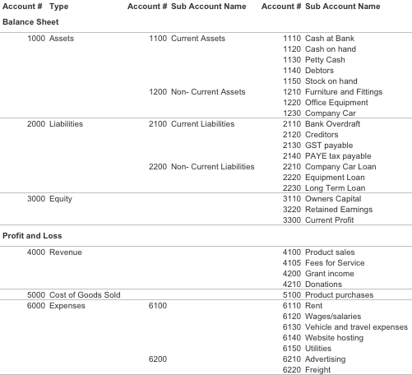

The account codes enable the preparation of financial reports :
- Operating statement – shows the values of revenues and expenses. Also referred to as the statement of financial performance and the profit and loss statement.
- Balance sheet – shows the values of assets, liabilities and equity. Also referred to as the statement of financial position.
These account codes are one element of the chart of accounts. Other elements include:
- Entity code
- Cost Centre code
- Activity code
- Fund code
- Product type code
- Identifier code.
The use of these codes enables transactions to be arranged and reported in different ways.
This combination of codes enables operating statements to also be produced for each team or division within an organisation.

The accounts used in finances form the basis for the reporting of financial information, where:
- The values of Assets, liabilities and equity are presented in a balance sheet (statement of financial position)
- The values of revenues and expenses are presented in a profit and loss (or operating) statement (statement of financial performance)


FINANCIAL POSITION
Assets:
Cash
Investments
Property
less Liabilities:
Loans
Provisions
Accounts payable
equals Net worth
FINANCIAL PERFORMANCE
Revenue:
Taxes
Grants
Sales of Good & Services
less Expenses:
Salaries
Supplies & Services
Facilities and Utilities
equals Net cost of services

Financial position is improved or deteriorated depending on financial performance. Poor financial performance (expenses greater than revenue) will result in a deterioration of financial position. Good financial performance (revenue greater than expenses) will result in an improvement in financial position.

Examples of financial statements for a government department are provided below.
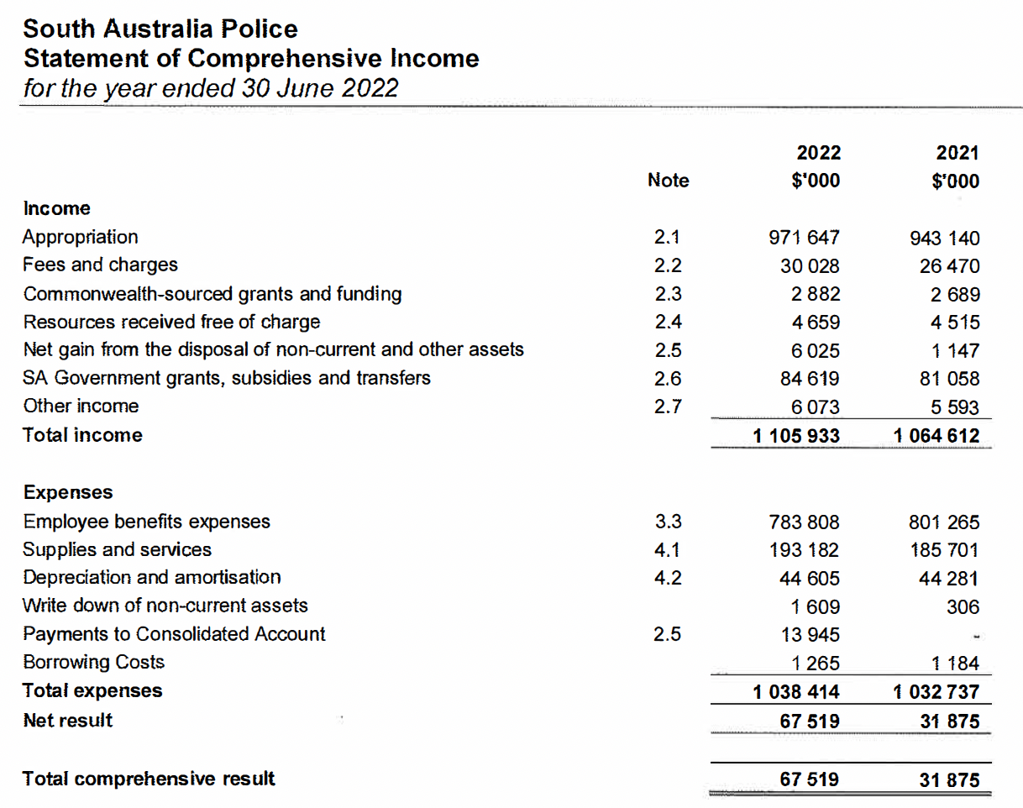
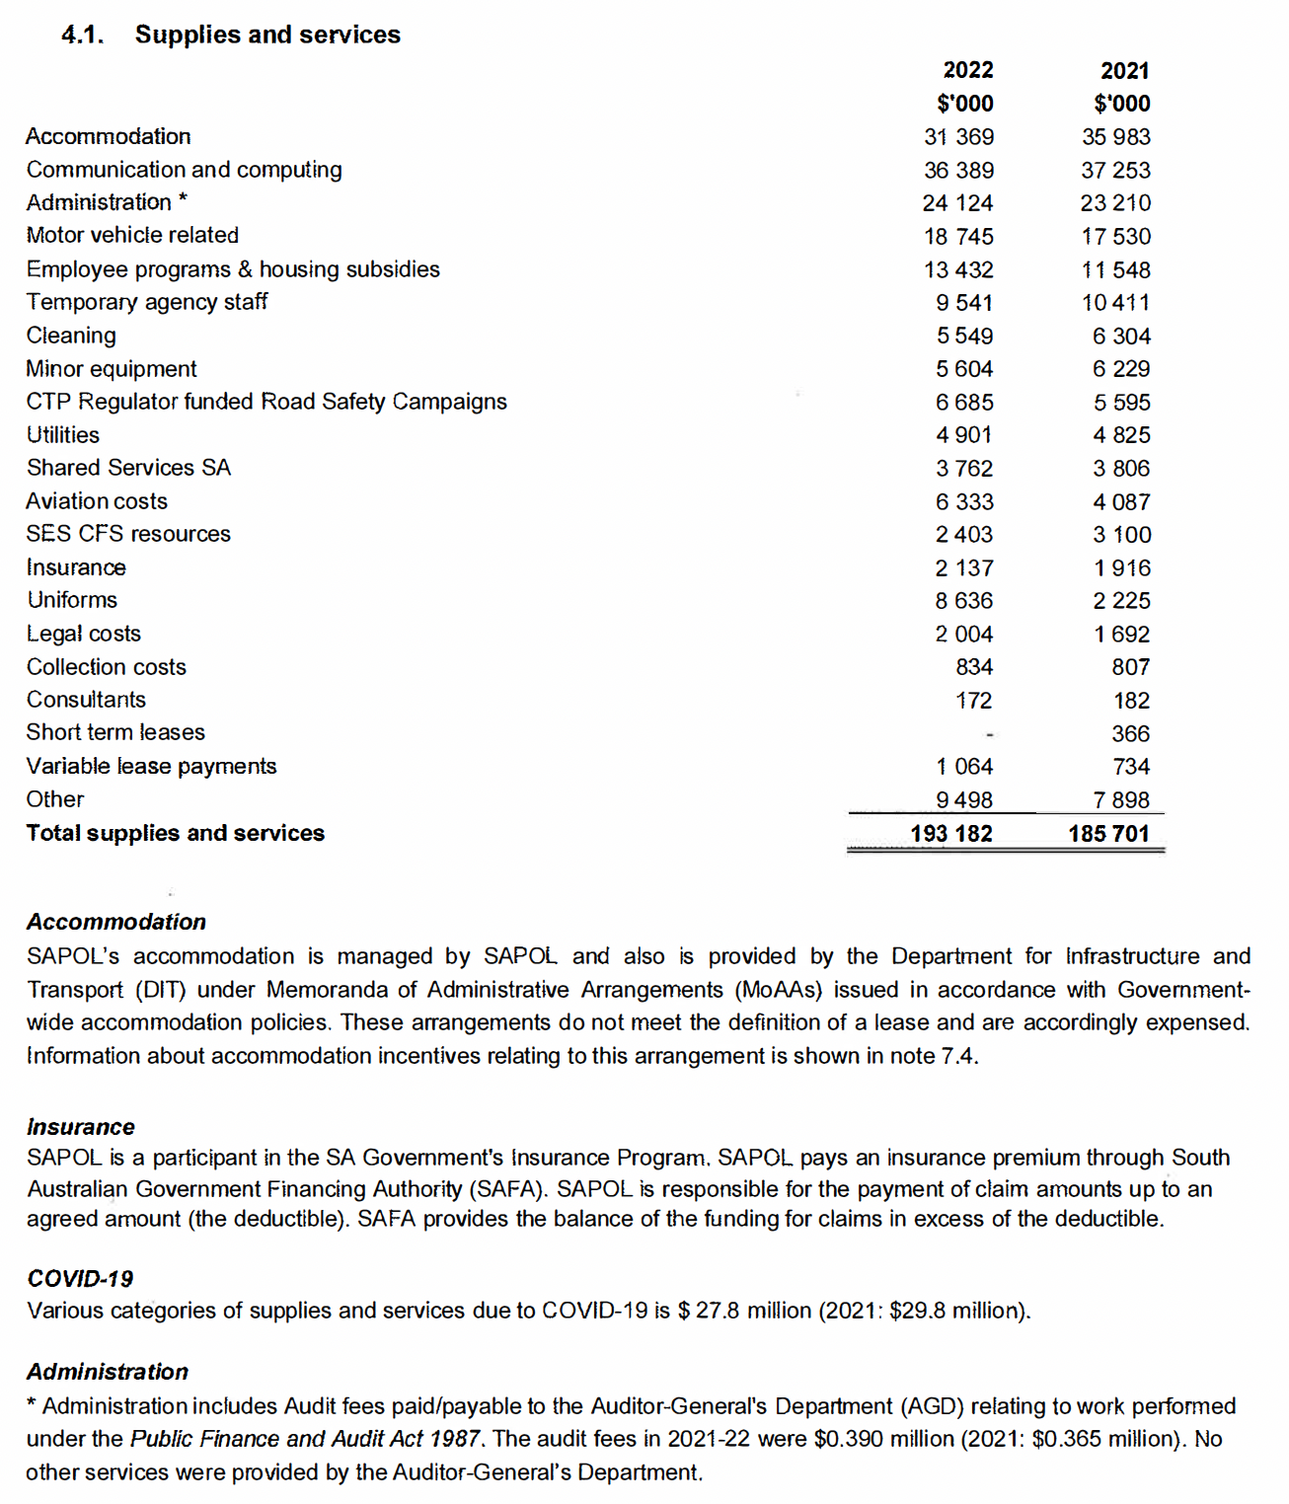
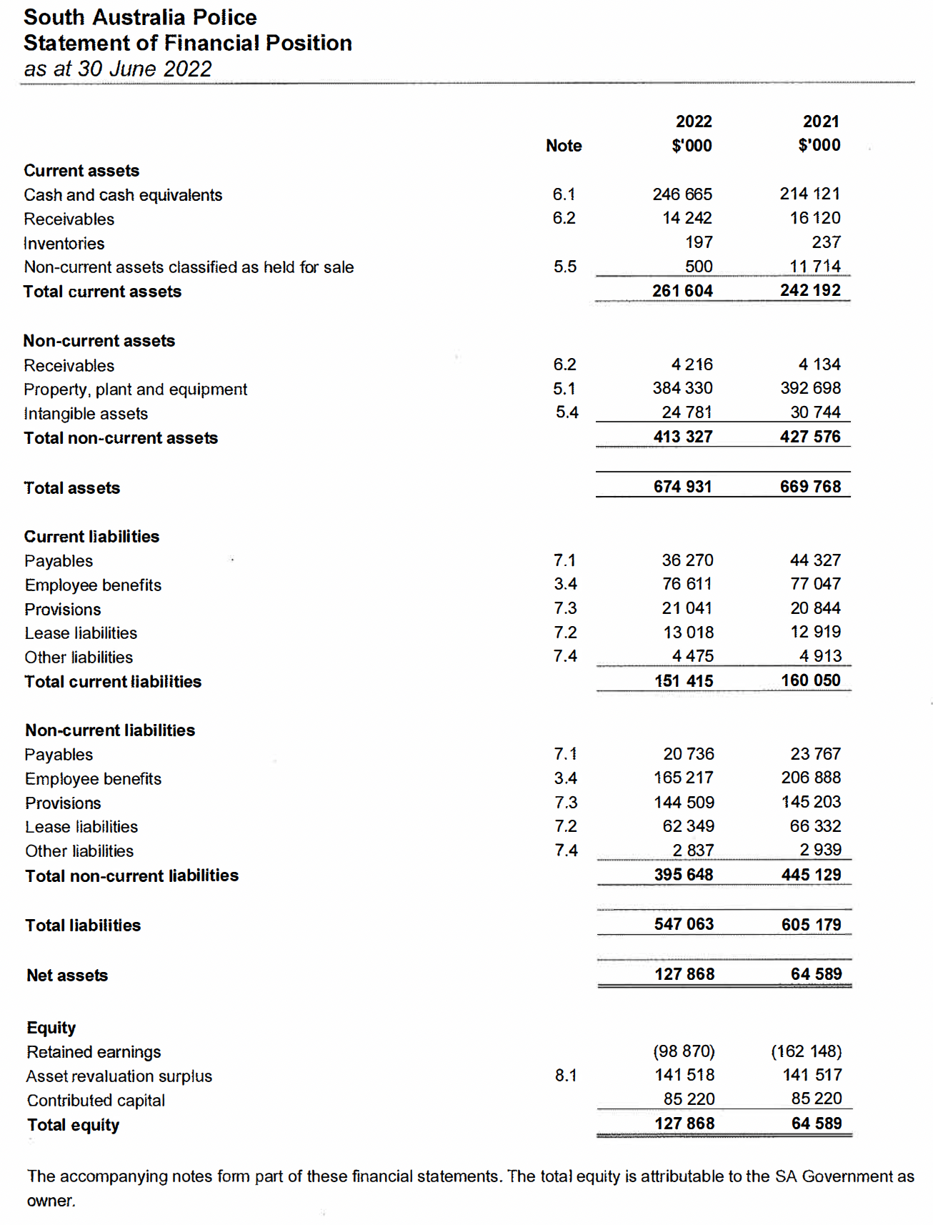
These statements tell the financial story of an organisation.
The statements above form what are known as external or statutory reports.
Another form of reporting produced to tell the financial story of an organisation are management reports or internal reports.

Reporting - Management Accounting vs Financial Accounting

Financial Accounting & External (Statutory) Reporting
Accountability results in the production of financial statements, primarily for those interested parties who are external to the business. This function is called financial accounting.
Financial Accounting is largely focused on producing external or statutory reports.
Statutory Reports are:
- Published in annual reports that are submitted to ASIC, provided to shareholders or tabled in Parliament.
- They are produced for external consumption according to accounting standards
- They are subject to external audit by an independent auditor (e.g. the Auditor-General for Government departments)

Management Accounting and Internal (Management) Reporting
As managers, we are mostly concerned with the following processes, which are not only financial but the development and use of which require managerial expertise and judgement:
- Planning: establishing goals and strategies to achieve those goals (the business plan)
- Decision-making: using financial information to make decisions consistent with those goals and strategies
- Control: using financial information to maintain performance as close as possible to the plan, or using the information to modify the plan itself
Managers need both financial and non-financial information to develop and implement strategy by planning for the future; making decisions about products and services; and ensuring that plans are put into action and are achieved through requisite control. These three functions are collectively called management accounting which produces management reports.
Management Reports are:
- Usually produced monthly and are provided to cost centre and division managers
- They are produced for internal consumption to track performance against targets (usually against budget) hence they tend to focus more on revenue and expenses
- They are tailored depending on the type of organisation and the needs of its decision-makers
Management reports are usually based on the operating statements but will include information about variances from budget. Management reports look different across different organisations.
Below is the layout of a monthly financial report for a section/division from Oracle.

Other examples of management reports are provided over the page.

Accounting concepts and terminology

Cash vs. accrual
Differences between cash and accrual accounting are observable at two levels:
- How they are reported.
- When transactions are recognised.
With respect to reporting, cash accounting focuses on the source and application of funds, hence the movement in cash balances. However, accrual accounting generates reports on financial performance (revenue and expenses) and financial position (assets and liabilities).
With respect to recognition, timing is the main difference between cash and accrual accounting. When transactions are recognised depends on the accounting method being employed.
Cash accounting recognises the value of a transaction when cash changes hands.
Accrual accounting recognises the value of a transaction when the transfer of the good or service occurs (more specifically, when there is a transfer of value or benefits).
For transactions where the receipt of the good or service occurs at the same time as cash changes hands (e.g. when we buy a sandwich at a café), the recognition of the transaction will be the same under both accounting methods.
However, where there’s a time gap between the receipt of a good or service and the handover of cash, the transactions will be treated differently in a cash system vs. in an accrual system.
When there’s a time gap between the cash and accrual recognition, it gives rise to items appearing on the statement of financial position such as accounts receivable, accounts payable and provisions. Each is an example of where transactions have occurred, but cash has not changed hands.
Example: Electricity bills are usually paid quarterly (i.e. cash changes hands quarterly) while the electricity is being received and used daily. In an accrual system, expenses will be recognised each month based on a reasonable estimate of electricity use during that month. Every month, this would result in the cost of electricity in a cash system being different to that shown in an accrual system. Over a year, it would be expected that the timing differences would even out and that the results would be similar under each method.

Commitments vs Actuals
Accrual accounting can be distinguished from commitment accounting. Being committed to future expenditure does not, in all cases, result in the recognition of a transaction. For a future commitment to be recognised in the accounts, there needs to be certainty about its value and its occurrence (e.g. raising a purchase order does not result in the recognition of an expense – a purchase order can be cancelled at any time). Only when future commitments are certain or discharged (i.e. when benefits or value is transferred) is an expense recognised.
Commitments are records of amounts outstanding against purchase orders entered into, where the goods or services have not yet been delivered.
They differ from actual spending where goods or services have been delivered.
When recognising actual expenditure by fulfilment of a purchase order, actual expenditure is recognised before payments are made (i.e. before cash is paid)
Revenue is recognised when invoices are issued for work completed and is recognised before cash is received.

Long Service Leave, Superannuation & Annual Leave
Some transactions take years to 'even out'. Long service leave and superannuation are two examples that are the most relevant of such transactions in Government. Each day an employee works, the employer incurs an expense associated with long service leave and superannuation. However, the cash associated with these items will only change hands when an employee takes their long service leave (or receives a lump sum) or when an employee retires. In these examples, the cash transaction will understate the true expenses in most years. Accrual accounting will recognise the long service leave and superannuation expenses when they are incurred at the end of each pay period. This is done by processing a journal from the payroll system or by the accounting section within a business.
Long service leave, superannuation and annual leave are good examples of where accrual accounting gives a truer picture of the financial performance of a business. When the expenses in an accrual system are greater than the cash payments, a provision (a liability) must be recognised in the accounts to indicate the value of the cash owed to employees. In the case of superannuation, the government sets aside cash to maintain investment assets at sufficient levels to meet future super payments. The gap between the investment assets and the value of future payments is referred to as unfunded superannuation liabilities. These are the largest liabilities of the SA Government.
NOTES

Assets and Depreciation
Cash and accrual systems also differ in the expensing of major assets. A cash system recognises the cost of an asset as an impact on the cash flow statement when it is bought. An accrual system recognises the cost of an asset as an impact on financial performance, as it is being used. Depreciation is how such an expense is recognised in an accrual system. In accrual accounting, the statement of financial position recognises the value of an asset and offsets this with the accumulated depreciation recognised for the assets.
Depreciation is the method used to allocate the cost of equipment and other assets to the total cost of products and services as shown on the income statement. Most capital expenditure items are depreciated (land is an example of one that is not). Accountants attempt to spread the cost of the expenditure on a capital item over the useful life of the item.
Amortisation is the same basic concept as depreciation, but it applies to intangible assets such as patents, copyrights, goodwill and capitalised research and development costs.
Example: Purchasing a vehicle for $10,000 at the beginning of the year. The vehicle is estimated to have a useful life of 10 years. Under cash accounting the $10,000 purchase is recognised in the cash flow statement in the year of purchase. However, accrual statements will recognise the use of the vehicle in a year (that is, using straight-line depreciation, 1/10th of the vehicle's value is used each year). The accrual statements will recognise a depreciation expense of $1,000 in the first year and an asset with a residual value of $9,000 (that is a purchase value of $10,000 less depreciation of $1,000).

Example – Accrual journals and GST?
An accrued expense is an expense that has been incurred but not yet paid.
An expense must be recorded in the accounting period in which it is incurred. Therefore, an accrued expense must be recognized in the accounting period in which it occurs rather than in the following period in which it will be paid.
An example:
In March, a government department seeks delivery of a training program scheduled for June. They raise a purchase order in March.
I deliver a training course to a government department on 25 June at a charge of $1,100, including $100 of GST.
I send the invoice in early July.
A commitment is recognised in March.
The expense of $1,100 was incurred in June against the purchase order and so the agency will process an accrual journal for June that records:
- $1,000 in training expenses
- $100 for GST paid.
It will pay the invoice in July, sending $1,100 to the bank account I specify (i.e. cash changes hands in July).
What happens to the GST?
For businesses and government agencies, GST is paid but can be claimed back as an input tax credit.
In the first quarter of the next year, the agency will complete a GST return showing that it paid $100 in GST (to me as the collector of the tax). The tax office will effectively return the $100 back to the department in that quarter.
I will complete my GST return showing that I received $100 in GST and will pay that GST to the Australian Tax Office.
The bottom line for me and the Government is that while the original transaction was charged at $1,100, the cost to the Government was $1,000 and my income is recorded as $1,000.
Therefore, when preparing budgets or costing projects, most government agencies will make their estimates exclusive of GST.

Grant recognition
“Government grants are assistance by government in the form of transfers of resources to an entity in return for past or future compliance with certain conditions relating to the operating activities of the entity.” AASB 120
Government grants are recognised as revenue on a systematic basis over the periods in which the entity recognises as expenses the related costs for which the grants are intended to compensate; i.e. match income and expenses.
If the grant relates to expenses or losses already incurred by the entity, or to provide immediate financial support to the entity with no future related costs, the income is recognised in the period in which it becomes receivable.

Operating vs Capital (or investing) Costs
Financial statements make distinctions between operating costs and capital (or investing costs).
Operating expenses are those expenditures that a business incurs to engage in any activities, both directly associated with the production of goods or services and those associated with supporting the running of the business and relationships with customers and suppliers. Some businesses break operating expenses into administrative expenses (indirect costs) and the cost of goods sold (direct costs). The cost of goods sold is the cost directly associated with the production of goods and services.
Capital (or investing expenditure) is money spent by a business or organisation on acquiring or upgrading fixed assets, such as land, buildings, and equipment. That is, it is expenditure that results in the creation of, or the increase in value of, fixed assets.
The issue of capital expenditure versus operating expenditure is an issue related to the recognition of assets. The Australian Accounting Standards Board Framework for the Preparation and Presentation of Financial Statements defines an asset as:
A resource controlled by the entity as a result of past events and from which future economic benefits are expected to flow to the entity.
The key features are:
- The agency must control the asset.
- There was a past transaction or event that gave rise to the control.
- There must be future economic benefits expected to flow to the agency.
An asset is recognised in the balance sheet when it is probable that the future economic benefits will flow to the entity and the asset has a cost or value that can be measured reliably.
An asset is not recognised in the balance sheet when expenditure has been incurred for which it is considered improbable that economic benefits will flow to the entity beyond the current accounting period. Instead, such a transaction results in the recognition of an expense in the income statement. This treatment does not imply either that the intention of management in incurring expenditure was other than to generate future economic benefits for the entity or that management was misguided. The only implication is that the degree of certainty that economic benefits will flow to the entity beyond the current accounting period is insufficient to warrant the recognition of an asset.
In addition to this test of recognition, many organisations will also apply a test of materiality. There will be a threshold value for recognition of assets. This means that even though an item of capital may have been purchased that will deliver future benefits, if its value is below the threshold, its value is deemed too small for it to be recognised as an asset, and the expenditure is recognised immediately as an expense on the income statement. As at 30 June 2024, the Australian Tax Office has a temporary threshold of $20,000 for the recognition of an asset for small businesses.
Most government departments set a threshold of $10,000 for spending to be considered capital investment.

Discussion questions
How are public finances different from finances in other sectors (e.g. private sector, household sector)?

If you were to start a private sector business – where would you need to source money from?

If you were to initiate a public sector organisation or initiative – where would you source money from?

Introduction and initial discussion
Finance as an expression of strategy
Understand costs and revenue – zero-based budgeting
Adapt to a top-down budget (including savings)
Cash flow (or phase) your budget
Exercise control over transactions
Monitor your performance against budget
Adapt to budget variations
Seek approval to change your budget
I am more confident in my ability to manage my budget and to work with finance staff in my department
Public Finance – the system we are part of
Organising principles of finance

Understand the system we are part of – Public Finances

Public finances differ from private finances
Public sector businesses and private sector businesses differ with respect to their purpose and with respect to their relationships with beneficiaries and funders.
Consider the ‘means’ and ‘ends’ of different businesses.
Typically, private sector businesses exist to generate profit for their owners and shareholders. Profit is their ‘end’. How they go about this is through the provision of goods and services.
For the public sector, this relationship tends to invert. The agencies and departments exist to deliver services, including services that would not otherwise be delivered due to market failures or that are provided to address inequities. The delivery of goods and services is the end. This end is met by attracting funding to support the delivery of goods and services.
This changes the relationship between finances and the strategy of the business.
 | Means | Ends
Public: | Funding – Attract $ | Deliver services/programs
Private: | Deliver services/programs | Profit - Generate $
For a private organisation, the strategy focuses on how the firm can compete better or find unique markets to improve profitability. Finances follow good execution. Customers determine how financially successful you will be. A customer (someone who pays a custom) is both beneficiary and funder of the organisation.
For public organisations, the strategy focuses on how the organisation scales up or down depending on external needs and the availability of public money. Finances precede delivery. Funders are a primary determinant of financial health.
These relationships impact on incentives.
Financial incentives in the public sector are fundamentally different to financial incentives in the private sector. In the private sector, if managers and directors stand to gain from being able to better manage money and produce financial results, budgets are more likely to be devolved to them to harness this. Where managers can own their results and benefit from their results, the circumstances lend themselves to more devolved budgets.
However, in the public sector, there are fewer, if any, personal incentives for managers and as a result there is less flexibility in the way finances are managed. There will still be the need for some ‘ownership’ of budget parameters. It is the case that if managers do not know the parameters of their budgets and how they have come about, they are less likely to be able to manage their programs or services within these parameters.
In the private sector, the purpose of a business is to generate returns from shareholders, the objectives and outcomes of the business will be to generate profits and provide returns to shareholders.
Profit = revenue > expenses. Loss = expense > revenue
It is not enough to simply make a profit. The amount matters. We want the profit to be enough to satisfy investors – it needs to provide an adequate return on their investment. Return on equity = profit/equity
For a commercial business to be sustainable, it needs to earn more from its outputs than it spends on its inputs, and it needs to provide a return to its owners that is higher than alternative sources of investment and risk.

Public finance terminology
Different terminology is used for financial targets in the public sector. Rather than using terms like profit or loss, terms like surplus or deficit are used.
Surplus = revenue > expenses. Deficit = expense > revenue
Some other terms used to describe the overall financial targets in the public sector are:
- Net operating result - the difference between revenue and expenses
- Net cost of services – the difference between revenue and expenses.
- Net lending/borrowing – the difference between revenue, operating expenses and capital expenditure.

Financing the business – relationship with funders
To start a private sector business, its funders will be its owners (equity funding) and financiers like bankers. They finance the business on the assumption that the business will generate revenue greater than other expenses to enable it to provide a return to these funders. This is return on equity and return on investment.
In a private sector business, those who benefit from the output of the business also fund the business (by price) and hence become customers.
Public sector businesses exist to deliver public value rather than shareholder value. A public sector enterprise will typically get funding in the form of appropriation (money provided by parliament) or grant that has been funded from taxation.
In most cases, the beneficiaries of public sector organisation outputs do not pay directly for those outputs. The relationship between beneficiary and funder is split with funding usually provided through budget processes (whole of government and internal).
In the public sector, funders buy outcomes.

In public finances – legislation and the budget are central
Public finances means the money is just that – public. As a result the Parliament has a pre-eminent role in the decision-making about the budget.
Parliament’s control over public money—how it is raised and how it is spent—is the most significant of its powers over the executive arm of government. The power emerged and developed over the centuries as a result of the continuing struggle between the English Crown and the House of Commons.
Two of the most important principles that emerged as a result of this struggle continue to underpin the management of public finances in this State. They are that:
- Only Parliament, by statute, can raise taxes
- Parliament must authorise the expenditure of any moneys raised by taxation.
Accountability for public money is driven by the Public Finance and Audit Act. This act dictates that all public money be received into the Consolidated Account and that the release of the money from the Consolidated Account be approved by Parliament.
Parliament approves the release of money from the Consolidated Account annually with the approval of the supply bill and the appropriation bill. In some cases, standing (or ongoing) appropriation from the Consolidated Account is approved under other legislation (e.g. payments for the Auditor General and the Commissioner of Police).
Responsibility for the Public Finance and Audit Act and the operations of the Consolidated Account rest with the Treasurer. The Public Finance and Audit Act allows circumstances where public money can be received directly by a department and applied by the department. The Act also makes provision for the Treasurer to establish deposit accounts for departmental operations. These accounts receive appropriations from the Consolidated Account.
The Public Finance and Audit Act also creates the role of the Auditor General and requires the Auditor General to audit the public accounts and the accounts of public authorities (departments and statutory authorities) and to report to Parliament on the quality of financial statements and financial controls exercised by public authorities.
Section 41 of the Public Finance and Audit Act enables the Treasurer to issue instructions regarding financial reporting and for procedures to be followed in the course of financial administration by public authorities.
Details of Treasurer’s instructions are provided in Appendix 7.

The SA Government’s financial system
The flow of money around the SA Public sector is presented below. It shows the relationships between revenues and expenses of the government, the accounts into which funds flow and the reliance on appropriations to Government agencies.

Revenue
Grants
Taxation
Dividends
Royalties
Fees & Recoveries
Agency Revenue
Specific Purpose Grants
Sales of goods & services
Fees & Fines
Expenses
Special Payment (e.g. Judges, Magistrates, Ministers, First Home Owners Grants)
Agency Expenses
Employee Expenses
Goods & Services
Grants
Subsidies
Capital Expenditure
Consolidated Account
Agency Operating Accounts
Agency Operating Accounts
Agency Operating Accounts
Appropriations (as per the Appropriation Act)
Money Markets
Borrowing
Repayment or Investment
SAFA

Is it in the Budget?
Authority to spend money in the Government starts with the budget approved by Parliament.
When the annual budget is presented to Parliament it is in the form of legislation – the Appropriation Bill with budget papers provided as information papers to support Parliament’s consideration of the budget. The budget papers detail how money allocated to Ministers and departments is planned to be used – programs and projects. This information is contained in the agency statements and in the budget measures document.
Hence, the first question to be considered is – Is the expenditure authority for our initiative in the budget or can it be met from within the budget?
If the expenditure being sought is not in the budget, Cabinet approval is required to change the budget.
The budget approved for agencies is to fund programs and investing expenditure detailed in the budget papers.
The budget is developed through the budget process. An overview of the budget process is shown over the page. It shows a whole-of-government budget process, but it is also the case that each government department should have its own budget process to determine the allocation of expenditure authority within the agency.

Appropriation bill
An excerpt from the 2025-26 Appropriation Bill is shown below.
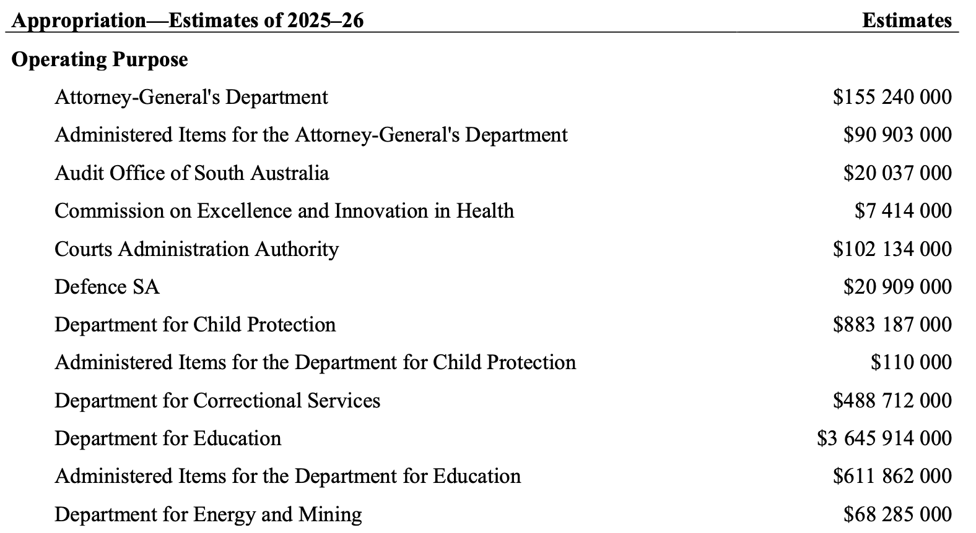

The budget process
The more sophisticated and larger an organisation, the more difficult it is to realise the benefits of zero-based or activity-based budgeting. In these circumstances, the cost of these methods will usually outweigh their benefits. The South Australian government is a large and complex entity. The sheer number of decisions required to frame a budget demands that the government use incremental budgeting in its approach to the state budget.
The budget cycle is the process by which the government develops, approves and presents the annual state budget (in non-election years).

The budget process starts using the previous year's budget as the starting point. At this point, each department in the government has a set of forward estimates for the current year and 4 forward years.
The budget cycle begins with the initial preparation and prioritisation of cost pressures and known policies and bids in the period leading up to and including December. Budget bids represent the amounts by which each agency wishes to change its starting point budget. This initial phase culminates with a Cabinet meeting that sets the financial strategy and targets for the budget and does preliminary prioritisation of bids.
Notes
In the period between January and April, further refinement, prioritisation and negotiation of initiatives occur, including negotiation of priorities with Ministers (in bilateral meetings and meetings with a Cabinet Subcommittee). This phase culminates in the approval of the budget by the Cabinet in April each year. All amendments to this approved budget for each department (both for controlled and administered items) must be approved by the Cabinet.
In parallel with and following the approval of the budget by the Cabinet, preparation of budget documentation is occurring. This involves the production of portfolio statements (primarily by departments), budget documents (by Treasury and Finance) and media statements and press releases (by Ministers in conjunction with departments). The budget is normally tabled on the first or second Thursday of June.
In election years, the cycle can be delayed for two to three months from March onwards.

Agency internal budget processes
Many agencies conduct their own budget and prioritisation processes in conjunction with the process above. Examples include the prioritisation of agency bids to be submitted to Treasury and Finance and the prioritisation of the allocation of capital expenditures within the agency.
Details supporting the Appropriation Bill are provided to Parliament in Agency statements.

2025-26 budget numbers
Source: SA Government 2025-26 Budget Statement

Carryovers
Carryovers relate to a delay in expenses associated with a project or program causing it to slip into a future financial year. Carryover approval is required when the budget for that future financial year cannot accommodate the additional expenditure spilling over from previous periods.
A bid for a carryover in the SA Government is a bid for additional expenditure.
The Cabinet determines the highest priority use of all government funds. Authority for agency expenditure is granted through the Cabinet and budget processes and includes authority for both state-funded and externally funded projects. Only expenditure included in an agency's budget and forward estimates approved by Cabinet and maintained and published by Treasury and Finance, on behalf of the Government, is deemed to be authorised.
The Cabinet's approval for expenditure is specific to financial years. A change in the timing of agency expenditure requires approval from the Cabinet. Even though a program or project has been previously approved by Cabinet the deferral of expenditure into different years requires Cabinet approval to be sought again.
The carryover process is part of the budget process coordinated by Treasury and Finance on behalf of the Cabinet. The carryover process applies to all agency expenses (controlled and administered, state-funded and externally funded) and occurs at two points in the budget process:
- Following the completion of a financial year
At the end of a financial year agencies become aware of expenditure delays that had not previously been expected. That is, there will be an unexpected deferral of expenditure from year A into year B. Cabinet policy requires that agencies seek and receive approval for additional expenditure authority in year B.
This process usually occurs between August and October following the end of the financial year and is overseen by the Expenditure Review and Budget Committee of Cabinet (ERBCC).
- In the lead-up to the budget
In the lead-up to the budget, agencies become aware of expenditure that is likely to be deferred from the current financial year into the next financial year. Cabinet policy requires that agencies seek and receive approval for an increase in expenditure authority in the next financial year(s) for these carryovers.
This process occurs as part of the budget bidding process and the development of forthcoming financial year budgets. It usually occurs in the period between February and April.
The approval of a carryover requires evidence that the deferred expenditure is still necessary either due to policy commitments or contractual commitments. If these cannot be adequately demonstrated, approval for the carryover expenditure is unlikely to be provided.
The availability of cash balances does not represent approval for expenditure in a time period outside that approved. Approval for changing the timing of expenditure cannot be presumed.

The Treasurer would generally not recommend approval of any carryover of under-expenditure that falls outside the following five categories:
- Approved major investing projects that have been delayed (excluding annual programs)
- Commonwealth-funded programs with unspent balances
- Other joint State Government/external party agreements with unspent balances
- Committed grant programs with unspent balances (possible from early receipts of funding) and
- Expenditure specifically tied to a particular source of revenue for which there are unspent balances.
This process further reinforces the need for good reporting and good forecasting and projecting of expenditure.
Early communication of delays or accelerations of revenue and expenses to your agency's finance section is essential to assisting the department in participating fully in carryover bidding processes.

Discussion questions
What are the ingredients and transactions necessary to run your business, your team or your project?

What are some choices about how you go about delivering services?

How would we expect the financial management of a project to differ from the financial management of an operational unit?

What are some reasons why projects fail?

Introduction and initial discussion
Finance as an expression of strategy
Understand costs and revenue – zero-based budgeting
Adapt to a top-down budget (including savings)
Cash flow (or phase) your budget
Exercise control over transactions
Monitor your performance against budget
Adapt to budget variations
Seek approval to change your budget
I am more confident in my ability to manage my budget and to work with finance staff in my department
Public Finance – the system we are part of
Organising principles of finance

Finances: An expression of strategy
Finances reflect how an organisation accounts for the value it creates or loses – the value of its revenue and expenses and the value of its assets and liabilities. These will be an indicator of the health of the organisation – is it creating or sustaining value, or is it losing value?
Your strategy reflects how you choose to go about your business. It is your approach to answering questions about what you do, how you do it, who you do it for, and why you do it.
The approach to finances for a business will depend on its strategy, on its choice of business model. Understanding our finances requires us to understand our business model.

What is our business model?
Understanding finances provides insight into aspects of our business model. A business model can be defined as:
“A business model refers to the logic of the firm, the way it operates and how it creates value for its stakeholders.
Strategy refers to the choice of business model through which the firm will compete in the marketplace.”
Casadesus-Masanell, R., & Ricart, J.E. (2010). Strategy to Business Models and to Tactics. Long Range Planning, 43 (2), 193-215.
“A business model describes the rationale of how an organisation creates, delivers and captures value.”
Osterwalder, A., & Pigneur, Y. (2010). Business Model Generation: A Handbook for Visionaries, Game Changers, and Challengers. New Jersey: John Wiley & Sons.
Consider the business model below that presents the logic of an organisation in terms of what it does, how it does it, who it does it for and why it does it.

Inputs
Outputs
Structure
Programs, projects, processes
Objectives
Outcomes
What we do
Why we do it
Beneficiaries
To achieve
How we do it
Who we do it for
Funders

The environment in which our organisation operates
Demographic & social trends
Market forces
Government & legal changes

The extent of costs and approaches to funding will depend on a range of choices that will determine how the business delivers the services.
Some of the choices may not impact the costs, but may impact how we account for the costs.
All businesses/programs will require inputs to deliver. These will include:
- Resources needed to set up the business
- Human resources – that may take the form of employed staff or contractors
- Resources needed to support staff - e.g. office accommodation, equipment, software, supplies and possibly vehicles
- Resources needed to support the delivery of services – these could consumables and supplies in offices, medical supplies in hospitals, course resources in schools
- Resources needed to run the corporate functions of the business.

Components of a Business Model
What the business does:
- Converts inputs (people, goods and services, technology, assets)
- Into outputs (products and services).
Inputs are required to set up the business, produce goods and services and to administer the business.
To set up a business/program | To produce goods and services | To administer the business/program
Property | Labour | Labour
Vehicles | Raw materials | Professional services (e.g. legal)
Operating equipment | Consumables | Insurances
Office equipment | Contractors | Registration
Equity funding | Energy and fuel | Licences and registration
Bank finance (loan) | Software, applications | Office supplies

In financial terms – inputs will be reflected as assets (what we need to own to set up and run the business), expenses (what we need incur to operate the business), liabilities (money we need to borrow to finance the business) and equity (money from owners to finance to the business).
In financial terms, outputs will be products that generate revenue.
How the business does it (activities)?
- Organisation structure - How authority is exercised and people are structured
- Policies and Codes (of conduct & practice) – how activity and behaviour are guided by values, rules and codes.
- Activities:
  - Processes – a series of actions or steps taken to produce a good or service
  - Projects - individual or collaborative enterprises that are carefully planned to achieve specified objectives
  - Programs – a temporary, flexible organisation structure created to coordinate, direct and oversee the implementation of a set of related projects and activities
  - Workmanship & know-how – skill development and experience of staff and suppliers
  - Marketing – links made between the business and its markets
  - Support functions - HR, Finance, and IT are designed to support teams.
In financial terms, activities determine the efficiency of an organisation in converting its inputs into outputs.
Who is involved?
- Employees – staff employed by the business to make it work
- Suppliers – goods or services purchased through contract, including contractors
- Beneficiaries – those who benefit from the goods and services produced
- Funders – those who pay to sustain the business (if a funder is also a beneficiary, they are a customer)
- Owners – those who contribute capital and then receive returns (dividends)
- Financier – lenders that expect interest and repayments.
Why?
- Purpose – visions, goals and aspirations of the business or team
- Objectives – A specific result that a person or system aims to achieve within a time frame
- Outcomes – the consequences of our work – the longer run (ultimate) impact we are trying to have.
The combination of the answers to these why, what, how and who questions starts to define the business model of an organisation. The elements of a business model can provide insight into the finances, in particular, the financial performance of an organisation. Input and activities will incur costs, while outputs can generate revenue, as can our relationship with our funders.
Understanding our business model can then help to identify what aspects of the model can change in the face of financial information that suggests the business is not performing to the standard required.
The purpose of using the business model as a tool is to help ensure:
- We are holistic in our approach to dealing with issues within our business.
- To understand the connections between the components of our business model, a problem or intervention in one place will usually have links with other aspects of our business.
- To understand the range of options we have open to us in dealing with issues and opportunities, we can change inputs, outputs, activities, customers, delivery channels, etc. These are the levers we have as leaders in charge of a business.
- It can help us think at both a ‘micro’ level (e.g. cost control, asset utilisation, efficiency) and also at a ‘macro’ level (e.g. expanding the business, transforming the model).

Projects vs Operations
Capital budgets are often associated with projects and asset creation. Operating budgets are associated with ongoing business operations and processes. Understanding the distinction between these types of budgets can begin with understanding the difference between projects and processes
Project | Operations (Processes)
Unique - have not been done like this before | Do the same thing repeatedly
Are time limited with a start date & end date. Projects come and go. | They are ongoing and at the core of the business
Create something new or to implement a change | Create value or deliver outputs by repeatedly performing a task
Project objectives and plans can be changed by whoever gives the approval | Processes can only be changed with significant investment
Projects create change | Standardised processes are usually designed to resist change
Aim to amplify variation or change | Aim to reduce variation

What is a project?
According to the Project Management Institute, a project is “a temporary endeavour undertaken to create a unique product, service or result” and project management is “the application of knowledge, skills, tools, and techniques to project activities to meet the project requirements.” Key terms in these definitions are “temporary” and “unique.” Projects have defined deadlines with clear start and end points and are designed to be specific to the product or service in question.
Projects are how businesses go about making changes to the way they do business.
Project management has a definite emphasis on achieving the end result.
The unique and temporary nature of projects tends to make them inherently risky and requires significant levels of planning.

What is a process?
A business process or business method is a collection of related, structured activities or tasks that produce a specific service or product (serve a particular goal) for a particular customer or customers.
Processes are not meant to be temporary or unique. Processes are typically designed to be repeatable. Process management involves careful planning and continuous monitoring of the performance of a given process to ensure quality requirements are met. Change, improvement, and re-engineering are all important components of process management. Process management has an emphasis on improving efficiency and improving quality.
Process management tends to focus on consistency, repeatability, reliability and continuous improvement to achieve efficiency. Processes tend to be at the core of how an organisation operates. Business process management activities can be arbitrarily grouped into categories such as design, modelling, execution, monitoring, and optimization.

Implications for financial management
Projects | Operations
Projects will be unfamiliar with budgeting going through different stages and requiring more approvals.  Tend to employ zero based budgeting. | Operations are familiar and previous years can serve as the basis for future year budgets.  Tend to employ incremental budgeting
Projects will usually be broken down into chunks like activities or milestones. For example, many projects will have work breakdown structures or elements that represent the tasks or activities to be undertaken. | Operational revenue and expenses are usually recorded by transaction type and by cost centres that are aligned with organisational structure.
However, projects can span across financial years and as such need to have expenditure recorded across financial years.  Are more likely to have carryovers approved  Will include inception to date reporting as well as annual reporting | Accounting for operations is typically done in financial years. At the end of financial year, accounts are reset to zero.  Unlikely to have carryovers approved
Project accounting will also want to record finances by activity or milestone requiring an additional reporting perspective. | Operational revenue and expenses will report variances between actuals and budgets a month at a time.

Projects will therefore require reporting against milestones, the timing of which may change over the life of the project. This can result in a scenario where the budget for a milestone was set for one point in time while the actual milestone was achieved at another point in time. We could therefore be comparing the budget for one month (when a milestone was expected to be achieved) with the actuals for another (when the milestone was achieved).
In project initiation and design - define outputs using concrete nouns and where possible quantify how many and detail quality. This better enables costs to be linked with scope.

Concrete nouns and parametric limits to describe project outputs | Abstract nouns that could describe objectives and outcomes
House with four bedrooms and 160 square metres gross floor area | Improved lifestyle for the family and greater capacity to entertain friends
IT system with defined functionality and security protocols in four locations with 500 users | Improved efficiency in process and security of data
Produce a report with recommendations for the review of a specific function in the business | Improve the operations of a team or unit
Produce 16 training modules each with a manual, slide deck, assessments and marking guide | Improve the skills of staff and achieve qualifications for each participant
Conference with 20 presentations, 2 panel discussions for 500 attendees over two days | Share research amongst a network of professionals

In project planning, in addition to scope we establish parameters for four other dimensions of our project: Time (schedule), cost (budget), quality and risk. These five attributes make up the success dimensions of a project.

See Appendix 4 for more details on project estimating and reporting.

Approaches to projecting and budgeting
Four different approaches to estimating and projecting:
- Incremental
- Zero Based
- Activity-based
- Rolling forward estimates

Incremental Budgeting
For ‘business as usual’ functions, because the work being done is familiar and repeated, financial projections and budgets will employ what is known as incremental budgeting.
Incremental budgeting is the most traditional style of budgeting used. Incremental budgeting involves the rolling over of the previous year’s budget into the current year after having made incremental adjustments to reflect changing activity levels, responsibilities or objectives. This has the effect of building in inefficiencies and can lead to allocation of spending to areas where money has been spent, rather than where it should be spent.

Zero-based estimating
For projects, the work being done is unfamiliar and uncertain. Financial projections and budgeting will employ what is known as zero-based estimating. Zero-based estimating is an approach in which all expenses are justified for each new period. The process of zero-based estimating starts from a "zero base," and every element of a project or every section in an organization is assessed for its needs and costs. The downside of zero-based estimating is that it is more time-consuming and can be too cumbersome for large organisations.

Activity Based Estimating
For organisations where finances can be linked with activity, estimates can be based on parameters that indicate that activity. The method requires that activity can be observed and measured and that reasonable estimates of cost per unit of activity can also be measured.
Activity-based estimating is used in the funding models for Health and Education.

Rolling forward estimates
A variation on incremental budgeting where estimates are established for multiple years (in government these are referred to as the forward estimates). Estimates are established for multiple years (usually using an incremental method) and each year a new year is added at the end of the forward estimates. That year can be referred to as a horizon year.
Each year in the budget process, participants put forward submissions or bids to add to their forward estimates or savings can be sought from participants that act to subtract from their forward estimates. This method of forward projecting is used for the budgets of state governments and the federal government in Australia.
Public sector finances use a mixture of these methods.
- At a whole of government level, the rolling forward estimates approach is used.
- At an agency level, funding models using both activity-based methods and incremental methods are used.
- Within departments for ongoing operational teams, incremental budgeting will be employed
- Within agencies, zero-based budgeting will be employed to produce estimates for new projects and bids and to review the finances of operational teams.
For large multifaceted organisations, preparing budgets and projections will require a combination of ‘top-down’ methods as well as ‘ground-up’ approaches that will demand consolidation of estimates.

Large multifaceted organisations and funding models
Many governments will have financial systems that devolve responsibility to portfolio ministers and departments to manage a global budget in delivering certain agreed outputs, programs and projects, which in turn are aligned with departmental objectives. Each department will have a Funding Model.
A funding model is a mechanism, usually for non-profit organisations, to determine the basis for how different sources of funding will be allocated to the organisation based on its activities or the outputs that it produces and estimates of costs of these activities and outputs.
As examples:
- A health funding model will detail the parameters for how funding is allocated based on the numbers and types of patients treated and the average cost of treating patients
- An education funding model will detail the parameters for how funding is allocated based on the numbers and types of students enrolled and the average cost of teaching those students.
These funding models support a ‘top-down’ approach to budgeting that is based on organisational parameters like the number of students and average costs per student that will have been developed based on history and based on benchmarking with other jurisdictions.
In health, hospital funding models are linked with a National Efficient Price that reflects the costs of delivering a range of health services across Australia.
Projecting and budgeting in large organisations will see:
- The need for a budget process to guide the involvement of others in the process.
- The use of funding models
- The need to consolidate estimates.
The concept of a funding model is applied in the Victorian Performance Management Framework. That framework refers to the need to link objectives with outputs. An excerpt from the Victorian Resource Management Framework is presented below.

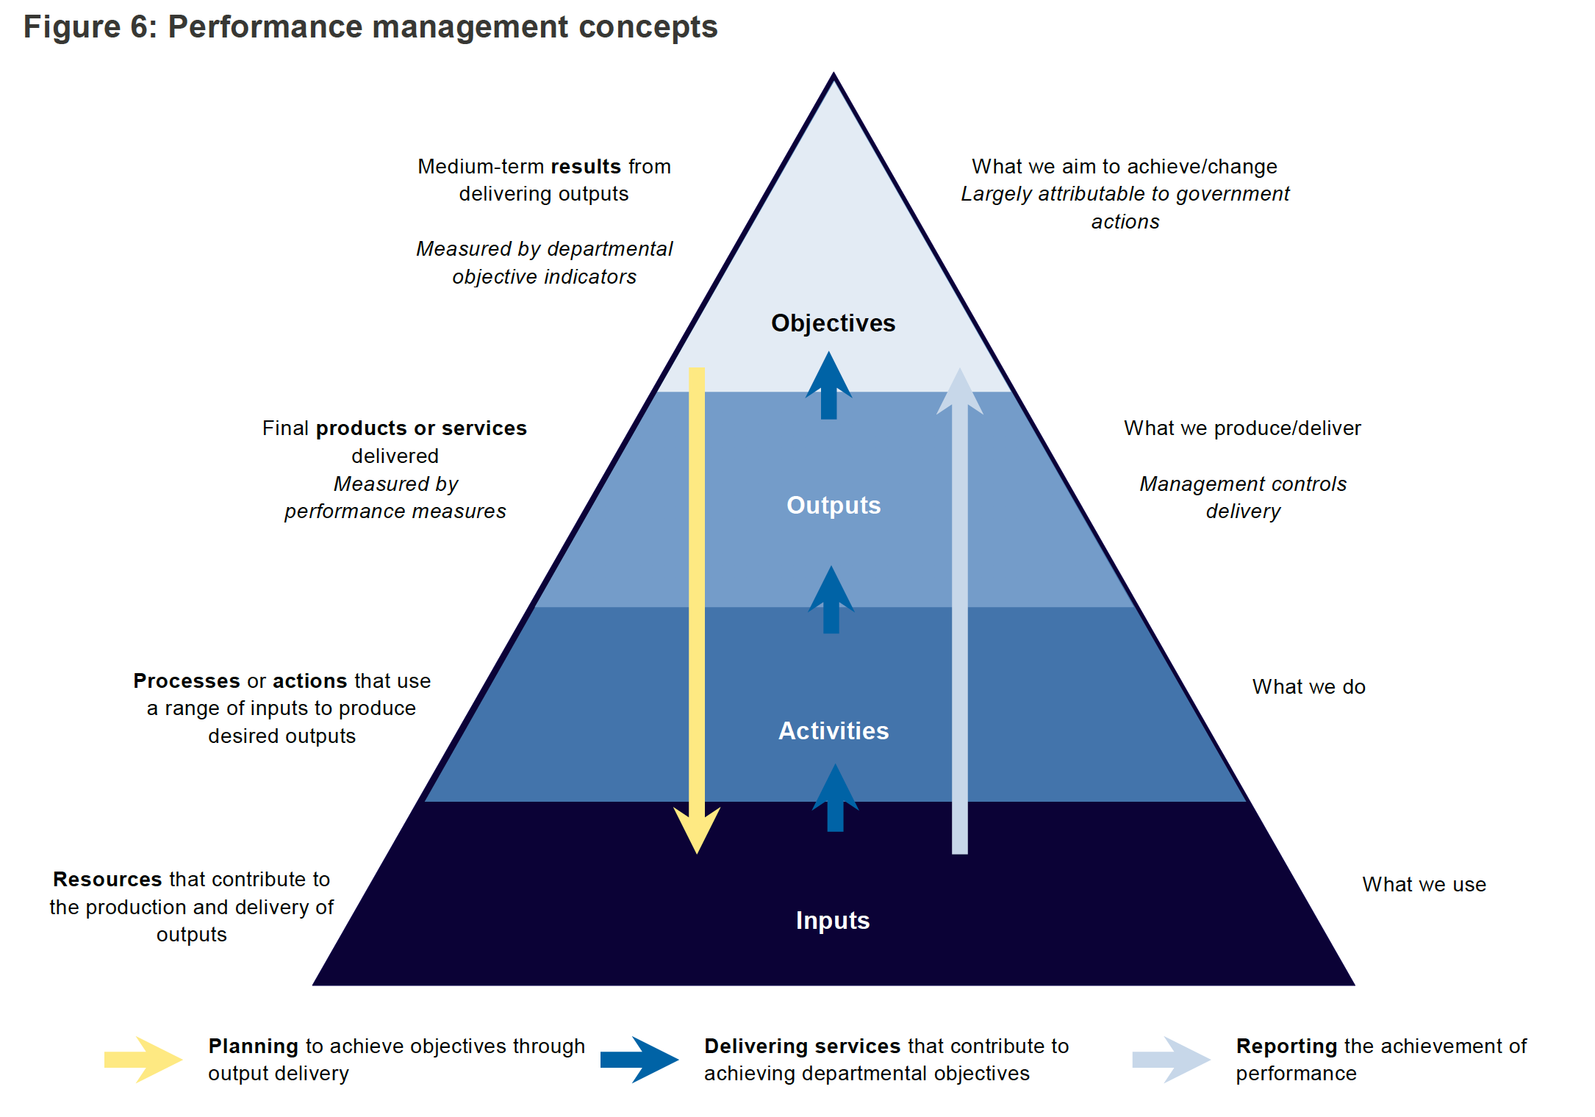

https://www.dtf.vic.gov.au/planning-budgeting-and-financial-reporting-frameworks/resource-management-framework

Logic models like this are also used to help understand the business or operating model of an organisation.

Introduction and initial discussion
Finance as an expression of strategy
Understand costs and revenue – zero-based budgeting
Adapt to a top-down budget (including savings)
Cash flow (or phase) your budget
Exercise control over transactions
Monitor your performance against budget
Adapt to budget variations
Seek approval to change your budget
I am more confident in my ability to manage my budget and to work with finance staff in my department
Public Finance – the system we are part of
Organising principles of finance

Managing Budgets and Financial Plans
Managing a budget at a cost centre level involves being able to:
- Understand your costs and revenues
- adapt to being issued a top-down budget, that is lower than a zero/activity-based budget
- phasing or cash flowing the approved budget
- exercise control over transactions
- monitoring performance against budget during the year
- adapting to unfavourable variations that occur during the year
- seek approval to change our budget - developing a business case or budget bid to influence the top-down budget.
We will work through each of these elements using a case study.
Following are some parameters that define the scope of the program and its budget:
- The program runs 20 houses provided as short term transitional housing for families moving into our state
- It is assumed that each household will consist of two adults and two children.
- Our department already owns the houses and the cars, and each house is furnished with basic furniture and white goods (i.e. no capital budget is required).
- Families will use our accommodation for up to eight weeks.
- While staying in the department house, all living costs will be covered by the department and a contribution towards moving costs will also be made.
- Each household will have access to a car that will be owned by the Department.
- It is envisaged that one case manager would be needed to oversee four houses

Understand your costs & revenues – Zero-based & activity-based budgeting
For a new program like that in our case study, we will employ zero-based estimating.
Developing zero-based estimates occurs in three steps:
- Identify as many expenses and revenues as possible for the revised initiative, program or project
- Document assumptions to make estimates of revenues and expenses transparent
- Populate a table showing all revenues, expenses and budget impacts for the item.

Identifying revenues and expenses
This step requires that we look at the various activities and transactions that will be undertaken by this division to understand the types of revenues and expenses that it will incur.
As a minimum, we should identify the categories of revenues and expenses as per the categories shown below. This process will enable us to eliminate a number of revenue and expense categories.
Revenue | Expenses
- Intra-Government transfers | - Salaries and wages
- Commonwealth revenue | - Depreciation
- Grants and subsidies | - Supplies and services
- Fees, fines and penalties | - Grants and subsidies
- Sales of goods and services | - Internal expenses
- Interest | - Borrowing costs
- Other revenue | - Other Government expenses
- User fees and charges | - Other expenses

To develop a useful budget, it is necessary to be more specific with our expense breakdowns. It is useful to think of the different supplies and services that we will be using. Examples will include office supplies, accommodation, travel, facilities hire, software etc.
Where possible, avoid categorising budget estimates as other expenses or miscellaneous expenses. Doing so will create variances when it comes time to report actuals against the budget.
The table over the page enables a list for different items we need to budget for.

Making assumptions
Having identified the types of revenues and expenses that relate to this division, the next step is to make some assumptions about each of these to develop budget estimates.
Work on the most material items first – this will ensure rigour around the majority of the budget.
Examples of the type of assumptions for salaries and wages will be:
- The number of employees
- Their classification
- On-costs
Examples of supplies and services will be:
- Accommodation – lease cost per square metre, number of square metres (this will usually depend on the number of people)
- Travel – number of trips, average cost per trip, average accommodation cost per trip, average meal and incidental cost per trip.
- ICT – there is usually an average cost per employee for computers and mobile phones. Assuming leased computers, the cost will usually be around $1,000 per annum per computer (for more sophisticated computers the cost will be higher) and for mobile phones, the cost will usually be around $1,000 per annum including calls.
- More specific supplies and services can be estimated by getting quotes from suppliers or based on recent experience in similar projects.
Where possible, avoid categorising budget estimates as other or miscellaneous. Doing so will create variances when it comes time to report actuals against the budget.
This exercise is focused on the transparency of estimates. It is not always possible to accurately predict the future and get estimates right. However, it is possible to make them, and the basis for making them, clear to others so that when the actual transactions differ from the budget, we have some detail to explain the differences.
For our case study, start by listing inputs or the activity base for our Migrant Housing Budget. It is recommended that these, and the assumptions associated with them, be documented using a table similar to that below:
Having documented our assumptions, we can now develop a budget, using various expense categories to generate the total cost for a household and the program.
Using this information, we can produce estimates for the first year of our five-year period. From this, we can estimate the forward estimates by making assumptions about growth across years. For example, we can assume:
- Salaries and wages grow by 2% and
- Goods and services growth by 2.5%,

Building a salaries budget
Identify staff requirements – number of staff and classification of staff. Where possible link staffing requirements with measures of activity, output or outcome.
Details the assumptions about staff classifications.
Based on the classifications, identify the base salary level for each position
For each position, apply assumptions for on-costs.
Labour Oncost Breakdown – Example
Superannuation | 12.00%
Payroll Tax | 5.00%
Long Service Leave | 4.00%
Maternity Leave | 0.50%
Insurance (e.g. workers comp) | 0.20%
Leave Loading | 0.30%
Total | 22.00%

These calculations become more complex for services that operate outside of normal working hours and where staff are working shifts and out-of-hours rosters. For example, if when staff take leave, their positions need to be filled to enable continuity of service, estimates need to be made of the ‘backfilling’ requirements for a position. An example of a backfilling calculation is presented below.

Building a goods and services budget
Categories for non-salary expenses will include:
- Staff related costs:
  - Training
  - Uniforms
  - Mobile phones
  - Car leases
- Vehicles (aside from staff-related leases)
- Accommodation related expenses
  - Leases
  - Utilities
- Technology related expenses
  - Computers
  - Software and applications
  - Networks and cabling
  - Printers and other devices
  - Website management
- Services
  - Legal
  - Insurance
  - Freight
  - Storage
- Travel related expenses
  - Accommodation
  - Airfares
  - Car hire and taxis
  - allowances
- Asset related expenses
  - Maintenance and support
  - Repairs
  - Parts
  - Specialist equipment
- Event-based expenses
  - Marketing
  - Venue hire
  - Catering
  - Security

Some departments collect information on commitments and contracts to gather much of this information as part of their zero-based budgeting.

Below is an example of a salaries build or staff establishment.
Version with allowances and backfill

Way of allowing for contingencies in our budgeting:
- An explicit Contingency line within unit/project budgets - this approach is applied as a standard in building projects where a budget is set aside for risks like not knowing what is under the ground.
- Parameter contingencies where we include conservative estimates for contingencies (e.g. fuel prices) that make some allowance for increases.
- Insurance – the most common way to financially manage uncertainty is to outsource it through an insurance policy.
- Organisational contingencies – instead of allowing for contingencies against specific projects or programs, some organisations will hold an organisational contingency that is available for units or teams to access should an unexpected event occur.

 | Year 1  $'000 | Year 2  $'000 | Year 3  $'000 | Year 4  $'000 | Year 5  $'000
Revenue
Where possible - specify
Expenses
Where possible - specify
Net operating result
Capital expenditure
Net lending/borrowing
Expenditure Authority

Conclusion
Rather than focus on whether a budget is right or wrong, it is more productive to focus on the quality of the estimates. The quality of estimates can be observed in at least three ways:
- Rigour – the extent of activity, cost drivers and detail in the assumptions made are indicators of quality.
- Substantiation – the extent to which assumptions can be checked or verified to reliable sources (e.g. wages to EB agreements).
- Transparency – the observable trail from cost driver, through assumption to dollars

Developing a Budget

1. Identify different revenues & expense activities

2. Develop assumptions in priority order

3. Convert into dollars and inflate
List of transactions
# of units & $ per unit
Table showing financial impact

Introduction and initial discussion
Finance as an expression of strategy
Understand costs and revenue – zero-based budgeting
Adapt to a top-down budget (including savings)
Cash flow (or phase) your budget
Exercise control over transactions
Monitor your performance against budget
Adapt to budget variations
Seek approval to change your budget
I am more confident in my ability to manage my budget and to work with finance staff in my department
Public Finance – the system we are part of
Organising principles of finance

Adapt to being issued a top-down budget, that is lower than my zero-based budget
It will often be the case that the budget we are allocated is less than our zero/activity-based budget. This demands that we can adapt to deliver services within the budget that we have been allocated. At this point, we revisit the activities and assumptions that we developed as part of our zero-based budgeting exercise to examine where we need to scale back from the zero/activity-based budget that we developed.

Whole of Government budgeting – Top-down view of budgeting
From earlier, we can conclude that the whole of government budgeting is not only an incremental process, it is also very much a top-down process or approach to budgeting.

Cost centre or project – ground-up budgeting
Earlier we developed a zero/activity-based budget. This started the process of ground-up budgeting.

We will work with our zero/activity-based budget and will look at how we manage our budget in an environment where the amount we are provided from a top-down budgeting process differs from the budget constructed from the ground up.

Focus is on financial sustainability and affordability
Focus is on need and the resources is necessary to deliver services
Whole of Government/Department approaches are ‘top-down’
Project, team and unit approach is ‘ground-up’
A process with interaction and iteration between the two is necessary to make ends meet

Our ground-up estimates are as per the table below.

Below is an example of the top-down budget allocated to run our 20 houses.

Discussion
List as many options as you can to address this situation.

Review the business model
Another approach is to review our business model in response to the lower budget. We can do this to reinforce the need to provide links between our resources and our inputs, activities, outputs, objectives and outcomes.

Focus on Inputs
Focussing on inputs will usually look at methods of cost control:
- Understand the mix of our inputs (types of costs)
- Reduce unnecessary costs – those costs that are not delivering value
- Can we share inputs with others to share costs (e.g. staff and space)?
- Look at how we are procuring inputs – are we getting value for money in how we buy goods and services from the market?
- Are inputs fully utilised?

Focus on How (activity)
Our focus on activity is usually a question of efficiency. Questions that probe efficiency include:
- Are we converting inputs into outputs as efficiently as possible?
- Have we arranged our processes properly?
- Do we need to review service delivery methods?
- Increase utilisation – look at how we are deploying staff and assets to assess the extent to which they are utilised. If an asset is underutilised, are we able to find ways of increasing utilisation or should we scale back our usage to find cheaper alternatives?
- Have we benchmarked our performance with others to assess our efficiency and identify better ways of doing things?
- Looking at different delivery channels like online vs. face-to-face delivery or the extent of self-service required by our clients
- Opportunities to outsource work by having it performed by external providers under contract rather than by staff.

Focus on Outputs (Products and Services)
A focus on outputs will require looking into opportunities to change the delivery of products and services with questions like:
- Are there products or services we could scale down or eliminate?
- Are there products or services we could scale up to increase our operating surpluses?
- Can we provide products and services to beneficiaries who will pay more?
- Are there other products and services that we can provide?

Focus on Who is Involved
This may warrant looking at questions of the extent to which we insource or outsource different goods and services:
- Are there other funding sources we can find (e.g. industry, grant provider)?
- Are there new customers/markets that we can seek out to increase revenue?
- Do we understand the margins on the work we do for different market segments?

Business Model Transformation
There will be cases where our response can be to work incrementally on each aspect of our business model to address cost overruns or revenue shortfalls. However, the accumulated effect of savings requirements may ultimately require us to rethink our business model
In some cases, where market and financial pressures are great, organisations have decided to review the entire business model to the extent that it transformed the way the business or the industry works (e.g. UPS, online newspapers, or the music industry).
Options to adapt will look at trade-offs in dimensions of success for our initiative arising from reducing the budget.

Options for revising our case study budget include:
- Staffing mix – change the mix of staff to have some case managers at Level 3 and some case managers at Level 2
- Efficiencies - reduce the staffing requirement to increase the caseload per case manager
- Procurement – seek to use purchasing power to get reduced prices for groceries or for house maintenance
- Nice to have vs must have – seek to identify aspects of the budget that are not obligatory and scale them back or eliminate them
- Seek alternate sources of funding/revenue – options for this include:
  - Contributions from the families being resettled
  - Contributions from local councils (e.g. rate relief) that benefit from having workers resettle in their area
  - Contributions from the employers that benefit from the program
  - Contributions from the Commonwealth with its interest in, and responsibility for, migration
- Scale the program back – reduce the number of houses to fit the program within the budget
- Re-profile expenditure by delaying the start of the program – the top-down budget reduced the program to $10.5 million over five years, a reduction of $1.5 million over five years. We could aim to save $1.5 million by starting the program later in the first year, reducing first-year costs from $2.3 million to $0.7 million.
- Outsource the program to a third party by seeking tenders to deliver within the financial parameters given
- Share costs with other programs operating in the regions (e.g. office accommodation or program management)
- Seek assistance from volunteers
- Reduce the size of families that qualify for the program
- Vacancy management - allow gaps between tenants in our houses to reduce household expenses. This will reduce the overall number of families resettled.

Introduction and initial discussion
Finance as an expression of strategy
Understand costs and revenue – zero-based budgeting
Adapt to a top-down budget (including savings)
Cash flow (or phase) your budget
Exercise control over transactions
Monitor your performance against budget
Adapt to budget variations
Seek approval to change your budget
I am more confident in my ability to manage my budget and to work with finance staff in my department
Public Finance – the system we are part of
Organising principles of finance

Cash flowing (phasing) the approved budget
Now that we have an approved budget, we will be required to estimate the timing of expenditure. The shortcut method for this is to estimate monthly costs at 1/12th of annual costs. However, doing this will result in monthly variance when some costs occur quarterly or even annually.
We want to estimate cash flows well for two reasons:
- Liquidity and viability – to ensure our organisation can plan for the cash balances and working capital it needs throughout the year. Estimating cash flows will help identify when the timing of revenue and expenses may be out of sync leading to working capital being run down. This can enable the organisation to plan to defer expenses or, if possible, bring forward revenue/funding.
- Enable variance reporting – to ensure that we predict revenue and expenses as best as possible so that reported variances reveal useful information. If revenue and expenses are poorly phased, they will reduce the ability of variation reporting to reveal good information about how our organisation is tracking.
Therefore, where possible, we should identify costs where timing is less regular than monthly and allocate budgets for these costs to the months where the expenses are expected to be incurred.
- Identify transactions/activities that occur:
  - Each month
  - quarterly
  - annually
  - irregularly
- Break down the budget into these components
- ensure the breakdown matches the total budget for each line.

Getting cash flows right
Working with a client having difficulty managing the finances of a team, it became apparent that one of the causes was poor phasing or cash-flowing of expenses.
The client, an education business, had set aside a budget for casual staff to supplement their core teaching staff during the year. They had been allocated a budget for the casual staff.
However, the budget was phased across the year to be spent each month. Based on a $420,000 budget for casual staff, it was estimated they would spend $35,000 per month.
Casual staff were hired in semester one March, April, May and June, and in semester two, hired in August, September and October. That is, they were required for seven months of the year. The spend in each of these months can be estimated at $60,000 per month.
Once the year was underway, the cash-flow of $35,000 per month masked material variances in the spending on casual staff. Actual monthly spending was $80,000.
The chart below is an attempt to demonstrate the impact on year-to-date variance. The chart contains three pieces of data:
- The monthly cash-flow of $35,000 per month is shown as the black line
- Actual monthly expenditure of $80,000 per month is shown as the grey bar
- The year-to-date variation accumulating is shown as the red bar.

As a result of the 12-month cash-flow, the year-to-date variance starts positive for months one, two and three. Only in month four did a negative year-to-date variance appear drawing some initial attention to it but not yet triggering any concern. In month five, the year-to-date variance triggered a review. Only then was it revealed to the corporate team that the team had hired more casual staff than budget and contracts had been locked in for these staff until the end of month 10.
The cash-flow approach compromised the quality of reporting and masked some poor financial decision-making.
Cash flowing our budget will result in us producing a table that looks something like the one on the next page.

Discussion
Using handout 1, indicate the timing of when different expenses will be incurred.

Handout 2– revised budget and cash flow

Reflection:
What has been an important learning and why?

Example of a cash flowed or phased budget layout

Discussion
Given the design of our program, what are some transactions that will occur?

Who will likely be in control of these transactions and what risks does this present?

What are some steps we could take to reduce risks and improve controls?

Introduction and initial discussion
Finance as an expression of strategy
Understand costs and revenue – zero-based budgeting
Adapt to a top-down budget (including savings)
Cash flow (or phase) your budget
Exercise control over transactions
Monitor your performance against budget
Adapt to budget variations
Seek approval to change your budget
I am more confident in my ability to manage my budget and to work with finance staff in my department
Public Finance – the system we are part of
Organising principles of finance

Exercise control over transactions

If budgeted, who has authority to contract and approve expenditure?
For the majority of Government initiatives, authority to enter into contracts and approve expenditure for the budget resides with Ministers. Ministers are proclaimed as bodies corporate with authority to enter into contracts with suppliers and to approve the spending of government money. This authority is then delegated to department Chief Executives to undertake this work on behalf of Ministers. The delegations from Ministers to Chief Executives are written and specific.
Details of delegations and financial authorities are provided by Treasurer’s Instructions 8.
The different types of ‘authority’ are detailed in Treasurer’s Instruction 8. Three types of authorisation are defined:
- Financial authorisation
- Contract authorisation
- Payment authorisation.

“Financial authorisation” means the approval given by Cabinet, a Minister, a governing authority, Chief Executive or nominated employee for a public authority to enter into a contract, including a purchase, subject to the authority’s procurement policies, or to make a payment or disbursement, including a payment between public authorities, up to a specified monetary limit.
A “contract authorisation” is a financial authorisation that relates to the approval for a public authority to enter into a contract, including for the purchase of goods and services, subject to the public authority’s procurement policies. An instrument empowering an employee or the occupant of a position to grant a contract authorisation may distinguish different types of contracts (and/or purchases) that the employee or the occupant of a position is permitted to approve.
A “payment authorisation” is a financial authorisation that relates to the approval of a public authority making a payment or disbursement, including, through a direct debit arrangement.
Cabinet approval is required for any initiative or for any circumstance that would cause an agency to exceed its financial targets, new initiatives or agencies that believe they will breach their financial targets.
Cabinet approval is required under Treasurer’s Instruction 8 to enter into contracts that exceed the delegation of Ministers.

Section 5 of TI 8 includes:
In any dealing to which these instructions apply a Chief Executive must ensure compliance with the public authority's enabling legislation.
No dealing to which these instructions apply may be approved unless—
- (a) the expenditure is necessary for the conduct of the public authority, and the requirements of the Public Finance and Audit Act 1987 and any other relevant Act or instruction have been observed in all respects; and
- (b) the Chief Executive has a reasonable expectation that sufficient financial resources will be available to meet commitments as they fall due.
Section 6 of TI 8 relates to contracts and states:
Unless the public authority's enabling legislation has alternative specific arrangements that are inconsistent with this instruction, a contract, including for the purchase of goods and services, can only be executed if approved as follows:

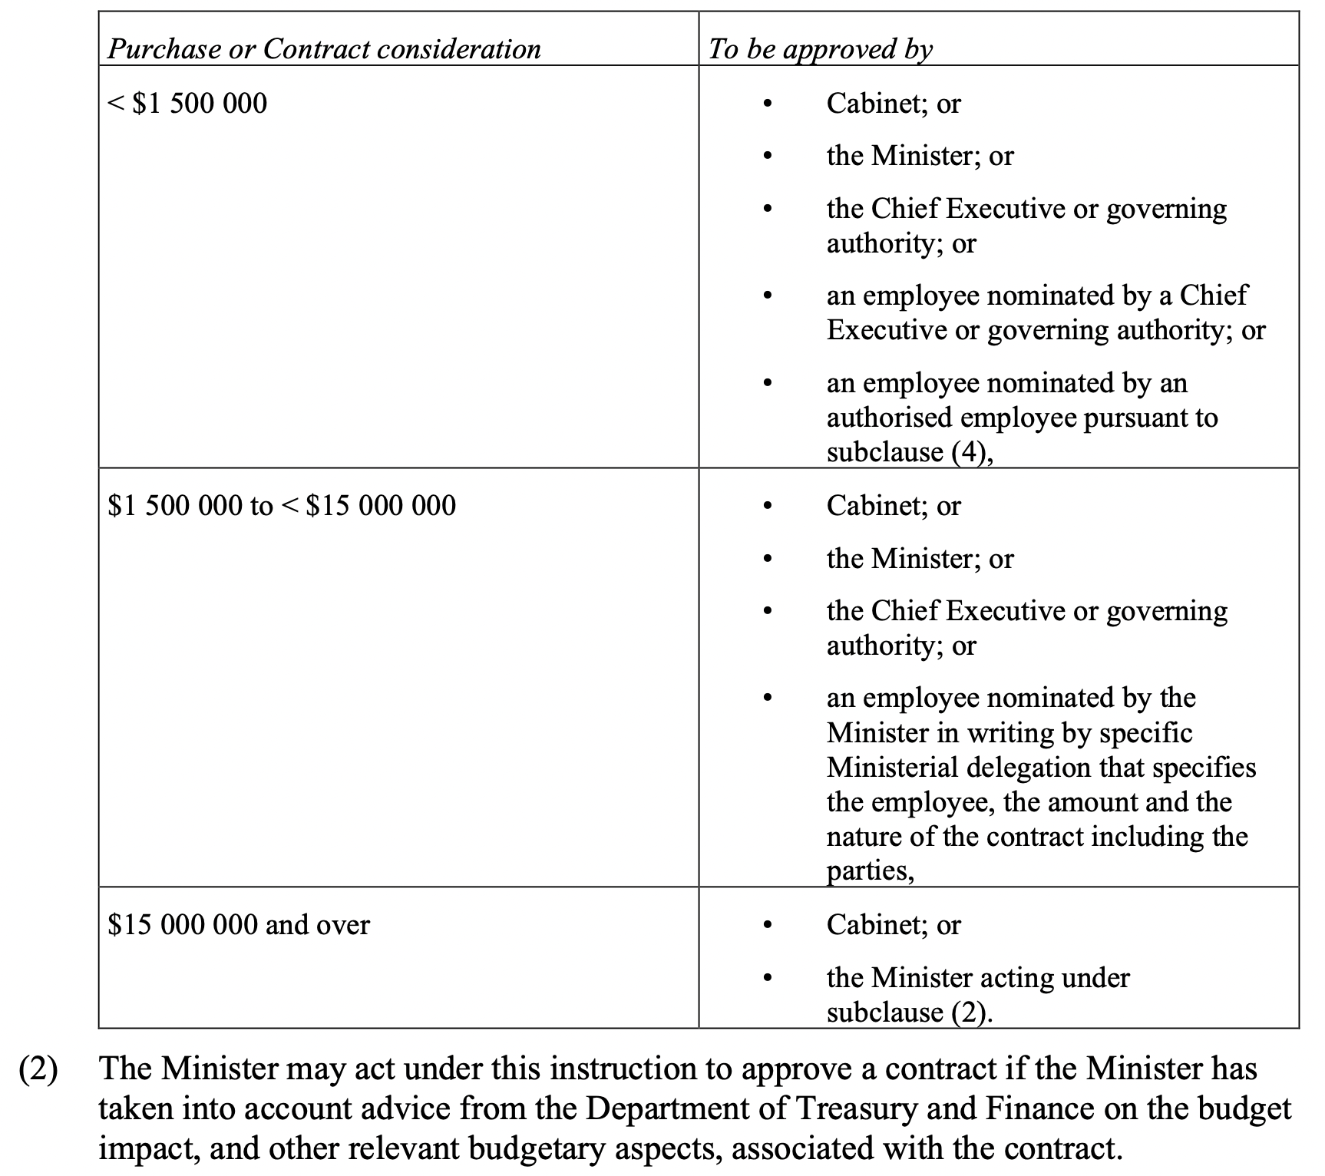

Is it value for money – have processes been followed?
Value for money for expenditure on supplies and services is achieved through the following procurement policies and processes. Treasurer’s Instruction 18 establishes arrangements for procurement in agencies. The objects of TI 18 are:
To promote good governance, contract management, transparency and record keeping by public authorities in the course of planning and undertaking procurements which create liabilities or potential liabilities for expenditure by public authorities; and
To promote compliance with whole-of-government procurement policies; and
To provide for reporting to the Department of Treasury and Finance about procurements by public authorities; and
To make Chief Executives of public authorities responsible for procurements by the public authority and for determining public authority-specific procurement arrangements.
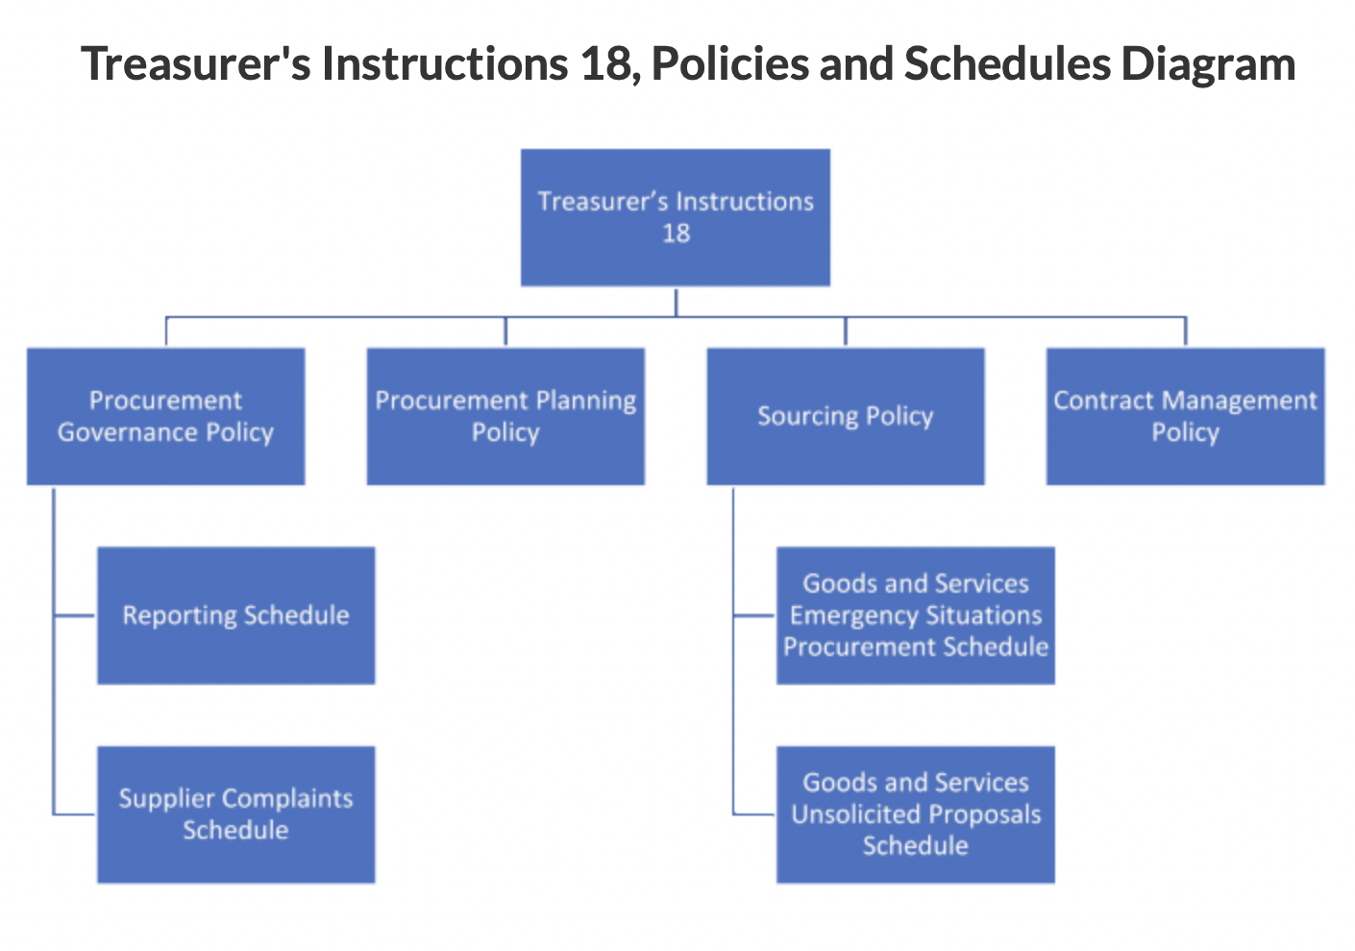
Procurement Governance Policy – is divided into 5 Parts:
Part 1: Key Procurement Principles – Value for money, creating South Australian jobs, increasing apprentices and trainees, stimulating innovation and new business and achieving environmentally sensitive, low-carbon, socially-just outcomes
Part 2: Procurement Governance
Part 3: Public Authority Procurement Frameworks
Part 4: Procurement Activity Planning and Reporting
Part 5: Procurement Policy and Process
Each Part contains key information about the across government approach to procurement.

Procurement and contract management processes are classified as either:
- Transactional – low risk procurements/contracts with a value up to and including $55,000.
- Routine – generally low/medium risk procurements/contracts valued above $55,000.
- Complex – generally medium risk and higher value (valued above $550,000) procurements/contracts.
- Strategic – generally high value, high risk procurements/contracts with a high complexity; but some lower value procurements or contracts may be strategic for reasons other than price.
The distinctions dictate procedures to be followed for each category. For example, the market approach will align with the process outlined in the following table.

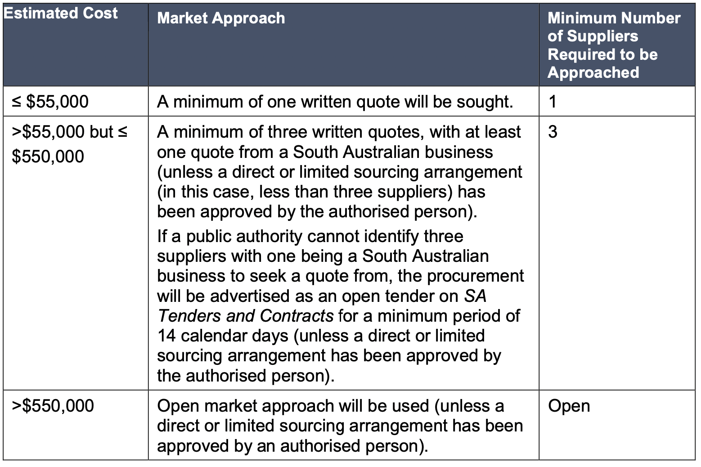

Procurement Planning Policy - outlines the requirements to plan a procurement process (i.e. acquisition strategy) on behalf of the South Australian Government (‘government’).
Policy requirements are to be applied to all procurements for goods and services, including construction projects valued up to $165,000.
Sourcing Policy - outlines the requirements for approaching the market to source goods and services, including construction projects valued up to $165,000, on behalf of the South Australian Government (‘government’).
Contract Management Policy - outlines the requirements for South Australian public authorities (‘public authorities’) to undertake effective contract management practices to achieve value for money.

Introduction and initial discussion
Finance as an expression of strategy
Understand costs and revenue – zero-based budgeting
Adapt to a top-down budget (including savings)
Cash flow (or phase) your budget
Exercise control over transactions
Monitor your performance against budget
Adapt to budget variations
Seek approval to change your budget
I am more confident in my ability to manage my budget and to work with finance staff in my department
Public Finance – the system we are part of
Organising principles of finance

Monitoring performance against budget during the year
The next component to managing a budget is to monitor performance during the year. This means receiving financial statements and reports that show the progress of expenditure against the budget. Monitoring budget performance may also require us to receive information relating to activity levels that are important to understanding our progress.

Reading financial statements
Financial statements can be very intimidating for people with a non-financial background. Confronted by many numbers without having the more important numbers distinguished from the less important numbers. Financial statements also contain terminology and language that is foreign which can make reading financial statements difficult.
Distinguish two types of reading.
- Reading for comprehension - what we do when we read text in books or reports. We read from left to right across the page and line by line down the page to understand the meaning.
- Reading for destination-when we read maps, we seek out specific points on the page. When reading financial statements, we read for destination seeking out specific numbers and variations. If we try and read financial statements for comprehension, we risk drowning ourselves in numbers.
The following is a three-step process to get a reader of financial statements started in understanding or deriving questions to ask about financial statements.
- Where and what is the bottom line – and what are the keys to its derivation?
This will focus on attention what the main takeaway point of the statements is. Is it showing we are on or off target? This is a fundamental starting point for reading further. In some cases, if the reader is satisfied that the bottom line is OK, only limited further analysis may be required. Beware! A reasonable bottom line can mask adverse trends – see step 3. If the bottom line is not OK, further insight into what is driving the bottom line is required.
For management reports, the specific numbers we are seeking out are the total variations for revenue and expenses.
- Focus on the big numbers
When there are many numbers in financial statements, it can be hard to know where to look next. When in doubt, after having found the bottom line, find the big numbers in the report. This will ensure you are focussing on the most important financial issues, that is, those areas where the highest revenues and expenses are incurred. This step is about prioritising where you look but should not limit where you look.
For management reports, we seek out the larger variances that explain the total variances identified in the first step.
- Identify trends
It can be a trap to look at data for one month or one period at a time. Looking at data across time can help identify patterns that are emerging and give you early warning on when problems may emerge. While the bottom line may be OK, key transactions underneath it may be moving adversely (certain expense lines growing rapidly or revenues slowing down) in a way that suggests the bottom line may deteriorate.
These three steps are designed to get you started but may not determine where you should finish. For variance reports, our goal is to understand the variances at the target level and then focus on large variances that explain the ‘bottom-line’ result.

Understanding and explaining variances
A manager with finance responsibilities is accountable not only for understanding and implementing actions to remedy variations, but for explaining reasons for variations and related remedies to their line manager.
Our understanding, explanation and remedies for variances should be evidence-based. Increases in expenses will arise from at least one of the following sources:
- Activity
- Complexity
- Price/cost growth/reduction
- Unbudgeted expenditure
- Timing – delayed invoice or budget phasing error
- Errors
Increases in expenses attributed to each of these categories can be supported by evidence.
Understanding, explaining and remedying variances is more straightforward if you have done “ground-up” budgeting. Ground-up budgeting enables a budget owner to understand the cost, activity and acuity drivers of their budget in advance.

Activity
Monitor the budget for our program using the statements below:

- How are the finances of this cost centre going?
- What is going well?
- What is not going well?
- What extra information do we need?

Introduction and initial discussion
Finance as an expression of strategy
Understand costs and revenue – zero-based budgeting
Adapt to a top-down budget (including savings)
Cash flow (or phase) your budget
Exercise control over transactions
Monitor your performance against budget
Adapt to budget variations
Seek approval to change your budget
I am more confident in my ability to manage my budget and to work with finance staff in my department
Public Finance – the system we are part of
Organising principles of finance

Adapting to unfavourable variations that occur during the year
It is one thing to receive financial information regarding a budget, it is another to have to do something about it by adapting to unfavourable variations that occur during the year. This will demand that we understand these variations in more detail.
As a result of looking at reports relating to our division/section or project, we may determine that steps need to be taken to more carefully monitor and track revenue and expenditure. It can be difficult to know where to start in understanding how relevant revenue and expenditure can be controlled.
Following are six steps that will help in move beyond reading financial statements to trying to do something about the financial situation we find.
- Seek information on a transaction-by-transaction basis –transactions report
To do this requires information on a transaction basis. Information is available in most organisations at the transactional level.
- Identify material transactions that are driving your variances (this follows from the previous section). Satisfy yourself that these transactions were necessary and correct. In addition, select a small number of material transactions and satisfy yourself that the related revenue or expenses were necessary and correct.
- Distinguish controllable expenses from uncontrollable expenses. In many cases, not all expenditure or revenue can be controlled by a cost centre or project manager. Some expenses will occur regardless of any actions that can be taken by the manager. It is important to understand which transactions fit into this category. You can then look at your cost centre reports from the perspective of controllable expenses versus uncontrollable expenses.
- Seek evidence and documentation to support variances in expenses. This can take the form of an email, contract or service-level agreement. The purpose of the documentation is to confirm the nature of the transactions and the degree of control you as a cost centre or project manager have over the expenses. Where the expense relates to a fixed cross charge – establish documentation over the nature of the charge, its likely amount and timing.
- Project forward as to how remaining material expenses will be incurred – satisfy yourself in advance that there will be some checks and balances in place to ensure the best value for money.
- Identify actions that can be taken to manage. Examples of steps that can be taken are:
  - Vary levels or quality of service
  - Make policy decisions to vary the method of service
  - Remove or defer discretionary expenditure
  - Identify possible sources of revenue
  - Review the business model
  - Alert your finance officer of your financial situation and the measures you are taking to address it.
There will be circumstances when expenses have increased above our budget bid due to cost blowouts, lack of control, or additional demand imposed upon us by management or customers. How do we handle these circumstances where we are expected to manage a budget yet all the assumptions underlying a budget are changing?
It is at this point that the quality of our budget will either help us or hinder us. A high-quality budget will help us. A poor quality budget will hinder us.
If we are operating to a budget that is poorly specified and lacks rigour and transparency, it will be very difficult for us to know where remedial action can be taken when reality gets out of line with our budget. By having a budget well specified, and our assumptions clear, it is easier for us to identify the impacts that can arise from having to adjust elements of our budget down.

Recalling our budget for fuel, it assumed families would use 30 litres per week for $1.50 per litre. The weekly usage equates to around 140 litres per month per family.
The transactions reports show variations arising from additional vehicle usage (activity), higher fuel prices (cost pressure) and vehicle services. The latter has been costed to this line while the budget for vehicle services is assigned to a separate budget line (an error).
Over the page, is an example of our budget forecast to year-end by updating our projections for the remaining months.

3. Understand and monitor relevant transactions
2. Identify key variances and trends
1. Bottom line and big numbers
Examine transactional detail
Summarised analysis & priorities
Reading financial statements

Introduction and initial discussion
Finance as an expression of strategy
Understand costs and revenue – zero-based budgeting
Adapt to a top-down budget (including savings)
Cash flow (or phase) your budget
Exercise control over transactions
Monitor your performance against budget
Adapt to budget variations
Seek approval to change your budget
I am more confident in my ability to manage my budget and to work with finance staff in my department
Public Finance – the system we are part of
Organising principles of finance

Seek approval to change our budget
In addition to attempting to deal with either a budget that is short of our ideal, or with unfavourable variations during the year, we could aim to seek approval to increase our budget to the level we need to deliver a viable service.
It is possible to get approval to change your budget. However, in all cases, this demands that early warning of these circumstances is given to your agency's finance or budget section.
In cases where the net cost of service or fiscal balance targets are likely to be breached, your finance officers need to be informed. Where a likely breach of budget targets cannot be managed internally, Chief Executives and Ministers will be required to make a submission to Cabinet to seek approval for an adjustment in the key budget targets.
An important step in managing the breach of budget targets is early warning to your agency's finance or budget section and in turn to Treasury and Finance.
Following is an example of an approval process that followed in some Government agencies.

Example of an approval process for a budget variation
Is the proposed expenditure within the current budget and forward estimates of the division?
YES
NO
Proceed (subject to delegations)
Can the division reschedule expenditure within its current budget and forward estimates?
YES -
Inform corporate
NO – documentation to Corp Finance required
Can the Dept reschedule expenditure within its current budget and forward estimates – Business case to Exec Management Team?
YES with CE approval
NO – budget bid or Cabinet submission required
Can the Government reschedule expenditure within its current budget and forward estimates? – requires budget or cabinet submission (submission requires CE approval)
NO
Proposed expenditure is denied
CE approved submission or bid
Cabinet approval?
YES
NO

Budget Measure - Cost Pressure example
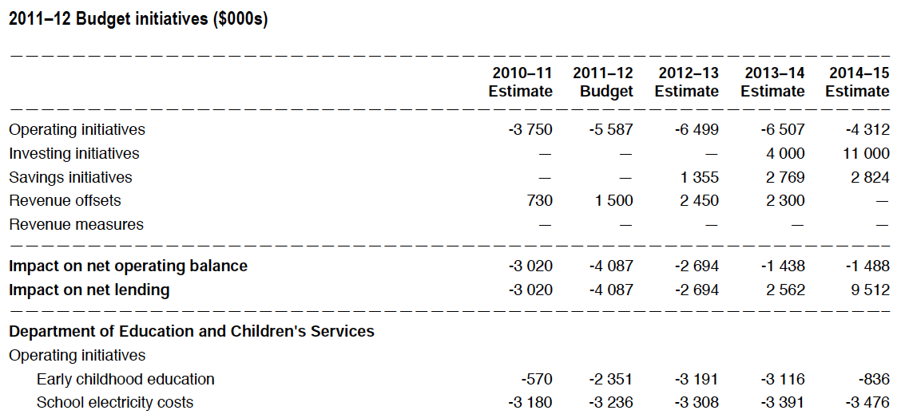
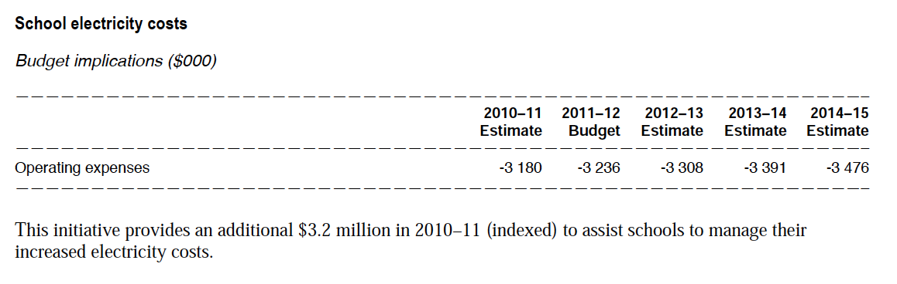

Budget Measure – Increasing Capacity Example
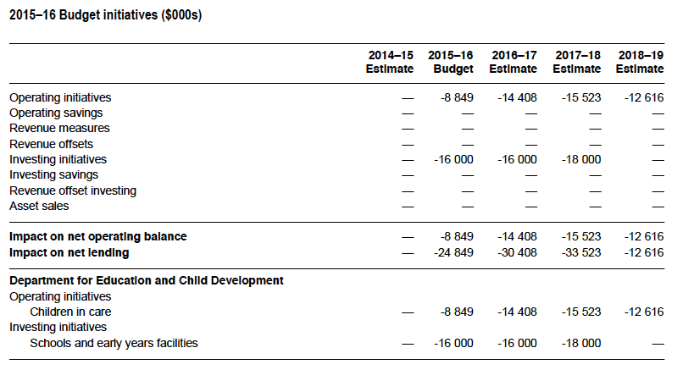

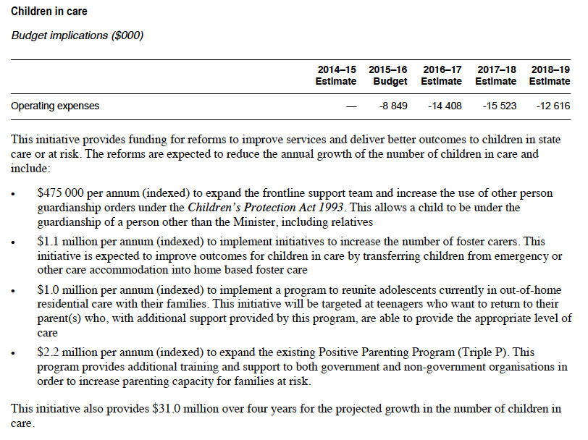

Summary of budgeting, reporting and monitoring
We have followed a process of building (budgets), exploring (financial statements) and drilling (transactional information).

Reflection and discussion
What has been my most important learning from this session?

Why?

Appendix 1: Financial management expectations
You might be like many managers who find their way into their role, get handed a budget and a financial report and are assumed to know how to manage the financial aspects of the role. Yet you have no financial background. How do you know what you need to know?
This section is designed for managers within the public sector to help them understand what is required of them ‘financially’. It details what is reasonable to expect of them in managing the finances of their cost centre or unit.
In most cases, public sector financial management demands cost centre management (revenue is being earned elsewhere in the organisation). These expectations largely relate to what is expected of a cost centre manager. There are some examples of where a manager will need to attend to earning revenue.
The expectations of a public sector manager in managing finances are arranged into five parts. Each part represents one element of financial management. The five elements of financial management are:
Targeting it
Funding it
Controlling it
Knowing it
Planning it
What is your financial bottom line(s)? Establishing financial targets
Do you know where your finances are now? Good financial reporting
Are you confident in your financial future? Good projecting and estimating
Are the financial implications of decisions rigorous and transparent? Good budget allocation & bids/business cases
Do you have assurance that transactions and records are right? Good financial controls
Public Money
- Financial targets and limits – establishing financial goals for an organisation (both for performance - profit, surplus, breakeven and for financial position – assets, liabilities, net work) and how they translate into targets for the units within the organisation (surplus, expense limits, revenue target)
- Financial reporting – the provision of financial information internally and externally to enable organisations, their staff and external parties to monitor financial performance and position.
- Financial planning – preparing projections and estimates to understand future revenues and expenses in order to understand future financial viability or need. Within organisations, this is usually performed as part of the budget process.
- Financial decision making – determining remedies to variations identified in reporting, determining how to adapt to changes in financial parameters and developing proposals or business cases to seek funding or changes in budgets.
- Financial controls – understanding how we need to exercise control over transactions through purchasing decisions, through the efficient use of resources and how transactions need to be undertaken according to policies established by the organisation.
A manager should reasonably be able to answer yes to each of the questions in the five sections that follow.

Financial targets and limits
I know the financial and FTE limits for my section (for a cost centre manager, the financial limit will be expressed as an expense budget). | Yes | No
I understand that these financial and FTE limits reflect what Parliament has approved and what the Government can afford given its priorities and its financial goals. | Yes | No
I understand that the Government’s finances are simply the sum of its parts and that overspending in one area will require reallocation of budgets or will compromise financial goals. | Yes | No
I understand that my financial limits do not discriminate for different sources of funds and that increases in spending of either above budget represents exceeding financial limits. | Yes | No
I understand that access to external or accumulated funds does not represent authority to spend and that authority to spend is represented in the financial limits for my section. | Yes | No
I understand that I need to discuss my finances with my line manager as well as with Finance staff as soon as I become aware that I might exceed my financial limits | Yes | No
I will advise my line manager and Finance (through monthly reporting) where it is expected that expenditure will fall short of budget. | Yes | No

It is expected that the manager understands
- What is financial performance?
- What is financial position?
- What is revenue?
- What is an expense?
- What is an asset?
- What is a liability?
- What is the difference between operating expenses and capital expenditure?

Financial reporting and analysis
I have access to a statement of financial performance for my area of responsibility. | Yes | No
I understand and analyse the financial statements provided to me each month | Yes | No
I know that I need to focus on understanding and remedying the variations shown in the report | Yes | No
I know how or where to get access to transaction information, FTE information and activity information (where applicable) for my area of responsibility. | Yes | No
I understand the extent to which variations and their remedies are within my control or are out of my control. | Yes | No
I have brought variances and end of year forecasts to the attention of those who do have some control over the relevant revenue or expense line. | Yes | No
I have explained my variations and strategies for remedying them with my line manager/leadership team. | Yes | No

It is expected that the manager understands
- How to access financial reports and supporting information
- The reporting deadlines of their agency.

Financial planning
I know the activity drivers and cost drivers for my section. | Yes | No
I can (with help from a Finance officer) build a budget, based on these activity and cost drivers, for my section. | Yes | No
I have estimated the financial costs associated with delivering the services expected of me. | Yes | No
I have estimated (with help from a Finance officer) the level of services that I can reasonably deliver with the financial limits assigned to me. | Yes | No
I have looked into the availability of reasonable benchmarks and comparisons that can be used to assess my financial plans. | Yes | No
I understand the extent to which my section can generate revenue. | Yes | No
I have estimated when the expenses and revenue will occur across the financial years (phasing or cash-flowing) taking into account when activity and events will occur | Yes | No
I understand that I need to discuss my financial plans with my line manager (and with finance staff) when they do not align with my financial limits or with the service expectations made of me. | Yes | No

It is expected that the manager can answer two questions
- I know what resources are needed to deliver what is expected
- I know what I can deliver with the resources available to me
Budgets and budget variations are presented in tables
Think in terms of tables – can you complete the following table for your directorate, cost centre or project?

 | Year 1  $'000 | Year 2  $'000 | Year 3  $'000 | Year 4  $'000 | Year 5  $'000
Revenue
Where possible - specify
Expenses
Where possible - specify
Net result from transactions
Capital expenditure
Net Lending/borrowing

Financial decision-making
I know the gap between the financial limits (top down budget) and the financial plans (my activity or cost based budget) that I have developed. | Yes | No
I have discussed the gaps between my financial limits and my financial plans with line manager/leadership team. | Yes | No
I have reviewed priorities and developed strategies to make the changes necessary to operate within my financial limits. | Yes | No
I have discussed the service impacts and known risks involved in operating within my financial limits with my line manager/leadership team. | Yes | No
I understand that I must get approval from a line manager to change the financial limits that I am operating to. | Yes | No
I understand that changes in my budget will require the reallocation of money within our Department and possible from other Government departments | Yes | No
I understand that should no approval to change financial limits occur, I need to put in place the changes, strategies and controls necessary to live within my approved financial limits. | Yes | No

It is expected that the manager
- Understand their agency’s budget and reporting timetable
- Has an awareness of the annual budget process
- Is aware of relevant agency budget policies and guidelines

Financial controls
I understand the delegations that are assigned to my position. | Yes | No
I understand the extent to which I can achieve efficiency through buying wisely | Yes | No
I will make every effort to ensure the efficient use of resources entrusted to my section by me and by my colleagues. | Yes | No
I am aware that where possible, I should use preferred providers and where possible use purchase orders | Yes | No
I am aware of procurement thresholds that dictate when to use different procurement options | Yes | No
I am aware that there are Department financial policies and procedures and I am able to locate them on the intranet when I need. | Yes | No
I am aware that there are Department delegations and authorisations and I am able to locate them on the intranet when I need | Yes | No

It is expected that the manager
- Is aware of Treasurer’s Instructions and related agency financial policies
- Is aware of Procurement policies and guidelines
- Understanding transaction cycles and controls across the cycle
Is aware of the IBAC/ICAC and reporting obligations arising from IBAC/ICAC

Appendix 2: Understand the fungibility of public money
Fungibility is the property of money that enables it to be moved from one area to another without reducing its value or failing to meet obligations. Highly fungible money can be interchanged and reallocated easily and therefore provides flexibility to managers. Less fungible money has restrictions over its movement. This money is harder to access and therefore more rigid.
The nature and implications of fungibility can be seen across different levels of government and organisations. It can be seen:
- Within the federation
- Within states
- Within agencies and departments.

Within the federation
State Governments in Australia receive large amounts of grants from the Commonwealth Government. The Commonwealth has a greater capacity to earn taxes while states have primary responsibility for the delivery of services. This imbalance is referred to as vertical fiscal imbalance. Grants from the Commonwealth to the States are categorised into:
- General Purpose Grants and
- Specific Purpose Grants

Within the Federation | General purpose grants |  |  |  | Specific purpose grants
 | Fungible |  |  |  | Non fungible

General Purpose Grants, primarily funded by the GST, are fungible. The State Governments can use and allocate this money to any purpose without restriction from the Commonwealth.
Specific Purpose Grants are non-fungible. These grants are tied or specified to a particular purpose. The allocation of the money from the Commonwealth to the state is conditional on the state using the money for a purpose, the details of which are captured in grant agreements. At the end of each year or the end of the period covered by funding agreements, the States are required to acquit that they have spent these funds as per the agreements.

Within State Governments
State Governments, through their Treasury and Finance, receive taxes and untied Commonwealth Grants into a public account (often referred to as the Consolidated Account). The money from this account is then transferred (appropriated) to Government departments.

Money is received by agencies from Parliamentary appropriations, from the sale of goods and services or from specific levies or taxes that are passed into special purpose or hypothecated funds.
Within the State Govt | Money from sales | Appropriation |  | Appropriation for specifically approved initiatives | Legally Hypothecated or contracted funds
 | Fungible |  |  |  | Non fungible

For agencies, money from the sales of goods and services is highly fungible. Money appropriated from Parliament will have different grades of fungibility. The vast amount of what is appropriated will be provided to agencies to deliver services and programs of that agency. This is documented in budget papers. Within these purposes, Chief Executive Offices can allocate funds within their agency with some discretion.
These can be classified as allocated funds.
Limits on this will include:
- Budget measures – money provided in the budget for specific initiatives that are detailed in budget papers. Money for these measures must be allocated for that purpose as documented.
- Cabinet approvals – money provided in the budget to fund specific measures approved by the Cabinet for the agencies. Again, these measures must be allocated for that purpose as documented in the Cabinet submission that sought approval.
These latter examples can be classified as committed funds.
Agencies will also receive money from legislated arrangements like fees and levies that are required to be set aside into a specific fund defined in legislation. An example in South Australia is the Emergency Services Levy. These are known as hypothecated funds and are not fungible. The purposes to which the monies can be applied are typically prescribed by the legislation that enables the levy and creates the fund.

Within Agencies
Finances are allocated within agencies across cost centres and projects usually designed to align with the organisational structure of the agency. This allocation will largely be at the discretion of the Chief Executive Officer subject to the limits described in the previous sections. The Chief Executive will delegate their authority to positions within the organisation to manage these monies and, if necessary, to reallocate these monies.
The reallocation or movement of money will therefore be subject to policies and rules within the agency.
In many cases, managers will operate to the budget bottom line (i.e. total expenses or surplus or deficit).
A budget allocated to a cost centre or project will be broken down into a budget for staff (employee expenses) and budgets for various types of goods and services. However, agencies will usually put some limits on how managers can reallocate money within their budgets.
A final category of budget is allocated to projects or programs where contracts or agreements have been entered into. These are examples of contracted funds that are non-fungible.
A common question raised in workshops is: Can the budget allocated for employee expenses be reallocated by a manager to the budget for goods and services or to another cost centre or project?

 | Reallocate from employee expenses to supplies & services | YES
Employee expenses budget |  | Supplies & Services budget
NO | Reallocate from supplies & services to employee expenses

Agencies will usually allow the reallocation of employee expenses budgets to supplies and services but will not allow reallocation in the opposite direction. Commitments of money to supplies and services can be limited by specific purchases and contracts, while the hiring of employees brings with it ongoing liabilities and matters of tenure.
Understanding the concept of fungibility in public money helps us understand that not all money is the same. Some can be more flexibly applied giving leaders and managers varying levels of discretion in how they apply public money.
Across all layers of government, the limits on fungibility will be captured in documentation between the relevant parties (like contracts, agreements, legislation and budget papers) and documentation of policies and rules in agencies.

Appendix 3: Accounting and Budget Terminology

Operating statement terminology
Revenue is the money a business brings in from its customers for providing goods or services related to its normal operations.
Expenses are decreases in economic benefits during the accounting period in the form of outflows or depletions of assets or incurrence of liabilities that result in decreases in equity, other than those relating to distributions to equity participants.
Other comprehensive income - includes revenues, expenses, gains, and losses that have yet to be realised and are excluded from income or expenses on an operating statement.

Cost of Goods Sold or Cost of Services (COGS)
The purpose of COGS is to measure all the costs directly associated with making the product or delivering the service. The materials, the labour and usually a portion of overheads directly attributable to the production or delivery of service are included in COGS. However, as with revenue, there are always some grey areas, such as do we include the wages of the plant supervisor, the quality control personnel, and sales commissions, or should these costs be part of operating expenses?
In reality, as long as all costs are recorded somewhere in the income statement, then the bottom-line net profit will be the same. It is important for a company to record its expense types consistently so a user or analyst of the financial statements can compare revenue and costs between periods.

Gross profit and gross margin
Gross profit is what is left over after a company has paid the direct costs incurred in making the product or delivering the service. Gross profit is a key number for most companies. It tells you the basic profitability of your product or service. If that part of a business is not profitable, the business is probably not going to survive for long. After all, how can the business expect to pay for operating expenses of management salaries, administration staff, and pay interest to service any debt, if they aren’t generating a healthy gross profit?
“Gross margin is a company's total sales revenue minus its cost of goods sold (COGS). It is often expressed as a percentage by dividing the gross margin, calculated in dollar terms, by total sales revenue. The gross margin represents the percentage of total sales revenue that the company retains after incurring the direct costs associated with producing the goods and services it sells.”
Source: Investopedia.com

Operating Profit or EBIT
Operating profit is gross profit minus operating expenses. Operating profit is also known as earnings before interest and taxes, or EBIT.
Why are interest and taxes not subtracted from EBIT? Operating profit is the profit a business earns from its operations.
- EBIT measures profit before the impact of financing decisions and tax implications.
- EBITDA (Earnings before Interest, Tax, Depreciation and Amortisation) measures the impact of profit before the impact of asset management decisions.
Interest expenses are sometimes shown separately because of whether the company is financed with debt or equity, and as such, the financial structure of the company does not indicate how well a company is run from an operational perspective.
Tax expenses are shown separately because they don’t have anything to do with how well a company is run. Taxes are the result of legislation and government policy.

Net Profit
Net profit is the bottom line of the income statement. Net profit is what is left over after everything is subtracted from revenue – cost of goods sold or cost of services, operating expenses, taxes, interest and one-time charges, and non-cash expenses such as depreciation and amortisation.

Balance Sheet Terminology

Assets
An asset is a resource controlled by the entity as a result of past events and from which future economic benefits are expected to flow to the entity. Assets are items you own that can provide future benefits to your business.

Liabilities
A liability is a present obligation of the entity arising from past events, the settlement of which is expected to result in an outflow from the entity of resources embodying economic benefits. The opposite of assets, liabilities are what you owe other parties.

Equity (or Capital)
Equity is the residual interest in the assets of the entity after deducting all its liabilities.

Current assets
Assets to be converted into cash or used with the next accounting period. Examples include cash at bank, accounts receivable or inventories held.

Non-current assets
Assets that are expected to remain in use for more than 12 months. Examples include property, plant and equipment.

Current liabilities
Obligations that are expected to fall due with the next accounting period. Examples include accounts payable, provisions for employee entitlements (short-term) and short-term loans.

Non-current liabilities
Obligations that are not expected to fall due for more than 12 months from the date of the balance sheet. Examples include long-term loans and long-term provisions for employee entitlements like long service leave.

Working Capital
Working capital is a different concept of capital. It is the capital (i.e. cash and other current assets) that is immediately available to a company for the operation of its day-to-day business.

It is calculated as:
Net working capital = current assets – current liabilities
“Working capital gives investors an idea of the company's underlying operational efficiency. Money that is tied up in inventory or money that customers still owe to the
company cannot be used to pay off any of the company's obligations. So, if a company is not operating in the most efficient manner (slow collection), it will show up as an increase in the working capital. This can be seen by comparing the working capital from one period to another; slow collection may signal an underlying problem in the company's operations.”
Source: Investopedia.com
Negative working capital indicates that a company has a short-term capital shortfall and needs to source or borrow additional funds to meet its commitments. Additionally, negative or low working capital prevents a company from investing in growth initiatives, such as purchasing additional stock during a busy season or pursuing an acquisition opportunity.
A positive working capital indicates that the company has sufficient capital to meet its commitments. An excess of working capital can be inefficient, as capital is tied up in unproductive assets such as cash, accounts receivable or inventories.

Right-of-use assets
A right-of-use asset is an asset that an organisation has access to as a result of a lease arrangement. The right-of-use asset is a lessee's right to use an asset over the life of a lease.
Changes in accounting standards have required organisations to recognise lease liabilities on their balance sheet and to also recognise the right-of-use asset as an asset, effectively ‘grossing up’ the balance sheet.

Budget Terminology
Appropriation Funding is provided by the State Government from the Consolidated Fund under the Appropriation Act to enable the Department to meet expenditure. An appropriation can be for either the provision of outputs, asset investment, or to make a payment on behalf of the state An appropriation is the legal instrument that Parliament uses to fund Departmental operations.
Budget Variation (BV) is an adjustment to the original approved budget. These are adjustments to budgets for internal (transfers between divisions/directorates) and external (Cabinet) decisions that impact on revenue and expenditure.
Carryovers - The Carryover process allows agencies to request the carryover of unspent funds from the current /Prior financial year for discrete programs/projects into future years, whether or not the agency underspent overall. Carryover requests occur twice a year:
- August/September – End-of-Year Carryover journals submitted following the actuals process, carryovers from prior financial year into the current or future years.
- February/March - Budget Time Carryover journals submitted for carryover out of the current financial year into future years, where underspending has already been identified.
Impacting data adjustments – Impacting data adjustments are those that increase or decrease the net operating result or the net lending/borrowing result. The Impacting Data Adjustment (IDA) process provides an opportunity for agencies to submit various updates to their budget, resulting in changes to accounting, activity and to correct errors, etc., at different times of the year. Updates for changes in activity for ‘parameter’ items, e.g. revenues based on current year experience, enrolments, revisions to asset sales profiles, depreciation in light of actuals, and operating to investing reclassifications.
Adjustments are submitted as part of the budget process in February and March.
Non-impacting adjustments - data adjustments are those that have no impact on the net operating result or the net lending/borrowing result. Common Types of adjustments include
- Data Corrections, Reclassifications, and machinery of government transfers
- Revenue and matching expenditure adjustments in a financial year
- FTE, balance sheet or matching errors
Agencies may submit Non-Impacting Data Adjustments via the Budget and Monitoring system, at almost any time. DTF aims to review and process or reject these cover sheets and journals within two weeks.
Horizon Year – the new year added to the forward estimates at the beginning of the budget process. In the 2025-26 Budget, the budget year was 2025-26 and the forward estimate years were 2026-27, 2027-28 and 2028-29. After that budget was handed down, a new year is added to the forward estimates – 2029-30. This year is termed the horizon year. The horizon year is created assuming no changes in policy and by automatically indexing employee expenses (by 1.5%) and supplies and services (2.5%).
Mid-Year Budget Review – Mid-year update for changes in activity for ‘parameter’ items, e.g. revenues based on current year experience, enrolments, revisions to asset sales profiles, depreciation in light of actuals, operating to investing reclassifications. It is a no policy change document and is not an opportunity for agencies to submit new initiatives.
Net lending/borrowing position - A measure of the net operating balance, less acquisition of non-financial assets, plus consumption of fixed capital (depreciation). Measures the extent to which accruing operating expenses (less depreciation) and investment expenditures are funded by revenues.
Net operating balance - A measure of the operating result of a sector of Government, calculated as revenue from transactions less expenses from transactions. It is a summary measure of the ongoing sustainability of operations and excludes gains and losses resulting from changes in price levels and other changes in the volume of assets. It is the component of the change in net worth that is due to transactions and can be attributed directly to government policies.
No Policy Change – budgets reflecting only existing Cabinet-approved policies and programs that have already been explicitly approved by Cabinet as having costs in the horizon year. Increases in demand due to population increases over time may be included, but expansions to the scope of service delivery should not be.
Rephase or reprofile – changing the estimated timing of revenue or expenditure both within the year but also across years. The latter is more so for projects with multiple years of expenditure. Rephasing or reprofiling can also bring forward funding from future years. Rephasing or reprofiling occurs when carryovers are being negotiated.
SRIMS - State Resource Information Management System (SRIMS) is the Government’s multi-purpose information management system for reporting and budgeting. The department feeds information into SRIMS for, but not limited to, the following:
  - Monthly actual financial data
  - Non-Policy budget adjustments
  - ERC funding requests
  - The asset investment program
  - Output performance reporting
  - Cash Management
Unavoidable Cost Pressure - This refers to a particular issue where the Department has an unavoidable obligation that will result in the incurring of expenditure of either an asset or output nature. This could include costs that are contractually unavoidable, those relating to policy decisions agreed to by cabinet but as yet unfunded, or administrative changes such as an accounting reclassification that has revenue or expense implications

What does budget impact mean?
In South Australia, the budget sector is the General Government Sector. Any mutually agreed transaction (excluding revaluations) or initiative that changes the net operating result or net lending/borrowing result of the government is defined as having a budget impact.
The graphic below presents the budget sector, entities within the sector and some transactions that may or may not impact the budget. Impacting transactions are presented with red arrows. Non-impacting transactions are presented with grey arrows.

General Government (Budget) Sector
Tax received into Consolidated Account
Consolidated Account

e.g. Support & maintenance payments for software to an external vendor.

DPC
Appropriation paid to DPC

Grant paid to Arts entities
Salaries to employees
Arts entities
Goods and Services expenses for works
Grant received from the Commonwealth

Budget impacting transactions (red arrows):
- Tax received by the State Government – a transaction with another sector of the economy
- A grant received from the Commonwealth - a transaction with another sector of the economy
- Support & maintenance payment for software to an external vendor – a transaction with another sector of the economy
- Salaries to Board employees - a transaction with another sector of the economy, and therefore does have an impact on the budget

Non-impacting transactions (grey arrows):
- Appropriation paid to DPC - a transaction between government entities and therefore has no impact on the budget
- Grant paid to an Arts entity from DPC – a transaction between government entities and therefore has no impact on the budget.

Appendix 4: Costing Terminology

Costing Definitions
Understanding costs and the ability to control the cost of operations are integral parts of good financial management. This section will review some common definitions of costing.
Total costs = direct costs + indirect costs

Total costs = fixed costs + variable costs

Cost type | Definition | Circumstances for use
Total costs | Direct costs plus indirect costs  OR  Fixed costs plus variable costs | - Where the service is long-term and reliant on related systems and databases.
Direct costs | Costs that can be specifically attributed to the delivery of a service/project. | - Assessing sustainability over the medium term.  - Evaluating the cost of delivering material but non-core services.
Indirect costs | Costs over and above direct costs that are necessary to deliver the service in the long term. | - Longer-term view and whole view of costs.
Full cost | When you consider total costs and add the cost of capital as a margin. | - Assessing sustainability over the longer-term view.  - Evaluating the cost of delivering core services.
Variable costs | Costs that grow or shrink as activity grows or shrinks. | - To understand the extent of flexibility a business has in pricing.
Fixed costs | Costs that do not grow or shrink as activity grows or shrinks. | - To understand the extent of flexibility a business has in pricing.
Average costs | The cost per unit when total costs are attributed across each unit of production. | - Usually applied in calculating prices per unit.
Marginal costs | Additional costs of providing an additional unit of service or collecting an additional $ of revenue. | - Assessing short-term sustainability.  - Adding a small revenue item to the collection base.

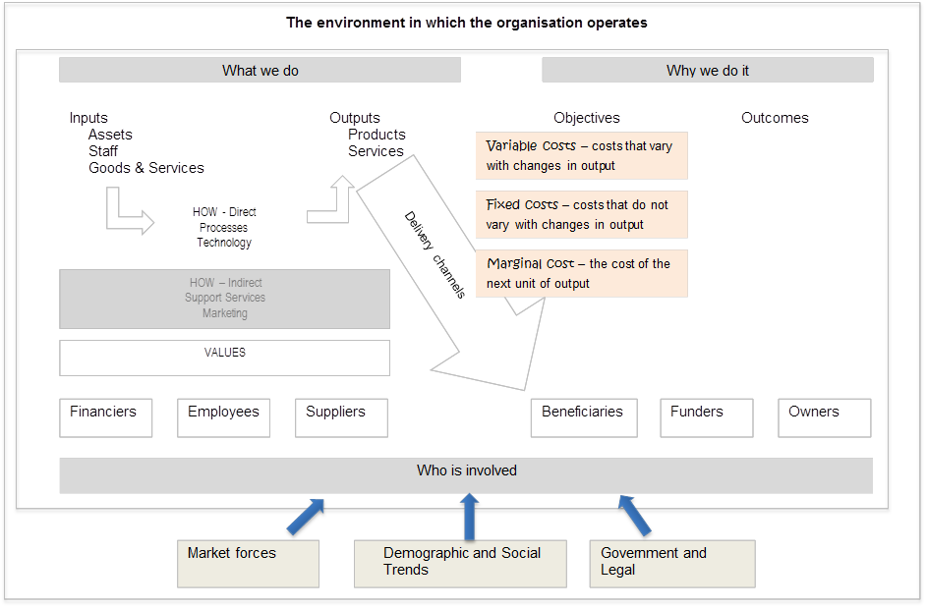

Indirect Costs
Return of Capital
Grants & subsidies
Direct Costs
Revenue from sales
Cost of Capital
Employee expenses
Goods & Services

Appendix 5: Project Estimating and Reporting
Estimating costs for a new project is fundamentally a matter of educated guesswork. We are trying to estimate:
- The breakdown of the type of work required for our project – what are the stages, what are the tasks (these may be different from the project stages or phases).
- The ingredients (labour, goods and services and capital) required for each of the stages and each of the tasks
- The time required for each of the stages and tasks and therefore the time required for labour and contractors (aligned with the school year and the budget available for each year)
- The cost per unit for each of the ingredients required.

The quality of our estimating
Different classes of cost estimates are defined by the level of definition that has occurred for a project or undertaking.
For a new project that is unfamiliar to the organisation and to an individual, there will be low definition and therefore cost estimating will be ‘low’ class.
At the other end of the spectrum, projects or tasks that have been done repeatedly and are therefore well specified and defined, will have cost estimating that is ‘high’ class.
Engineering and construction standards refer to five classes of cost estimates:
- Class 5 (lowest quality) – used for long-term planning, project and concept screening. Expected to have a low degree of accuracy
- Class 4 – Study or feasibility and preliminary budget approved.
- Class 3 – Budget authorisation is used to seek funding approval and will often be an estimate which is subject to budget control.
- Class 2 – Contractor bid/tender control – based on detailed estimates from providers that become a form of baseline
- Class 1 (highest quality) – used for final project control and for specific items to be negotiated with contractors.
Each of these classes corresponds with the degree of project definition and maturity. In the early stages of defining a project, there are higher levels of uncertainty regarding costs. As the project matures and is better defined, the levels of uncertainty around costs should decrease.

The project lifecycle has four phases:
- Project Initiation & design
- Project Planning
- Project delivery/execution
- Project completion.
Project completion (or termination)
Project delivery
Project planning
Project initiation & design
Life cycle stage

Contracted cost, revenue & payment schedule
Initial Whole costing – often parametric
Detailed budgeting – first principles
Monitor finances
Project invoicing
Agree variations
Updated forecasts
Acquit project costs and income against budget
Financial manage-ment
The tightening of cost and revenue estimates across the project lifecycle can be reflected in what is referred to in forecasting as the ‘cone of uncertainty’.
Accuracy range
Degree of project definition
Class 5 estimates
Class 4 estimates
Class 3 estimates
Class 2 estimates
Class 1 estimates
Global estimating
More detailed first principles estimating – unsubstantiated
First principles estimating – backed by contracts
First principles estimating – backed by quotes
Unit rate (parametric) estimating

The cone of uncertainty attempts to capture the reality of the relationship between the accuracy of cost estimates and the degree of project definition. In the early stages of estimating a project’s costs, a wider range of outcomes can be expected because we know less about the project.
The concept of the cone of uncertainty should be front and centre in the process of considering and approving projects to overcome psychological biases that are likely to be present in the consideration of projects.
The different classes of costing are presented with the cone of uncertainty. Some cost estimating standards will go so far as to assign the class of cost estimates with the extent of project definition. For example, class 5 estimates relate to projects that are barely defined (0 to 2% definition) and class 3 estimates relate to projects that are between 10% and 40% defined, while class 5 estimates relate to projects that are between 70% and 100% defined. Note that the extent of project definition is of itself an estimating process.
There are different cost estimating methods used across each stage of a project’s definition.
As the level of project definition increases, the estimating methodology tends to progress from conceptual (stochastic/parametric) techniques to deterministic/definitive techniques.
The class of estimates can be incorporated into different project planning stages.

Global estimates
At the very early stages of estimating (class 5) the costing method applied is global estimating (or “Order of Magnitude” estimating). An order-of-magnitude estimate is prepared when little or no design information is available for the project. It is called order of magnitude because that may be all that can be determined at an early stage.
Global estimating describes an approximate or low-order method of estimating involving the use of ‘all-in’ or ‘global’ rates. The project could be considered as consisting of one or two estimating elements only and the estimate prepared on this basis.
Examples:
- A road costs $1.5 million per kilometre and we want to build 20 km. Estimated project cost is $30 million.
- Business X implemented a new IT system at an average cost of $3,000 per user across 10,000 users ($30 million). We have 8,000 users, so our initial estimate is $24 million.
- We want to build a new classroom – a global estimate is $2,500 per square metre. Our room is 650 square metres. In this case, the global estimate is $1.625 million.
- We want to run a conference – a global estimate is $300 per attendee per day. We are estimating 500 attendees for two days. In this case, the global estimate is $300,000.

Unit rate estimating
Unit rate estimating calculates the cost of each element of the project by multiplying the quantity of work by historical unit rates. The project cost is then determined by the sum of the elemental costs.
This is a class 4 estimating method progressing from a broad order of magnitude to the use of more sophisticated parametric estimation that adds more detail to some of the parameters around the project.
This type of estimating is also referred to as parametric estimating.
For a software project, it might say that the project has the following conceptual ingredients with comparisons for the comparator project:
Better estimates of each parameter could be determined based on the number of users or number of devices and the fixed and variable components of each.

First principles estimating
The foundation of “first principles” estimating is the calculation of project-specific costs based on a detailed study of the resources required to accomplish each activity of work determined necessary for the completion of the project and subsequently recorded within the project’s work breakdown structure.
The first iteration of first principles estimating is a class 3 estimate. A class 3 estimate has more detail for each of the components, supported by more detailed resource planning, but that has not yet been fully substantiated by market-based quotes. They could be substantiated from other examples or from indicative quotes. Class 3 estimates reflect a significant increase in planning and costing detail.
Class 2 estimates are based in detail and are substantiated by market-based quotes from suppliers and contractors. That is, it is first principles estimates backed by specific quotes from suppliers and contractors.
A class 1 estimate will have this planning detail and that is substantiated and supported by contract arrangements. That is class 1 estimates will be largely ‘locked-in’ by contractual arrangements.
At the later stages of project definition, more detailed estimating methods are used. These are referred to as definitive estimates or detailed estimates. Examples include:
- Activity-based estimates – where estimates are made for the costs of pieces of work
- Unit costing estimates – where estimates are made for each of the specified ingredients to the project based on the unit cost of each ingredient.
To achieve activity and unit-based costing estimates, a breakdown and definition of work is usually required to enable specified units of inputs to be estimated.
Detailed estimates will be required of the:
- The number of units of inputs (e.g. labour hours)
- The cost per unit (hourly rates or rates per litre or rates per kilogram)
- Escalation rates – the increases in costs over the project’s whole life.

Project Resource Planning
For a project that relies primarily on staff to undertake activities and deliver outputs, resource planning for staff can be done to estimate costs.
Resource planning is the process of assigning people to tasks or tasks to people and estimating the duration of the task assignment.
A resource plan will result in estimates of the number of FTEs needed at different times for a project and provide the FTE levels linked with the project’s timetable. An example of a resource plan for an IT project is below.

The FTE estimates in the resource plan can be used to estimate the cost of the project and for the costs of phases of the project by adding assumptions about the cost per role and on-costs. A version of the resource plan with cost estimates is shown below.

Project Reporting example
Consider a project with a total budget of $16.7 million over 18 months. The expenditure profile of the project is summarised below.
We receive regular monthly reports for our project. Below is an example of a basic financial report for our project as of month 6.

What can we conclude from this report?

What other information do we need?

The initial report received is reasonable for an operational group or team that provides regular and predictable services across a year. This report may not be as useful for a project.
For our project, year-to-date variance appears reasonable but needs to be viewed considering the progress of the project in meeting its milestones.
For projects, low variances or underspending against budget by time can be indicative of delays in the project. The delays in the project can result in costs associated with stages being greater than anticipated. For our project, we can track the costs by stage to see if stages are taking longer and costing more. This reporting by stage is an important early warning system for the financials of a project experiencing delays.
At the six-month mark, it was initially hoped that the first three stages of the project would be completed:
- Procure and plan
- Configure the system and test
- Configure sites.
However, at the end of six months, only the first two stages have been completed. The under-expenditure on the original report is symptomatic of delays.
An additional report for us is to track expenditure by stage. Such a report is presented below.

This report shows that each of the stages completed to date has cost more than the budget for each stage.
Now, what is our view of how the project is going?

Earned value management
Earned value management (EVM) is a project management methodology that integrates schedule, costs, and scope to measure project performance.
Three core concepts to earned value analysis
- Planned Value (PV) – is the approved budget assigned to scheduled work. It defines the physical work that should have been accomplished at the reporting date.
- Earned Value (EV) – is a measure of work performed at the reporting date expressed in terms of the budget approved for that work.
- Actual Cost (AC) – is the cost incurred for the work performed on an activity during the period up to the report date. It is the amount of money spent in accomplishing the work that the EV measured.
The relationship between PV, EV, and AC is shown in the diagram below.
 |  | Expenses
 |  | Budget | Actual
Work/Activity | Scheduled | Planned Value
Work/Activity | Performed | Earned Value | Actual Cost

We can apply these concepts to our project. As at the six-month point:
- The planned value for our project can be calculated from the approved project value. The planned value (excluding contingencies) is $7.333 million.
- The earned value for our project is the budgeted cost for the first two stages. The earned value (excluding contingencies) is $5.290 million.
- The actual cost for our project is the inception to date cost - $7.313 million.

Earned Value Variance Analysis
Based on these figures, we can undertake, some Earned value variance analysis. Two basic measures include:
- Schedule variance and
- Cost Variance.

Schedule Variance (SV)
Scheduled Variance = Earned Value – Planned Value
Schedule variance is a measure of the divergence from the initial planned schedule. A negative SV indicates that the project is behind schedule, a positive SV indicates the project is ahead of schedule and zero means that we are exactly on schedule.
If positive – the project is ahead of schedule. If negative, the project is behind schedule

Cost Variance (CV)
Cost Variance = Earned Value – Actual Cost
Cost variance is a measure of the divergence from the initial planned budget. A negative CV indicates that we are over budget for the work done to date, a positive CV indicates that we are under budget for the work done to date and zero means that we are exactly on budget.
The table below presents this analysis for our project.

The report shows:
- a schedule variance of -28.0 % - the project is well behind schedule
- a cost variance of -35.4% - the cost to complete stages to date is higher than the budget.
This can occur with projects that incur delays but where staff costs cannot be reduced and as a result have costs incurred that do not link to activity outcomes for the project.

Earned value analysis can be presented in graphical form.

Estimate at completion
A report that compares the approved revenue and expense budget for the project with our best updated estimate of revenue and expenses that we think will occur once the project is completed. The comparison between the approved budget and the revised estimate produces variances.
Our estimated cost at completion is based on:
- actual costs up to the end of the current month
- our best estimates of the cost and timing of costs for the remaining months.
An example of the estimate at completion report for our conference is shown below.
The estimate at completion can also be presented on a graph.

The analysis for this project suggests that if remain months go according to the original plan, the project will be completed two months late with an unfavourable variance of $2.0 million and without additional funding will run out of money before the end of month 18.

Appendix 6: Different Approaches to estimating and projecting
For ‘business as usual’ functions, because the work being done is familiar and repeated, financial projections and budgets will employ what is known as incremental budgeting.

Incremental Budgeting
Incremental budgeting is the most traditional style of budgeting used. Incremental budgeting involves the rolling over of the previous year’s budget into the current year after having made incremental adjustments to reflect changing activity levels, responsibilities or objectives. This has the effect of building in inefficiencies and can lead to allocation of spending to areas where money has been spent, rather than where it should be spent.
Advantages of incremental budgeting
- The budget is stable, and change is gradual.
- Managers can operate their departments on a consistent basis.
- The system is relatively simple to operate and easy to understand.
- Conflicts should be avoided if departments can be seen to be treated similarly.
- Co-ordination between budgets is easier to achieve.
- The impact of change can be seen quickly
- Changes to the budget are incremental which enables changes to be tracked over time.
Disadvantages of incremental budgeting
- Assumes activities and methods of working will continue in the same way.
- Few incentives for developing new ideas.
- Few incentives to reduce costs.
- Encourages spending up to the budget so that the budget is maintained next year.
- The budget may become out of date and no longer relate to the level of activity or type of work being carried out.
- The priority for resources may have changed since the budgets were set originally
- Requires the business to maintain processes to identify inefficiencies and improvements.

Zero-based estimating
For projects, the work being done is unfamiliar and uncertain. Financial projections and budgeting will employ what is known as zero-based estimating. Zero-based estimating is an approach in which all expenses are justified for each new period. The process of zero-based estimating starts from a "zero base," and every element of a project or every section in an organization is assessed for its needs and costs. The downside of zero-based estimating is that it is more time-consuming and can be too cumbersome for large organisations.
Advantages of Zero-based estimating
- Results in an allocation of resources that is based on needs and benefits
- Provides an opportunity for managers to find cost effective ways to improve operations
- Enables detecting inflated budgets
- Useful for service departments where the output is difficult to identify
- Increases staff motivation by providing greater initiative and responsibility in decision-making
- Identifies and eliminates wastage and obsolete operations.
- When employing this way of budgeting and to ensure that benefits are realised budgets that are developed should be compared back to actual trends for each area of the business.
Disadvantages of Zero-Base Budgeting
- Difficult to define decision units and decision packages, as it is very time-consuming and exhaustive.
- Forced to justify every detail related to expenditure.
- Necessary to train managers. ZBB should be clearly understood by managers at various levels otherwise they cannot be successfully implemented. Difficult to administer and communicate the budgeting because more managers are involved in the process.
- In a large organization, the volume of information may be so large that the process becomes cumbersome. Compressing the information down to a usable size might remove critically important details.
- This process can result in the organisation exceeding approved budgets due to timeframes to develop and assure budgets, divisional areas may commence spending to the inflated budgets.

Activity Based Estimating
For organisations where finances can be linked with activity, estimates can be based on parameters that indicate that activity. The method requires that activity can be observed and measured and that reasonable estimates of cost per unit of activity can also be measured.
Activity-based estimating is used in the funding models for Health and Education.
Advantages of activity-based estimating
- Allows estimates to be linked with activity and therefore have finances scale up and down
- Provides a line of site between the finances of an organisation and activity
- Can enable benchmarking of cost per unit of activity to drive efficiency
- Can provide greater certainty to organisations to know the levels of activity they can afford.

Disadvantages of activity-based estimating
- Fixed costs and overhead costs are not easily accommodated in activity-based estimating
- Requires sophistication in the development of cost parameters to maintain the models. In health, there is an industry involved in coding patient data to maintain records of activity and the relative levels of complexity associated with each case
- Activity-based weightings of transactions can be debated
- Subject to averaging methods - average cost per activity and will create debate on how to deal with outliers or cases that are not average.

Rolling forward estimates
A variation on incremental budgeting where estimates are established for multiple years (in government these are referred to as the forward estimates). Estimates are established for multiple years (usually using an incremental method) and each year a new year is added at the end of the forward estimates. That year can be referred to as a horizon year.
Each year in the budget process, participants put forward submissions or bids to add to their forward estimates or savings can be sought from participants that act to subtract from their forward estimates.
This method of forward projecting is used for the budgets of state governments and the federal government in Australia.
Advantages of rolling forward estimates
- Provides medium to long-term clarity about financial projections and facilitates longer-term thinking about the direction of a business
- Is relatively straightforward to administer.
- Provides the ability to track historical changes.
- Supports staffing planning
Disadvantages of rolling forward estimates
- The cumulative impacts of savings and initiatives can be masked and therefore require the budget to be maintained at levels that reflect the business operation.
- Require more sophisticated budget management systems.
- As with incremental budgeting – this method can embed inefficiencies.
Our approach to budgeting (our budget process) will look at how we manage our projections and budgets in an environment where the amount we are provided from a top-down budgeting process differs from the budget constructed from the ground up.

Appendix 7: Treasurer’s Instructions – List

Treasurers Instruction | Objective(s)
1 – Interpretation & Application | To provide guidance on the interpretation and application of the instructions
2 - Financial Management | To specify certain procedures in relation to financial management, and to require each public authority to develop, implement, document and maintain policies, procedures, systems and internal controls to assist Chief Executives with their financial management responsibilities.
3 - Appropriation | to require the Chief Executive of each public authority to institute appropriate controls in respect of money appropriated by Parliament for the public purposes of the State.
5 – Debt recovery and write offs | To require the Chief Executive of each public authority to ensure that the authority establishes and implements policies for the management of debt recovery that aim to recover all amounts owing to the authority and to prescribe the circumstances under which a debt may be written off or waived by a public authority
6 – Statutory Accounts and Banking | To set out requirements for the establishment and operation of:  (a) deposit accounts, special deposit accounts and the Consolidated Account under the Public Finance and Audit Act 1987 (the statutory accounts); and  (b) bank accounts and merchant facilities.
7 – Corporate Governance | To allow the Treasurer to appoint a Treasurer's representative to attend board meetings of a designated public authority where there is no power to appoint a representative in the specific governing legislation of the designated public corporation; and  to prescribe the procedures to be followed in relation to public sector employees acting as Treasurer's representatives on the boards of designated public authorities; and  to prescribe the role and responsibilities of the Chair of the board in relation to the Representative.
8 – Financial Authorisations | To establish a governance regime to apply to all public authorities such that prior approval is required, by a person authorised pursuant to these instructions, before the public authority can:  (a) incur expenditure through contractual arrangements, including purchases; and  (b) enter into an agreement with the potential to lead to expenditure; and  (c) make a payment or disbursement.
9 – Payroll deductions | To establish requirements for the making of deductions from salaries and wages.
10 – Engagement of Legal Practitioners | To require public authorities to seek the advice of the Crown Solicitor before engaging a legal practitioner other than the Crown Solicitor.  To require public authorities to obtain a certificate from the Crown Solicitor in respect of the purchase of land.

Treasurers Instruction | Objective(s)
11 – Payment of Creditors’ Accounts | To prescribe the policy for the payment of creditors’ accounts by public authorities including, where required under the Late Payment of Government Debts (Interest) Act 2013, the payment of interest on overdue accounts.  To require public authorities to report account payment performance information to the Department of Treasury and Finance.  To enable public authorities to charge other public authorities’ interest on overdue accounts.  To prohibit payment for goods not received and services not rendered.
12 – Government Purchase Cards | To prescribe a policy for the control and use of government purchase and stored value cards.
13 – Expenditure incurred by Ministers and ministerial staff | To specify requirements for the documentation of expenditure incurred by Ministers and Ministerial Officers.  To specify a policy for the use of purchase and other credit cards by Ministers and Ministerial Officers.  To prohibit the purchase of alcohol by Ministers and Ministerial Officers.
14 – Ex Gratia payments | To specify the requirements for the approval of ex gratia payments by public authorities.
15 – Grant funding | To establish appropriate accountability on the part of non-South Australian Government entities that receive a grant(s) from an administrative unit(s)
17 – Public Sector initiatives | The object of these instructions is to ensure that public sector initiatives are:  justified; and  subject to the appropriate approvals before they proceed
18 – Procurement | To promote good governance, contract management, transparency and record keeping by public authorities in the course of planning and undertaking procurements which create liabilities or potential liabilities for expenditure by public authorities; and  To promote compliance with whole-of-government procurement policies; and  To provide for reporting to the Department of Treasury and Finance about procurements by public authorities; and  To make Chief Executives of public authorities responsible for procurements by the public authority and for determining public authority-specific procurement arrangements.
19 – Budgetary Control and Reporting | To set out the responsibility of each public authority for the discharge of financial accountability in respect of that authority and the maintenance of accounting and other financial records to permit the Treasurer to comply with statutory and other reporting requirements.
20 – Guarantees and Indemnities | To ensure the Government’s exposure to guarantees or indemnities given by public authorities is appropriately monitored and managed.  To require each public authority to maintain a register of guarantees and indemnities given by it.
22 – Tax Equivalent Payments | To specify the requirements for the calculation, and manner of payment, of tax equivalent payments.
23 – Management of Foreign Currency Exposures | To prescribe a policy for the appropriate management of foreign currency exposures incurred by public authorities.
Treasurers Instruction | Objective(s)
25 – Taxation Policies | To outline procedures for the preparation of Commonwealth and State taxation returns and Commonwealth private taxation rulings.  To require certain prior approvals before a private taxation ruling is lodged with the Australian Taxation Office or legal counsel is engaged to pursue a taxation matter/disagreement with the Australian Taxation Office.
28 – Financial Management Compliance Program | To require each public authority to develop, implement, document and maintain a robust and transparent financial management compliance program

DPC Circulars
DPC Circular | Purpose
PC001 – Guidance on the development and review of DPC circulars | The purpose of this Premier and Cabinet Circular is to provide guidance on the preparation of new circulars and to introduce greater consistency and quality control across existing circulars.
PC002 - Briefing requests from members of Parliament | This circular provides guidance on the handling of requests for information and briefings by Members of Parliament to public sector employees. The circular aims to ensure as much access as possible while preserving the political impartiality of public employees and the confidentiality of government business.
PC006 – Media monitoring services | A whole of government contract has been established for Media Monitoring Services. This Circular outlines the requirement for relevant entities to utilise the Government of South Australia’s contracted supplier for this service.
PC009 The Master Media Scheme for Government Advertising | Two media agencies, collectively known as the Media Panel, have been appointed to provide media advertising services to government.  The key principle of this policy is that government entities are required to use the Media Panel to undertake all media strategy, planning, buying, booking and management services for all Brand and Functional media advertising. Government entities are not permitted to use any other suppliers for these services.
PC012 Information Privacy Principles (IPPS) Instructions | This circular is a Cabinet Instruction that contains the Information Privacy Principles (IPPs). The IPPs regulate the way South Australian Public Sector agencies collect, use, store and disclose personal information.
PC013 Annual Reporting Requirements | This circular provides the directions of the Premier in the preparation and publication of annual reports by General Government Sector agencies that present their reports to Parliament in South Australia. For these agencies, the use of the circular and the accompanying template are mandatory.  Public Financial Corporations and Public Non-Financial Corporations are not bound by PC013 but may choose to use the circular and template.
PC015 Procedures for submissions seeking the review of Public Works by the Public Works Committee | This circular deals with the referral of certain public works (that have materially departed from their approved scope and/or exceeded the approved budget) to Cabinet and/or the agency’s Minister and reporting on public works to the Public Works Committee (‘the PWC’) following advice to Cabinet/and or the agency’s Minister.
PC016 Remuneration for Government Appointed Part-time Boards and Committees | This circular is for the information of Ministers’ offices, Chief Executives and staff involved in appointments and payments to members of government appointed part-time boards and committees.
PC017 Legal Services Commission of South Australia - Remission of Fees | A general Direction in relation to the remission of fees payable to the Crown and the free supply of copies of official documents in connection with professional work carried out by or for the Legal Services Commission of South Australia.
PC018 Government Office Accommodation Framework | This circular sets out the policy adopted by Cabinet to govern office accommodation including the roles, responsibilities and procedures to be followed, and the issues to be considered for the planning, leasing, fit-out, utilisation and management of office accommodation leased or owned by the South Australian Government.
PC022 Establishment and Governance Requirements for Government Boards and Committees | This circular aims to prevent the proliferation of boards and committees by promoting community engagement strategies and departmental structures as a first preference for delivering services.  PC022 also establishes tests and approvals for when to establish a new board, provides general guidance on the structural options and ensures that existing boards and committees undergo regular review.
PC025 Common Branding Policy for the Government of South Australia | This circular outlines the policy for common branding. The key principle is that all government entities maintain a consistent and professional image, and are easily identifiable as belonging to the Government of South Australia. This policy aims to provide a unified approach to branding by all government entities. Clear and consistent branding enables the public to recognise South Australian Government activities. It improves service to the public by facilitating access to programs and services provided by the government.
PC027 Disclosure of Government Contracts | This circular prescribes a policy applying to all public authorities subject to the Public Finance and Audit Act 1987 for the public disclosure of certain contracts involving government expenditure and the sale of government assets, and for the management of contract information.
PC028 Construction Procurement Policy: Project Implementation Process | This circular relates to responsibility for construction procurement policy and application of the Project Implementation Process which is applicable by all agencies to every ‘prescribed construction project’ as defined by Regulations under the State Procurement Act 2004
PC029 Guidelines for the Chief Executive Performance Appraisal Process | This Circular outlines the framework for Chief Executive performance management and development in the South Australian Public Sector for 2023-24.
PC030 Protective Security in the Government of South Australia | This circular outlines the strategic decision, approved by Cabinet, for a whole-of-government approach to protective security by adopting the South Australian Protective Security Framework (SAPSF) as the protective security policy requirements for the Government of South Australia.
PC031 Disclosure of Cabinet Documents 10 Years or Older | This policy allows selected Cabinet documents to be proactively disclosed on a government website and considered for release through the FOI process, if 10 years have passed since the end of the calendar year in which it came into existence. The Department of the Premier and Cabinet is assigned as the agency that will publish selected Cabinet documents online and deal with all FOI applications under the policy.
PC032 Lobbyist Code of Conduct | The Lobbyist Code of Conduct has been designed to introduce greater accountability and transparency into the lobbying process and the interaction between lobbyists and the South Australian Government.
PC034 Procedures in relation to the referral of subordinate legislation to the Legislative Review Committee | This circular sets out the requirements for the referral of subordinate legislation to the Legislative Review Committee (“the LRC”), in particular the procedures to be adopted by agencies in preparing submissions to the Committee.
PC035 Proactive Disclosure of Regularly Requested Information | Proactively disclosing information that is regularly requested and released under freedom of information (FOI) ensures that information is shared with all members of the South Australian community. By allowing the public access to more information, it demonstrates that the government acknowledges the information it holds is a valuable public resource and that it is committed to being open and accountable, informing and engaging with citizens, and encouraging public participation.
PC036 Best Practice Community and Stakeholder Engagement | This circular provides advice on how government agencies can develop a best practice approach to community and stakeholder engagement.
PC038 Unsolicited Proposals | This circular relates to the application of the Guidelines for the Assessment of Unsolicited Proposals which are applicable to all Government agencies and all public authorities under the Public Finance and Audit Act 1997. The objective of the Guidelines is to provide a consistently applied framework for the assessment of unsolicited proposals that originate from a private entity (either for profit or not-for-profit) and are submitted to Government without formally being requested.
PC039 Complaint Management in the South Australian Public Sector | This circular requires all South Australian public sector agencies to establish and maintain an effective complaint management system that conforms to the principles in the Australian/New Zealand Standard: Guidelines for Complaint Management in Organizations (AS/NZS10002:2014).
PC040 Air Travel | This circular articulates the principles South Australian public sector agencies must adhere to when planning and booking air travel.
PC042 Cyber Security Incident Management | This circular addresses the requirements for Agencies to manage, report and respond to cyber security incidents in coordination with the Control Agency for ICT Failure.
PC044 South Australian Funding Policy for the Not for Profit Sector | The South Australian Funding Policy for the Not for Profit Sector aims to provide a simplified and consistent approach to funding that will make it easier for NFPs to apply for, manage, report on and acquit government funding. It also ensures that we capture learning and evidence that can be used to continually improve outcomes for South Australian communities.
PC045 Disclosure Logs for Non-Personal Information Released through Freedom of Information | This circular requires agencies to publish information that has been released under freedom of information, providing the information is not related to a person’s personal affairs, is not exempt from disclosure, and would not cause harm to a person.
PC046 The South Australian Productivity Commission | This Circular sets out the Objects and Functions of the Commission, how inquiries are referred to the Commission, undertaken and reported on, and how the Commission and public sector agencies cooperate in support of the performance of the Commission’s functions.
PC047 Disclosure of Cabinet documents to investigative agencies | This circular provides guidance on the disclosure of Cabinet documents to the Auditor-General and other investigative agencies.
PC048 Communications Approval Process for the Government of South Australia | This circular outlines the policy for the mandatory approval process for the communications activities undertaken by the Government of South Australia.
PC049 Infrastructure SA Major Project Assurance Framework | This Circular outlines the policy Cabinet approved on 23 March 2020 with respect to the review and assessment of major publicly funded infrastructure activities undertaken by public sector agencies, as defined in the Public Sector Act 2009, in South Australia.
PC114 Government Real Property Management | This circular describes Cabinet policy on the utilisation, purchase and disposal of government real property (including Crown Lands). This revised version came into effect as of 29 April 2019 and does not apply retrospectively to properties for which a contract of sale has been entered into as of that date.

