
ANALYSING AND PRESENTING DATA
PART 2 – PRESENTING NUMBERS
Professional Development Course Book
Presented by Mark Priadko

Learning objectives:
- Understanding terminology and definitions
- Basics in tables and charts
- Presenting numbers and decision-making
- Principles in the design of tables and charts
- Presenting data analysis

Self-evaluation
My proficiency in presenting numbers is:
 | 1 | 2 | 3 | 4 | 5 | 6 | 7 | 8 | 9 | 10
 | Low |  |  |  |  |  |  |  |  | High
List of what I need to know to move up one point on this scale
- .........................................................................................
- .........................................................................................
- .........................................................................................
- .........................................................................................
These course notes are designed to support the presentation of information in the module. They are based on the knowledge and experience of Mark Priadko. These notes are not designed to present comprehensive documentation of the requirements for presenting numbers.

Table of Contents
Introduction 4
Briefing to our Minister 6
Numbers that summarise 8
Presenting numbers – telling or revealing 10
Present gaps to reveal/discover 13
Options for presenting data 16
Working with tables and graphs 17
Anatomy of a table 17
Anatomy of a graph 18
Different Graphs for different stories 18
Narrative Structures - Telling a Story with Numbers 34
Pyramid Structure for information reports (Telling) 35
PRAISE as a narrative structure (Discovery) 37
For the Review of the Office of Case Management 39
Excellence in presenting numbers 42
From Edward Tufte 42
From Stephen Few 43
From Sally Bigwood and Melissa Spore 43
Principles of design in tables and graphs 46
Use of colours 47
Combining text and data 49
References 50
Appendix 1: A basic case for infrastructure 51
Appendix 2: What makes a good story? 54
Appendix 3: Presenting cost and activity analysis 56
Appendix 4: Some thoughts on dashboards 60
Appendix 5: Bullet graphs 64

Introduction
Numbers form a fundamental element of presenting evidence in the development of public policy, in preparing reports as part of managing public money, in managing performance and in presenting submissions and proposals. However, many people find numbers difficult to deal with when they are presented to them, causing them to be confused, even disoriented. This often happens because numbers are presented poorly – poorly designed and poorly organised. In this part of the workshop, participants will be introduced to some key principles behind the design, organisation and presentation of numbers.
The initial graph produced by Excel is below:
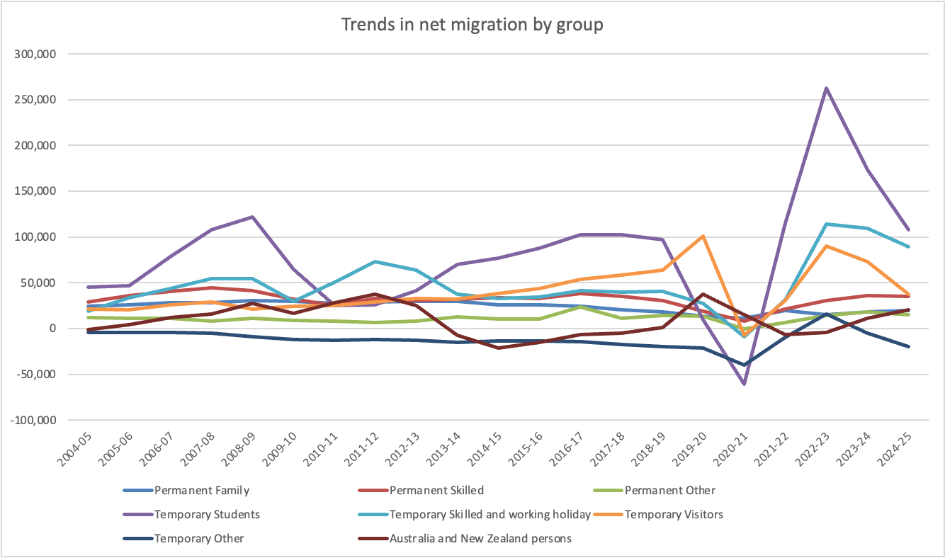

While this graph is helpful in our analysis to reveal the big impact of temporary students, temporary skilled and working holiday migrants and temporary visa, the graph is very busy and less helpful in our presentation of our findings.
The graph has too many lines to be easily decipherable and require readers to find the story rather than have the story more easily revealed to them. It is also the case, the larger numbers associated with the temporary net migration numbers are overwhelming the smaller figures associated with permanent migration.
It may then be better to split the permanent and temporary numbers to see the trends in each separately.
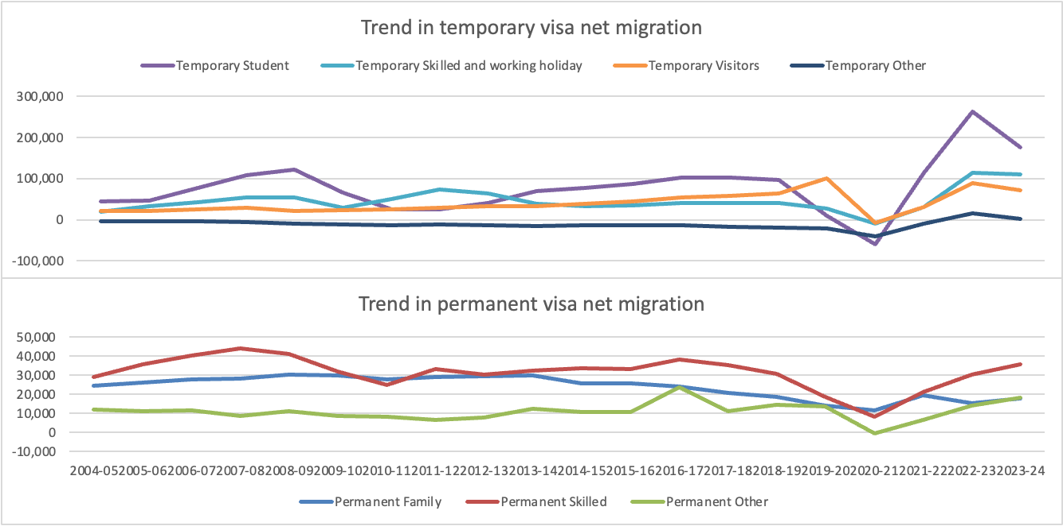
This visual is created by combining two graphs with each sharing the same horizontal axis. It has been done this way to distinguish two categories of visa.
Preparing this graphic requires some data preparation and modification of the standard line graph by deleting the horizontal axis from the top graph and then sizing the two graphs to ensure they are consistent with the horizontal axis.
It still suffers from some deficiencies:
- The reader still has to find the story
- Distinguishing and tracking the colours may be a challenge
- The legends are occupying valuable vertical space.
We can improve the presentation of the graph for it to tell more of a story in the following ways:
- Create more space for the data by labelling each line and deleting the legends
- Use the titles to describe what is happening with the data, rather than just describing the data
- Using one colour to contrast the main line (temporary students) from the other lines, that can be shown using neutral colours like grey and black.
An updated version of the visualisation is shown below.
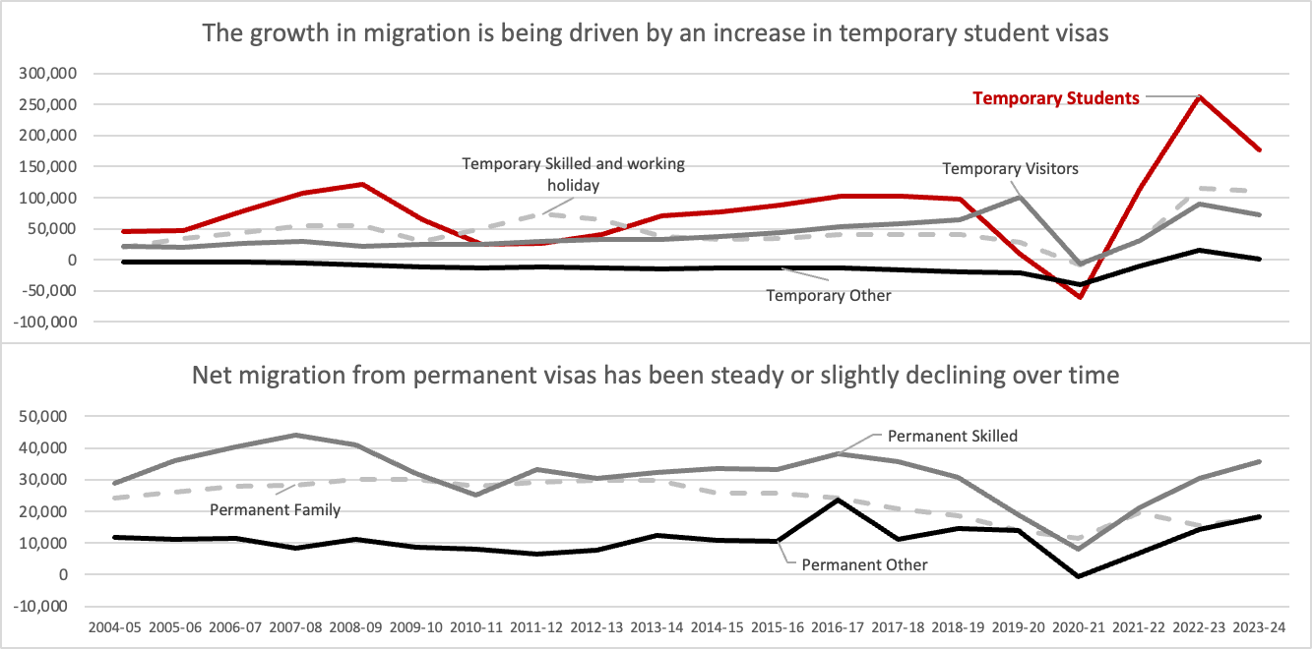

Briefing to our Minister
Topic: Analysis of ABS net migration data (2024-25)
Recommendation: It is recommended that you note the findings from the analysis of ABS net migration data (2024-25).
Key Points
In 2024-25, net migration into Australia was 305,190 persons which equates to an average of 5,869 per week and 836 per day across Australia. Net migration in 2024-25 is 29% lower than in 2023-24 (429,280 persons). Net migration in South Australia was 18,720 persons, which equates to an average of 360 per week and 51 per day. Net migration in 2024-25 is 20% lower than in 2023-24 (23,380 persons).
A table showing the top seven countries, with growth over the last ten years, is presented below.
Note: UK, CIs and IOM – United Kingdom, Channel Islands and Isle of Man
Key points to note from the table include:
- Strong growth in net migration of 5.2% per annum for Australia and 5.3% per annum for South Australia. Growth has come from most of the top seven countries with the exception being China
- South Australia has seen high growth in net migration from Nepal and Sri Lanka. South Australia has a higher share of its net migration from India (25.9%) compared with the Australian share (18.8%) and a lower share of its net migration from China (9.5%) compared with the Australia share (11.5%).
Trends in migration growth have been dominated by the number of temporary students. The graphs below show the breakdown in net migration by groups for Australia.
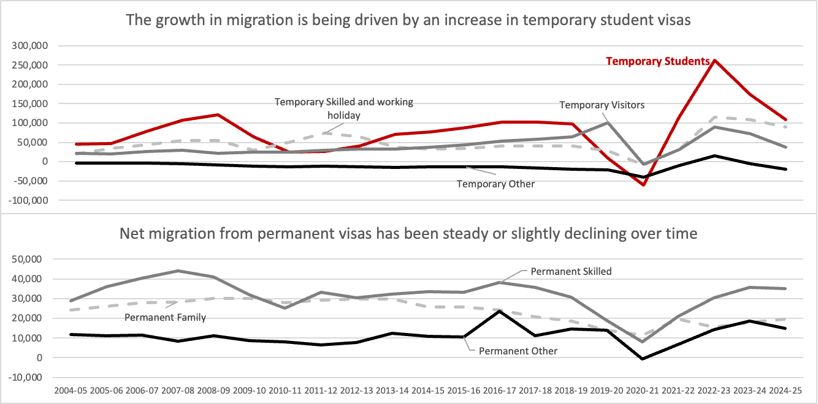
The growth in net migration has been strong since the mid-2000s. The graph below shows the trend in net overseas migration since 1983.
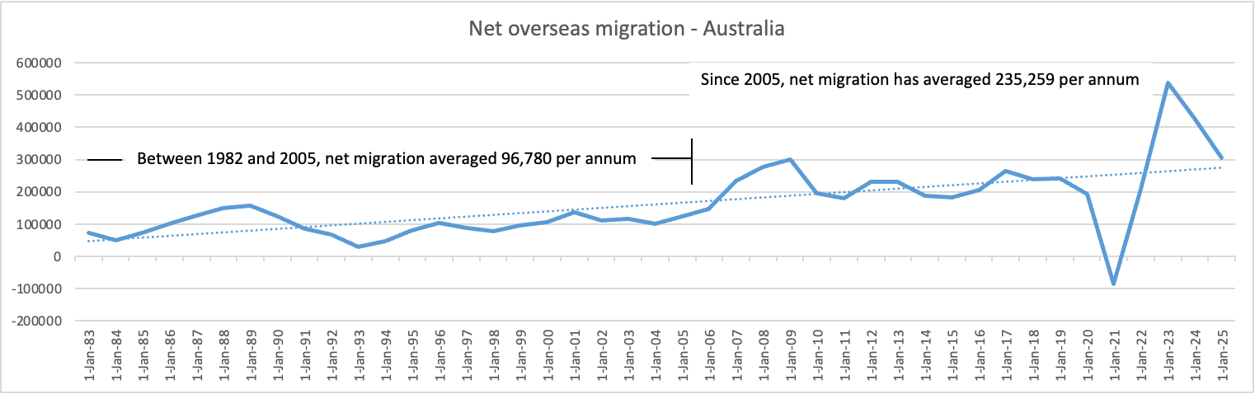
This growth in migration was not forecast by demographers or by the government in 2004. In 2004, population projections for the future were made for 2023. The population in 2022-23 is much higher than what was projected in 2004. The projections at that time underestimated net migration growth. When projections were made, the mid-range estimates (series B) assumed that net migration would be around 110,000 per annum.
The higher-than-expected net migration has changed the profile of the population by age. The graphic below compares the age profiles for Australia between 1983 and 2023.

The impact of net migration since 2023 has been to increase the number of persons in the population below the age of 40. The net migration has offset the impact of ageing of the underlying Australian population.

Numbers that summarise
Numbers that summarise help give us focus and help us see the parts and whole.
Totals - Totals help give the big picture
Measures of summary
- Mean (average) - an average, or central tendency[1] of a data set is a measure of the "middle" value of the data set. Averages give focus.
- Median (middle) - a median is described as the numerical value separating the higher half of a sample, a population, or a probability distribution, from the lower half.
- Mode (most common) - the mode is the value that occurs most frequently in a data set or a probability distribution.
Measures of distribution (or variation)
- Standard deviation - standard deviation is a widely used measurement of variability or diversity used in statistics and probability theory. It shows how much variation or "dispersion" there is from the average (mean, or expected value). A low standard deviation indicates that the data points tend to be very close to the mean, whereas a high standard deviation indicates that the data are spread out over a large range of values.
- Percentage variation
Measures of relationship
- Percentages - a percentage is a way of expressing a number as a fraction of 100, as part of the whole
- Correlation & dependence - In statistics, dependence refers to any statistical relationship between two random variables or two sets of data. Correlation refers to any of a broad class of statistical relationships involving dependence. Beware, correlation does not mean causation.
- Ratios - a ratio is a relationship between two numbers of the same kind
Measures of growth – growth figures measure change over time.
Commonwealth spending on school education in 2010-11 was $18 576 million
Commonwealth spending on school education in 2018-19 was $20,379 million
Commonwealth spending on school education has grown in dollar terms, but has it really grown?

Nominal vs Real
Nominal value refers to a value expressed in money terms (that is, in units of a currency) in a given year or series of years. By contrast, real value adjusts nominal value to remove the effects of price changes over time. For example, changes in the nominal value of some commodity bundle over time can happen because of a change in the quantities in the bundle or their associated prices, whereas changes in real values reflect only changes in quantities.
Most raw financial data is presented in nominal terms. Our school example is below.

Presenting numbers – telling or revealing
A dilemma for a writer is to make choices about the extent to which we tell our readers the story or have the reader discover the story.
When you write to tell rather than write to discover you get straight to the point and present conclusions rather than allowing the reader to deduce anything.
When you tell you will present findings first and support them with facts and data second.
When you write to reveal, you will present facts and data first and findings and conclusions second. Reveal will present the reader with some information in a particular order and in an open-minded way, enabling the reader to draw a conclusion(s). Writing to reveal enables the reader to discover. Discovery requires more structure in our writing. When you write to discover and write to reveal rather than tell, you make the reader part of the experience.
Each has its place.
Telling has the advantage of being direct and more succinct.
Telling works well when all you need to do is inform someone.
Telling has the disadvantage of being less engaging.
Discovery works well when we need the reader to ‘understand’ the conclusion of the document by having them draw the conclusions themselves. This means withholding judgement in our writing, allowing the reader to draw conclusions. Discovery writing can also demonstrate an open-mindedness on behalf of the writer.
The presentation of numbers mattered when the Space Shuttle Challenger was launched in January 1986. January is the middle of winter in Florida, where the shuttle was launched. Following are copies of some of the tables that were used in an attempt by engineers to highlight the risks associated with a launch in cold weather, in particular the risks associated with damage to O-rings designed to seal fuel booster rockets.
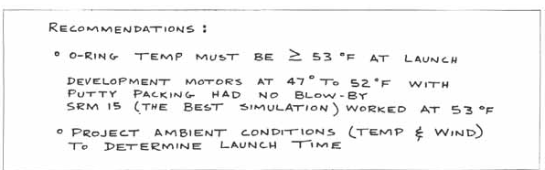

An example of a graphic used to demonstrate the performance of O-rings under different conditions is presented below.
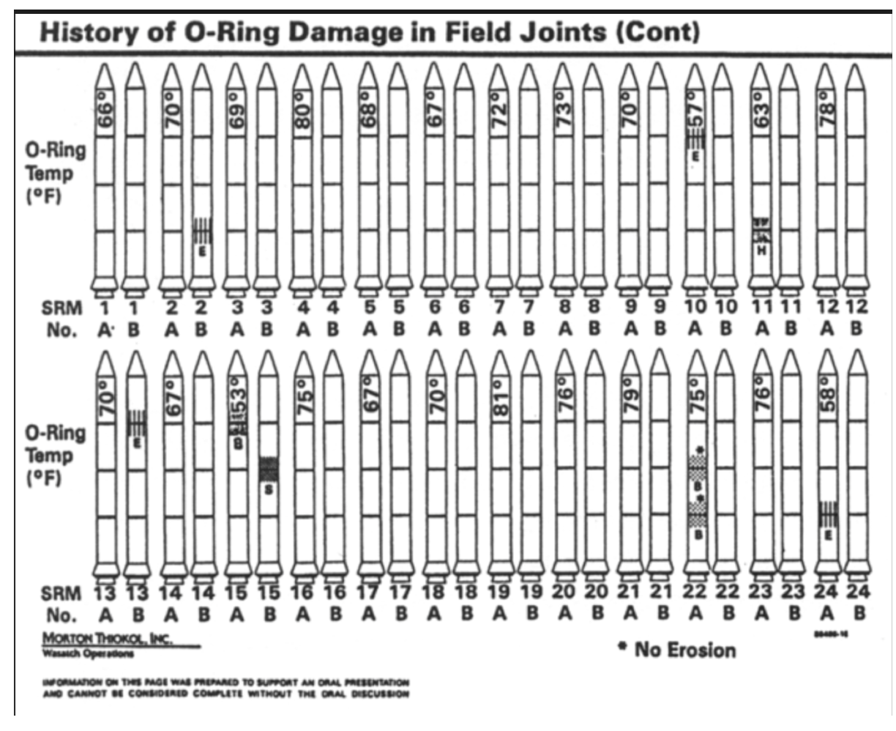
The critical step in making the link between temperature and O-ring performance was not well communicated. The graph above does not adequately show any pattern between temperature and O-ring performance. Note the order the data is presented – flight number order. It would be more informative to rank the data by temperature.
The engineers at the launch pad produced 13 charts (including the graphic above) but failed to stop the launch.
“Yet, as it turned out, the chartmakers had reached the right conclusions. They had the correct theory and they were thinking causally, but they were not displaying causally.” Edward Tufte, Visual Explanations, pg 44
It was observed that the data presented in the 13 charts was very thin.
An alternate presentation was developed by Edward Tufte showing an overall damage score for previous launches. These are presented in the table over the page.
“When assessing evidence, it is helpful to see a full data matrix, all observations for all variables, those private numbers from which the public displays are constructed. No telling what will turn up.”
A scatterplot of data from previous launches shows that the risks associated with O-rings increase as temperature decreases. Before the Challenger, the coolest temperature for a launch with no O-ring damage was 66°F. On the day of the launch of the Challenger, the temperature was 37°F.
While not all of us are involved in the presentation of data in such dramatic circumstances, there are many circumstances when the presentation of data has a significant impact on decisions being made across the public sector.
What is critical is that we ensure that the presentation of data reveals evidence and insight rather than just providing information.
“Everyone spoke of information overload, but what there was in fact was a non-information overload.” Richard Saul Wurman, What-If, Could-Be

Present gaps to reveal/discover
To support decision-making with the graph on the previous page, I would consider adding a couple of elements that highlight factors critical to the decision by revealing gaps with:
- A line of best fit on the data
- A reference point or benchmark for the decision to be made
- Highlight the gap between the data and the reference point.
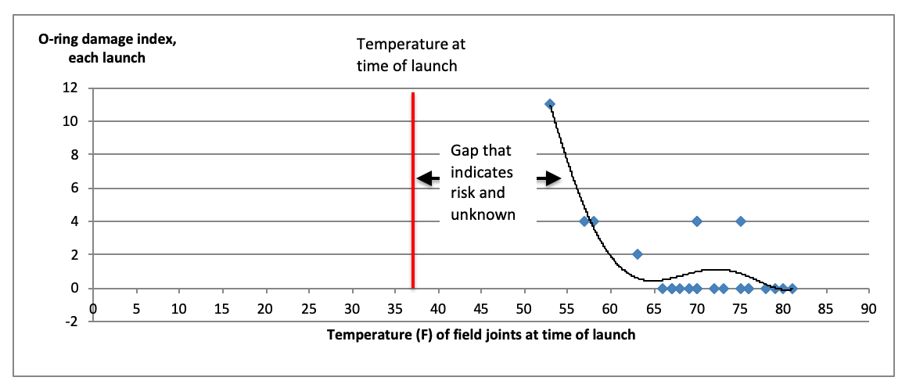
A business case or funding request will usually be based on there being a gap between an ideal or target performance and current or real performance. For example, a business case for more building capacity can be based on revealing a gap in the target (or benchmark) waiting list and the current or project waiting list. Discovery of such a gap can occur by:
- Presenting the ideal state – the benchmark or target.
- Presenting the most recent trend against the benchmark to show any gap between recent performance and the target.
- Presenting the projected trend based on current assumptions to reinforce the gap between performance and the target.
- Presenting findings regarding the gap, along with evidence of building capacity as the main reason for the gap
- Presenting data to show the number of rooms required to close the gap.
Examples of graphs that do this are shown over the page:

There is a trend growth in the backlog of cases. There has been trend growth in the backlog of cases as shown in the graph below.
Projected growth in the waiting list compared to the benchmark is presented in the graph below.

Modelling has been done of the growth in cases and the growth in the number of facilities (e.g. operating theatres, beds, rooms, offices) required. This modelling has estimated that to increase the number of cases processed to eliminate the waiting list gap from the benchmark, three additional facilities are required, along with extra staff to operate and process cases in these facilities.

Discussion
When and why might you use tables vs graphs?

What type of graphs might you choose and under what circumstances?

Options for presenting data

Tables
“A table is a structure for organising and displaying information; a table exhibits the following characteristics:
- Data are arranged in columns and rows
- Data are encoded as text (including words and numbers).”
Source: Page 40 of Show Me the Numbers, Stephen Few

Graphs
“A graph is a method for displaying quantitative information that exhibits the following characteristics:
- Values are displayed within an area delineated by one or more axes
- Values are encoded as visual objects positioned in relation to the axes
- Axes provide scales (quantitative and categorical) that are used to assign values and labels to the visual objects.”
Source: Page 42 of Show Me the Numbers, Stephen Few

To use tables or graphs?
A common dilemma is whether or not to use tables or graphs in the presentation of quantitative information. Below are some simple principles that can help us determine whether we use tables or graphs.
- Tables are the best way to show exact numerical values. Graphs are the best way to show indicative numbers.
- Tables are preferable to graphics for many small data sets. "Tables usually outperform graphics in reporting on small data sets of 20 numbers or less. The special power of graphics comes in the display of large data sets."
- Tables also work well when the data presentation requires many localised comparisons (e.g. when showing many electorates in an election)
- Graphs are best when making comparisons over time
- Graphs are best for showing shapes, trends and relationships in and between data.
If in doubt – use a table, they are more versatile and data-rich.

Writing about numbers
Some conventions regarding the inclusion of numbers among words include:
- Use numerals for 2 and above in text
Use words for numbers when: | Write all numbers as numerals:
starting a sentence | in units of measurement
writing a fraction | when you are comparing numbers
writing a proper noun that includes a number written as a word | to show mathematical relationships (e.g. equations, ratios and decimals
writing a publication title that includes a number written as a word | in specific contexts – such as steps, instructions, age and school years
quoting a figure of speech. | for dates and times
 | in a series of numbers
 | in tables and charts
 | in scientific content.

Working with tables and graphs

Anatomy of a table
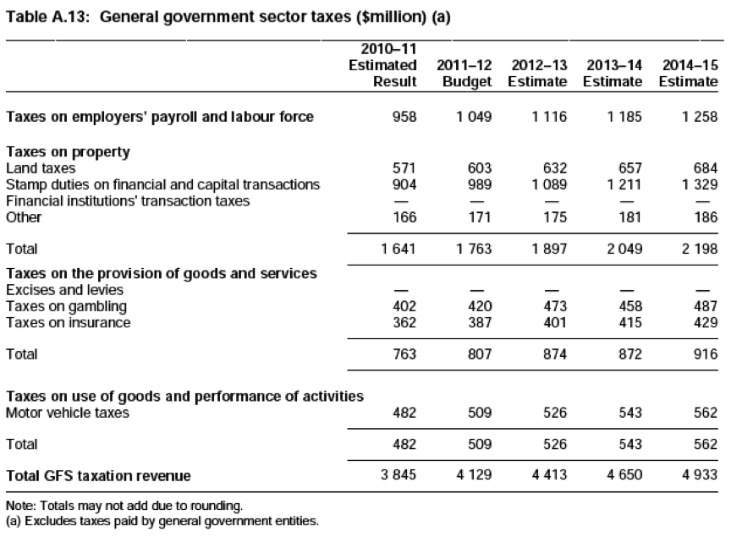
Title with units identified
Footnotes
Column
headings
Row
headings
Table body (data)
Source: SA Government 2011-12 Budget Statement

Anatomy of a graph
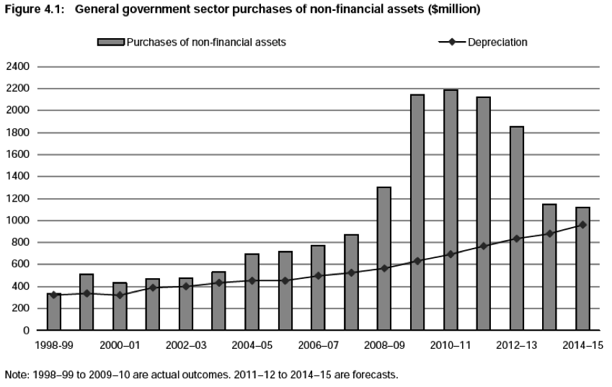
Secondary Y-axis
Title
Legend
Gridlines
X-axis
Primary Y-axis
Source: SA Government 2011-12 Budget Statement
Key components of a graph are shown, namely:
- The title,
- the legend,
- gridlines,
- the x and
- y-axis.
The numbers on the y-axis represent the scales on which the data is shown. The area including the data bordered by the x and y axes is called the plot area.

Different Graphs for different stories
Values can be shown in graphs using the following objects:
- Points (used in scatter charts)
- Lines (used in line charts)
- Bars (used in histograms or bar charts)
- Shapes (used on pie charts and box plots)
The type of graph we want to use depends on what we want to communicate. The notes will look at different messages best delivered by different graphs. Notes will include graphs for the following types of stories:
- To show correlation and relationships
- To tell temporal stories (trends and changes over time)
- To show composition and the relationship of the parts to the whole
- To show variations and performance against benchmarks or targets
- To show distribution and summary statistics
- To show locations where events occur

To show correlation and relationships
Scatterplots or point graphs are used to show relationships between multiple pieces of data or show large volumes of data over time. We used a point graph to show the relationship between O-ring damage and temperature.
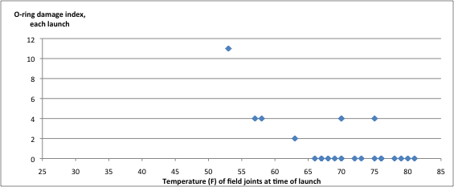
A bubble chart is a variation on the scatter graph above. With bubble charts, the size of the point can be used to display another variable. An example of a bubble chart used to present the relative ranking of projects for planning is presented below.
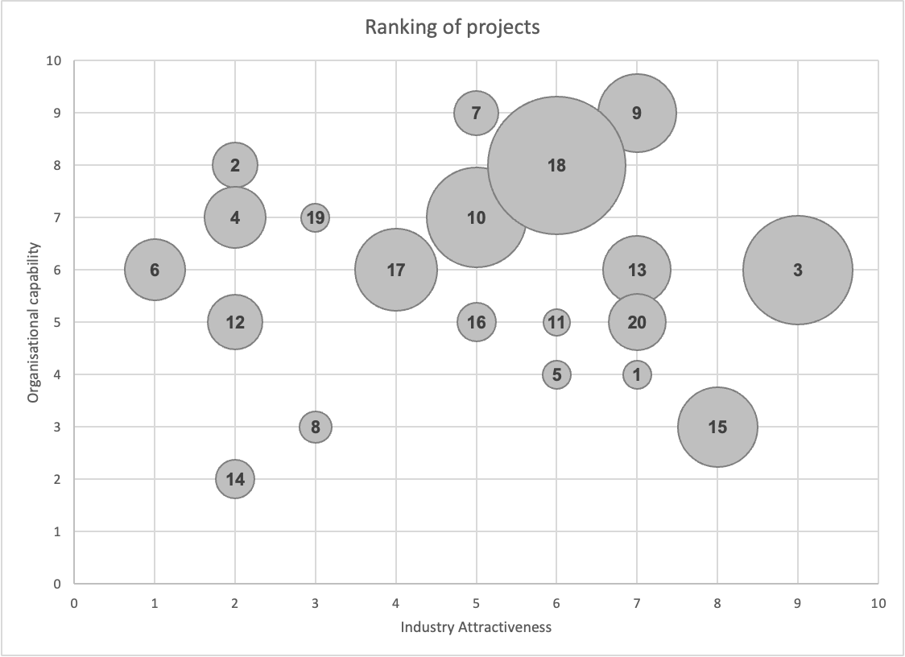
The bubbles show the ranking of projects for a University team with ranking done for organisational capability (vertical axis) and industry attractiveness (horizontal axis). The size of the bubbles reflects the budget for the projects. The visualisation was developed to prioritise project areas for planning. Projects to the left and towards the bottom were culled before projects to the right and near the top.

To tell temporal stories (trends and changes over time)
Line graphs are best for showing trends and volatility over time
The line chart below tracks Adelaide’s maximum temperatures throughout 2010.
The chart shows not only the broad trends of warmer in summer and cooler in winter, but also shows the extent of volatility that is higher in warmer seasons and lower in late autumn, winter and early spring.
Waterfall Chart
A waterfall chart is a form of data visualisation that helps in understanding the cumulative effect of sequential values. For example, for a project by stage:

Gantt Chart
Gantt charts are used in project management as a way of showing activities (tasks or events) displayed against time. On the left of the chart is a list of the activities, and along the top is a suitable time scale. Each activity is represented by a bar; the position and length of the bar reflect the start date, duration and end date of the activity.
An example for the production of an annual report is shown below.

Sparklines are small, high-resolution graphics usually embedded in a full context of words, numbers or images.
Edward Tufte has devoted a chapter to the concept of sparklines in his book Beautiful Evidence. Sparklines are ideal for dashboards and presentations that require condensed data displays.
An example of the use of sparklines by Primary Industries and Regions South Australia (PIRSA) is presented below.
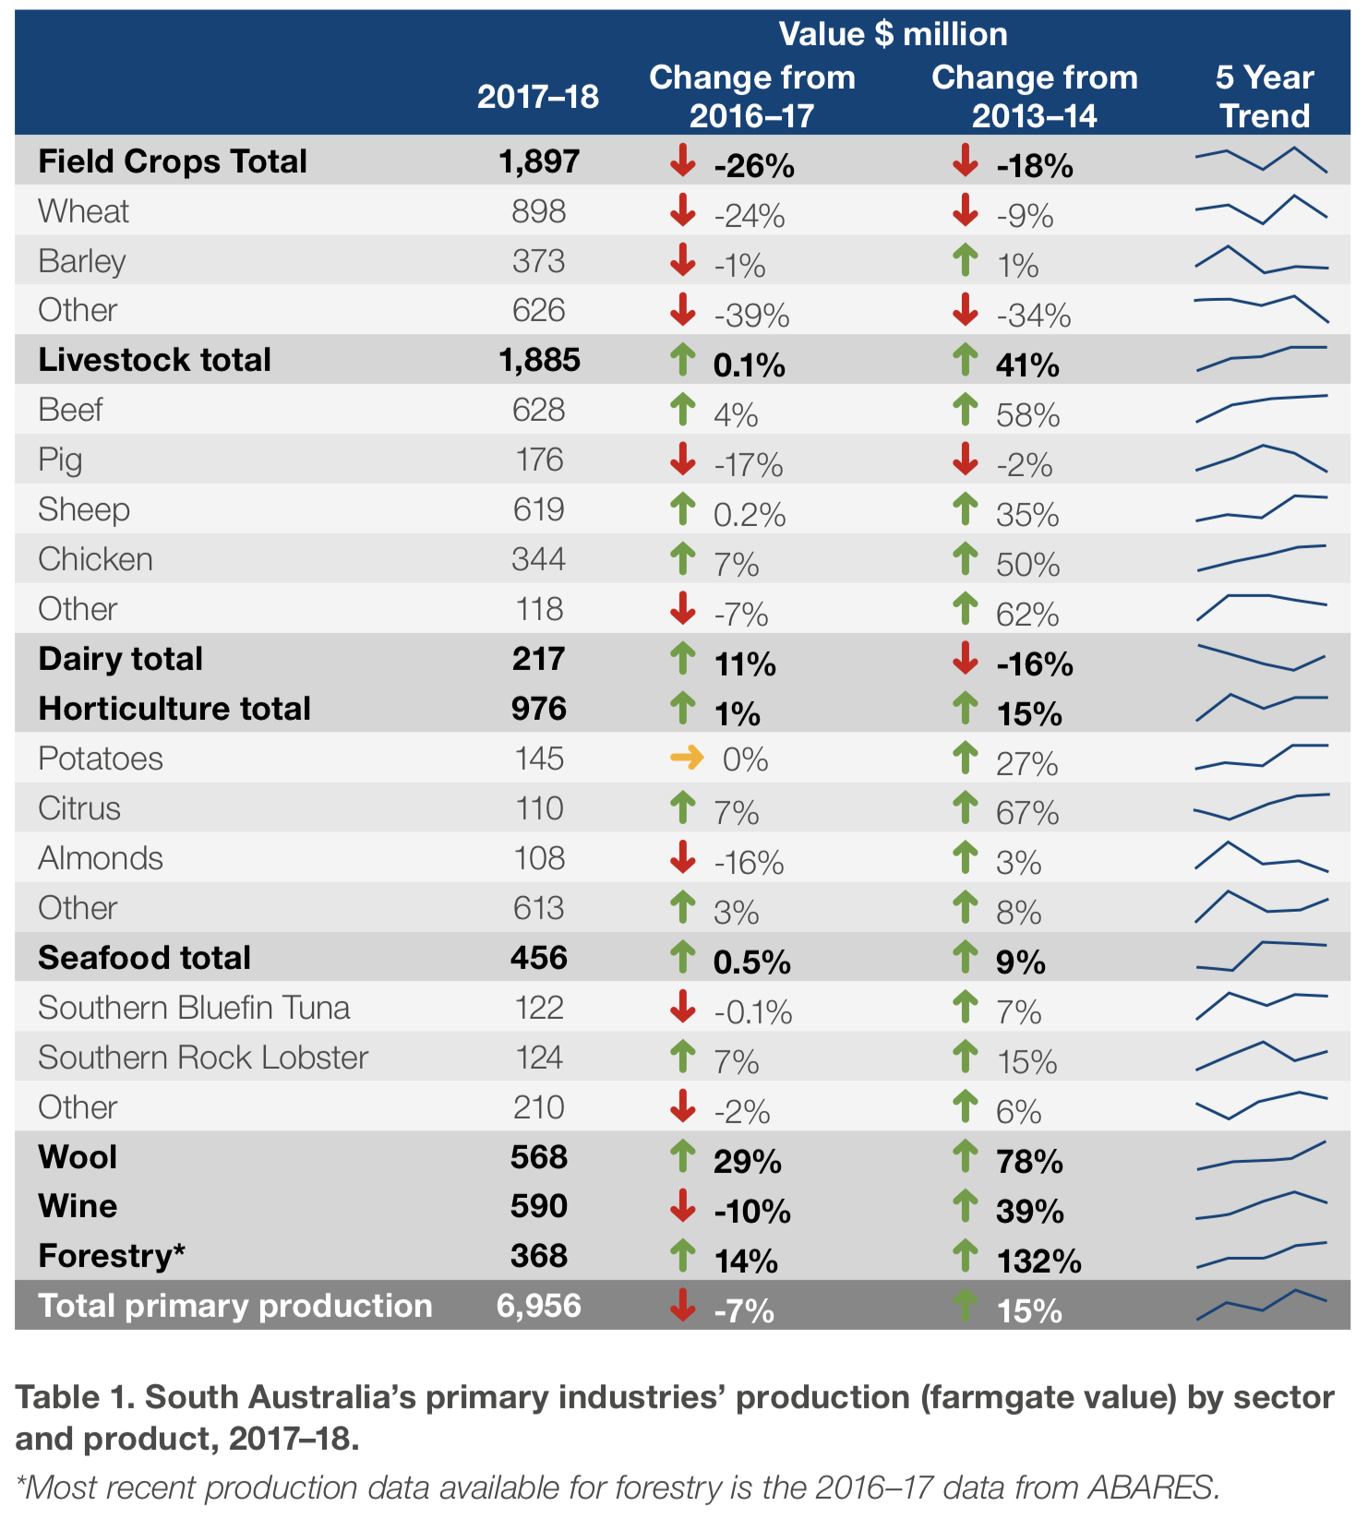
Source: PIRSA Primary Industries Scorecard 2017-18

To show composition and the relationship of the parts to the whole
Pie charts
Pie charts or area charts are used to show compositional data – how the parts relate to a whole.

A donut chart is a version of a pie chart with a hole in the middle.
Treemaps can also be used to show composition but do so using rectangles rather than slices. Treemaps will arrange hierarchy and can be used to distinguish subcategories.
Pareto charts
A Pareto chart contains both bars and lines, where individual values are represented in descending order by bars, and the cumulative total of the sample is represented by the curved line.
The 80/20 Rule (also known as the Pareto principle or the law of the vital few & trivial many) states that, for many events, roughly 80% of the effects come from 20% of the causes.
A Pareto chart for Australia’s net migration in 2022-23 is shown below.
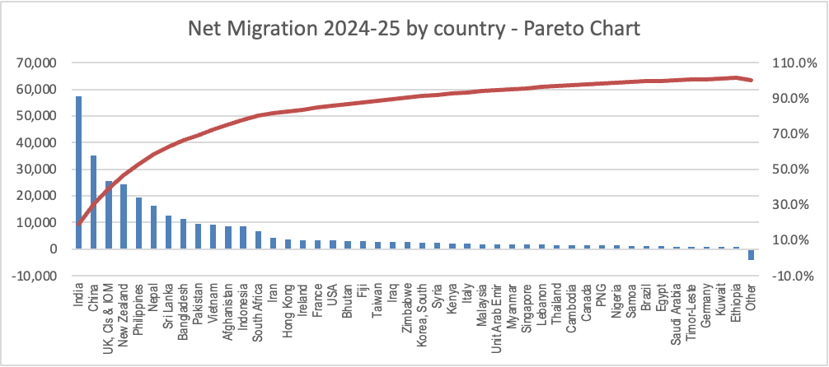

Survey results usually show the share of each response to the total. This is compositional data. To visualise compositional survey results, we can use stacked area graphs. Three versions are presented below.
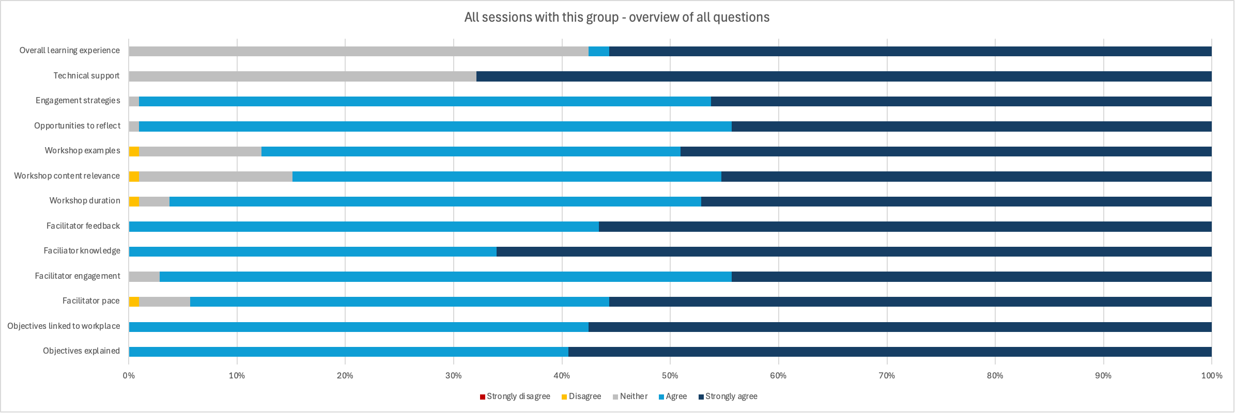
The second version treats agree and strongly agree results as positive and all other responses as negative.
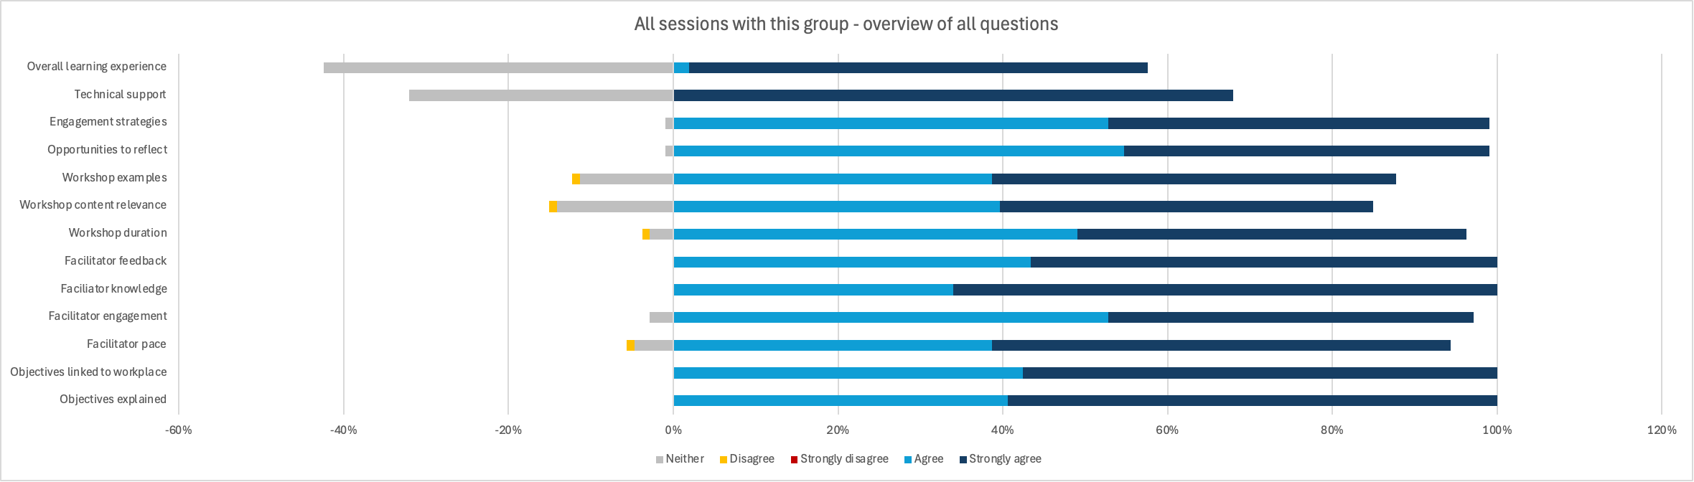
The third version combines these figures with summary statistics (average) and comparisons with other groups or benchmarks.
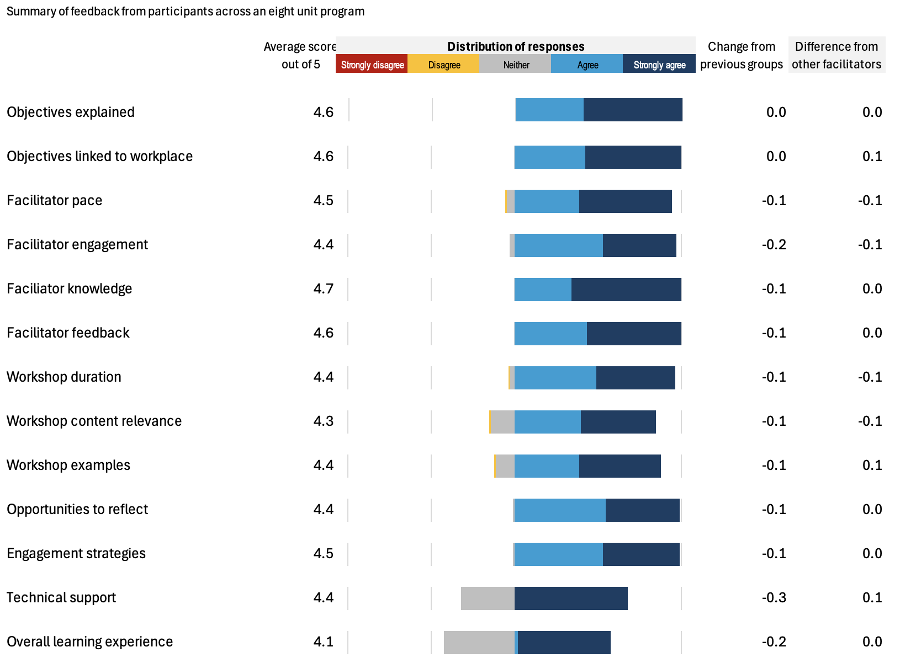

To show variations and performance against benchmarks or targets
Bar charts are often used to make comparisons between sets of data or comparisons over time. The chart below from the Commonwealth budget papers compares Australia’s budget balance with that of G7 countries. The chart shows both comparisons across countries and comparisons over time.
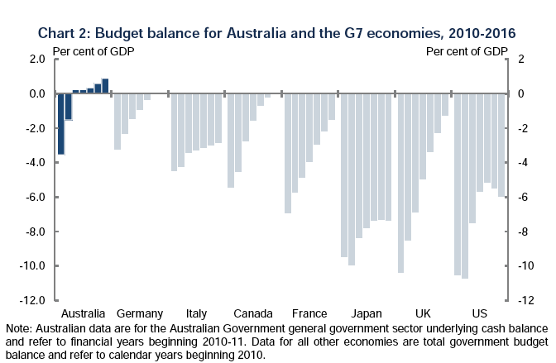

Another example contained in the course resources is below.

For our population data, we can present the variations between projections for 2022-23 made in 2004 and the actual population in 2022-23.
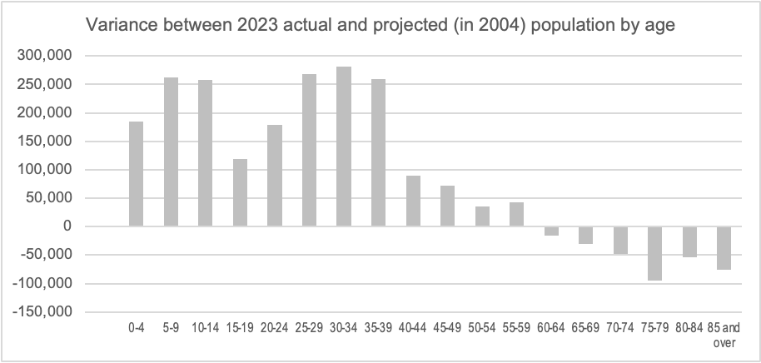

Note the underestimation of population for younger cohorts and the overestimation for older cohorts. This has occurred due to the underestimation of net migration, which has seen increases in population in younger cohorts. The graph may also show that life expectancy has not increased as much as expected, reducing population numbers relative to the projection in older cohorts.
Variation reporting is used frequently in finance. A report showing a summary of monthly variances would appear similar to the graph above, with the horizontal axis showing months.

Control Chart
The control chart (also known as a Shewhart Chart or a Statistical Process Control Chart) is a graph used to study variations in a process over time. Data are plotted in time order. A control chart always has a central line for the average, an upper line for the upper control limit, and a lower line for the lower control limit.
An example of a control chart for website visitors is presented below.
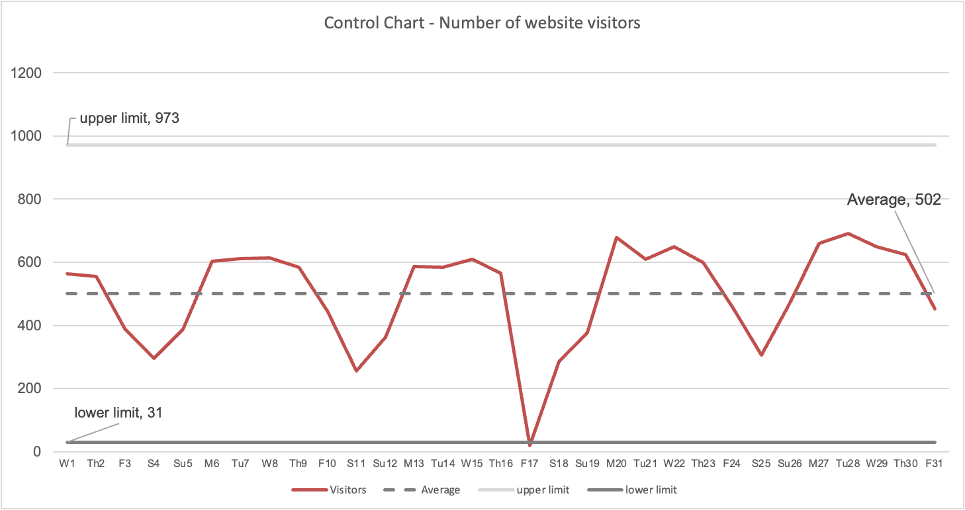

The variations within the upper and lower limits are deemed ‘normal variations’
The variations outside the upper and lower limits are deemed ‘special cause variations’ that warrant explanation.
For the example above, the low figure for Friday the 17th could have been caused by the website being down or power issues experienced on that day.

To show distribution and summary statistics
A box plot or boxplot (also known as a box-and-whisker diagram or plot) is a convenient way of graphically depicting groups of numerical data through their five-number summaries: the smallest observation (sample minimum), lower quartile (Q1), median (Q2), upper quartile (Q3), and largest observation (sample maximum). A boxplot may also indicate which observations, if any, might be considered outliers.
Following are scores (out of 10) from a survey I conducted with participants in a course at four times in the day. The scores were anonymously provided so no reference is made to participant identification. The box plots for these scores are shown alongside the table.

This data shows that participants reported their confidence increased throughout the day.

Histogram
A histogram is a bar graph of the frequency distribution of measurements. The example below is a histogram showing the distribution of staff by age for an organisation. The graph was used as part of the workforce planning of the business to identify the number of staff at or near retirement, as well as the distribution across lower age brackets.
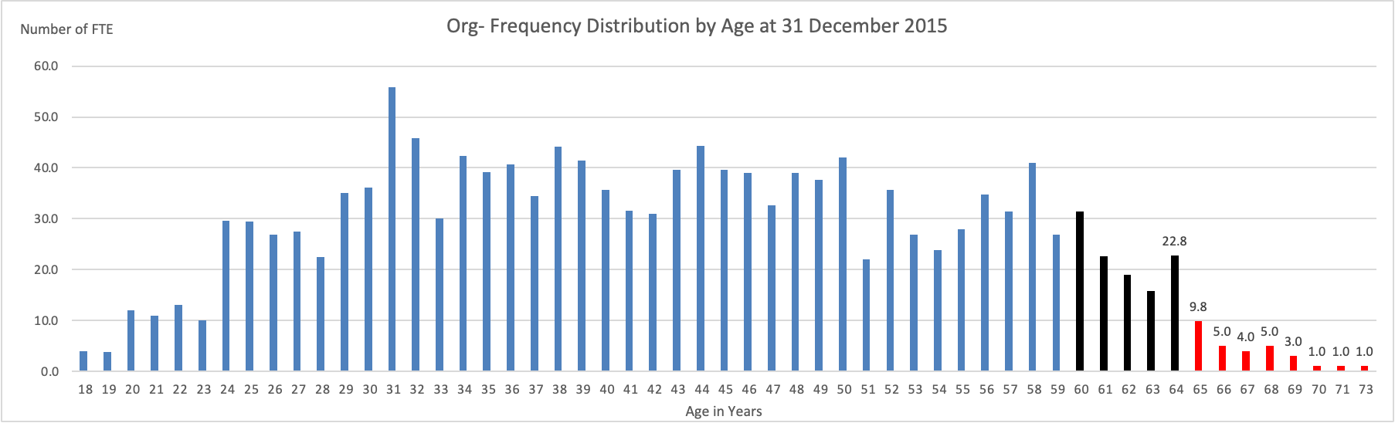
The graph highlights staff either nearing (in black) or having reached (in red) retirement age.
Heatmap
Heatmaps can be used to show the relative frequency of events or observations. They are commonly used in representing risks.
Below is a heatmap for birthdates between 2007 and 2016 in Australia from the ABS. The lower the number and the lighter the colour, the more popular the birthdate. The higher the number and the darker the colour, the less popular the birthdate.
The ABS made the following observations from this data:
- Of the five most common birthdays, three are in September,
- Two of the five least common birthdays are in December,
- The least common birthday is 25 December (excluding 29 February, which only occurs in leap years).
"These trends are similar in New Zealand, England and Wales, and the United States," Beidar Cho, the ABS Director of Demography, said. "More babies are likely to be conceived around the Christmas/New Year holidays, resulting in more babies born in September and October. Fewer babies are born on public holidays - possibly a result of doctors scheduling deliveries on non-public holidays."

To show locations where events occur
Data on maps is becoming popular with the increased sophistication of technology.
Excel (at least the version I am working with) allows me to map location-based data onto a map using Bing Maps. Below is a summary of crime statistics in South Australia for the first three quarters of 2017-18, showing the top 20 suburbs by number of offences.
Offences by Suburb in Metropolitan Adelaide: Q1 to Q3 2017-18.
Bing Maps has then enabled this data to be presented on a map of metropolitan Adelaide.
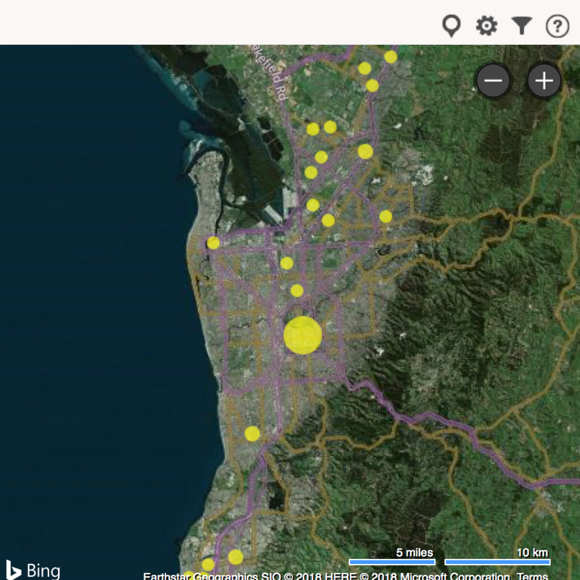
Reflection

Other references
Graph selection matrix available at:
Perceptual Edge – Library/other brief publications
Microsoft Power BI – Has a guided learning website.
Other references
https://datavizcatalogue.com/
https://datavizproject.com/
YouTube resources:
MyOnlineTrainingHub (e.g. Building Excel Dashboards)
Leila Gharani

Discussion
There is a team operating within an organisation. The roles and responsibilities of the team are well defined. The work they do is: Case management, investigations and attending to public enquiries.
The team and their leaders are struggling with their work and are experiencing high levels of stress. They have raised this with senior management and made a plea for additional resources to address their situation. Senior management is not convinced that additional resources are required and believes there could be other reasons why the team is struggling with their work and experiencing high levels of stress.
We are asked to review the team and produce a report on the resource adequacy or otherwise of the team.
What data could we analyse and include in the review and report?

The review of the Office for Case Management revealed the following data:

What do we conclude from this table?

Narrative Structures - Telling a Story with Numbers
Presenting data to others to help them make decisions requires that we can tell a story of change with the data we have.
To tell a story we have to make choices about what of our analysis to include and what to exclude. We have to help our readers discover without them experiencing all the difficulties we have or without having to digest all the data we have.
The choice of what to include, and how to include it, is our narrative.
“Narrative is the choice of which events to relate and in what order to relate them – so it is a representation or specific manifestation of the story, rather than the story itself.”
Source: http://beemgee.com/blog/story-vs-narrative/

Some examples of basic non-fiction narrative structures:
- Past – Present – Future
- Beginning – Middle - End
- Why, what, how and what’s next
- Context – Discussion – Findings – Recommendation.
Most organisations will establish document templates that will prescribe the order and sequence of what we write.
More detail on five structures follows:
- Pyramid structure for information papers
- 4Ps structure
- Shawn Callaghan’s Clarity Story
- SOAP
- PRAISE as a narrative structure.

Pyramid Structure for information reports (Telling)
This structure for information reports is designed to ensure time poor decision-makers are firstly provided with summary information and conclusions and then gradually introduced to increasing levels of detail that explain the results and support the conclusions.
An example for a finance report is below.
First breakdown – organisation presented by team or by revenue and expense category
Whole of organisation totals and main conclusions
Second breakdown – detail for each team, unit or project by line item
Details of matters that support the finances (e.g. FTEs, activity levels, relevant transaction details)

For finance reports, this structure requires information to be summarised for our readers before presenting them with detail. We gradually increase the amount of detail we present to our readers.

4Ps structure
The 4 Ps to consider are:
- Position: this is like the Background section in a government template. It summarises the circumstances that have resulted in the need for action.
- Problem: this is like the Discussion section in a government template. It outlines the problem that needs to be solved.
- Possibilities: this is an analysis of all the possible solutions to the problem and their associated risks and benefits.
- Proposal: this is the recommended course of action supported by evidence and with details about what the reader needs to do next.
* Ros Jay, How to Write Proposals and Reports that Get Results (Pearson Educational Ltd., 1999)

Shawn Callaghan’s Clarity Story
In his book, Putting Stories to Work, Shawn Callahan includes a narrative structure for telling stories of change. He calls them clarity stories. He states:
“Human beings like reasons, and the clarity story gives people a reason….
The clarity story has a simple four-part framework:
Part 1 ‘In the past….’ (how things were before the change happened)
Part 2 ‘Then something happened…’ (the event/s that caused the problem or opportunity)
Part 3 ‘So now…..’ (the decision/s made to counter the problem or take advantage of the opportunity
Part 4 ‘In the future….’ (the likely outcome)”

SOAP (used in Healthcare)
The SOAP note (an acronym for subjective, objective, assessment, and plan) is a method of documentation employed by healthcare providers to write out notes in a patient's chart, along with other common formats, such as the admission note.
Subjective - information provided by the subject (patient) regarding his/her experience and perceptions about symptoms, needs and progress toward goals
Objective – information observed and gathered by the professional on vital signs, examinations and results from tests and scans.
Assessment – the diagnosis and judgements made about the subject’s conditions and progress made over a period of time.
Plan – What steps will be taken and what will be done to treat the subject or to better understand the subject’s condition.

PRAISE as a narrative structure (Discovery)
The PRAISE narrative structure is designed for reports or briefings that require the reader to be convinced of a need to change and act differently.
The centrepiece of this narrative structure is that a change is needed and the reasons to support the change have been researched and understood.
The PRAISE narrative structure is designed to support decision-making by guiding the reader towards insights that reveal the need for, and the reasons for, change in an organisation. Change can include:
- New investments
- Changing a business or service delivery model
- Decommissioning a site or service
- Adding products or markets or eliminating products or markets.
PRAISE is shorthand for a narrative structure with six components:
- Purpose
- Recent History
- Analysis
- Insight
- Solution
- Execution Plan (next steps)
The PRAISE narrative structure is designed for reports or briefings that require the reader to be convinced of a need to change and act differently.
The centrepiece of this narrative structure is that a change is needed and the reasons to support the change have been researched and analysed. Within the structure, we provide our evidence.
PRAISE = Purpose, Recent History, Analysis, Insight, Strategies, Execution
General
Specific
Purpose
Recent History
Analysis
Insight
Strategy
Execution
Proceeding decisively
Problems or opportunities
Solutions

The structure is designed for readers to be able to follow a flow or logic that makes high-quality decisions easier to make based on the substance of the evidence that we have brought together.
“The purpose of an evidence presentation is to assist thinking” Edward Tufte, Beautiful Evidence
PRAISE summarises the readers’ journey through our report, helping them think through our issue or proposal.
The PRAISE model proposes that there are six elements that need to be included in what we present to enhance transparency in our communication with others. These six elements are:
- Purpose – The purpose section presents a quest or goal that matters to the reader. This is an important means by which to involve them in this story. It will impact their goals or the goals and outcomes by which they will be judged. We are using the goals and outcomes as a means to engage with our readers and decision-makers – they get a sense of purpose.
- Recent History – some background to our organisation, unit, issue, problem or opportunity is the subject of our thinking. This will include the events that have led up to where things are now and previous attempts to approach this subject.
- Analysis – we present facts and data that capture our observations and show necessary detail. This can include detailing options we have considered and eliminated.
- Insight – our diagnosis and assessment, where we draw conclusions from the history and analysis included earlier. In problem-solving, the insight will be the main diagnosis of the root cause of the problem.
- Strategy (or Solutions) – we outline what the appropriate strategies/responses are given the conclusions we have drawn. This can also include some options and the process of reaching a preferred solution.
- Execution – we detail the next steps. This can include specific instructions to remedy what we have found.
The purpose and insight section of our presentation should ensure that the receiver understands the context for, and the importance of, what we are presenting and can draw some conclusions about what and why change is required.
The analysis and execution sections will be where we present details and specifics regarding the data we have collected and regarding how the recommended response should be executed.
In delivering presentations, PRAISE can give us some guidance as to the pace and detail we want to work with.
The purpose section is deliberate, the recent history and analysis can be more fast-paced and detailed, the insight requires us to get our audience to stop and think more reflectively while the last two elements can grow in speed to give the sense of momentum associated with getting a decision made and getting on with making things happen.

For the Review of the Office of Case Management

Purpose
The State Government has made clear public statements demonstrating its commitment to better protect the most vulnerable members of our community and break the cycle of disadvantage. Legislation has created the Office for Case Management (the Office) that plays an independent and leadership role in meeting the Government’s policy commitment.
The services delivered by the Office are of high public value. We value that each member of our society will be protected and supported when confronted with difficulties and dealing with disadvantages that could occur to any of us at any time and at no fault of our own. The importance and value of the Office are reinforced by stakeholders. In addition to the case management services provided, value the independence of the Office and the advocacy it offers on behalf of vulnerable persons.

Recent History
The Office was created in 1983 with 6 FTEs and grew to 9.5 FTEs in 1995 following a restructure. A successful budget bid in 2016 increased the staffing to 10.5 FTEs. The funding model for the Office allows for inflation growth but does not allow for changes in activity. The tables below show that in the last four years, demands for all services have grown rapidly: case management (11.7% per annum), investigations (17 % per annum), enquiries and outreach have grown rapidly.

Figure 1: Growth in cases

Figure 2: Growth in investigations

Figure 3: Growth in enquiries

Analysis
Analysis has been performed of the workload and the way work is done in the Office and has concluded that workloads are growing rapidly and that the Office has taken steps to improve its efficiency and effectiveness. The benchmarking analysis presented below shows that when compared to interstate offices, workloads in South Australia are excessive.

Figure 4: Interstate workload comparison

Other legislative requirements of the Office have been set aside to enable it to deal with the demands of increasing caseloads.

Insights
The functions of the Office specified in the legislation are not being performed to the extent required with flow-on impacts associated with failures to exercise a duty of care and failures to comply with legislative requirements. This is a risky situation for the Office and the Government. The stresses within the system present real and present risks of public failures to meet legal obligations and exercise duties of care that are likely to trigger litigation.
The root causes are the growth in demand, which is outside the control of the government, and a deficient funding model that is within the control of the government. A funding model and budget process that ignores growth in caseloads and that requires the Office to repeatedly bid and negotiate additional funds is at odds with the independence of the role. It is also at odds with the legally binding nature of the cases being managed and appears to ignore the duty of care implications of resource shortfalls.

Strategy
Addressing these shortcomings requires a revised approach to the structure, resource base and funding model of the Office. A revised structure for the Office consisting of 18.5 FTEs is recommended along with a supporting resource plan. This structure and resource plan have been recommended based on a reasonable caseload and based on the reinstatement of positions required for education and community programs that were part of the original structure of the Office. It is recommended that the funding model for the Office be changed so that the Office receives a level of funding linked to demand for its services as a case manager, without compromising its duty of care or compromising the standard of its services.
The table below details the additional resources required over the forward estimates.

Execution
Recommended actions to implement this strategy include:
Immediately:
- Submit a budget bid for the amounts shown above to the Treasurer
- Immediately revise the case manager job and person specs to broaden qualifications and add decision-making skills to the personal skills requirement
- Recruit additional case managers to address caseload excesses.
- Develop a job and person specification for the Business Manager position
Within 6 months:
- Recruit a Business Manager
- Seek agreement on a revised approach to funding the office (as detailed above) with the Treasurer
- Seek to have the remuneration of the Chief Executive Officer considered by the Remuneration Tribunal
- Review the classifications of:
  - The Lead Case Manager
  - The Office Administration staff
- Develop job and person specifications for the position of Liaison Officer to the Authority
- Develop an accommodation plan.

See Appendix 1 for an example of the PRAISE model applied to the infrastructure case study introduced earlier.

Excellence in presenting numbers
Different authors have different views about excellence in presenting numbers.
Edward Tufte advocates intensity in data presentation – high volumes in small spaces with a high number of ideas in a short time but with the least ink possible.
Stephen Few is an author of a number of books on presenting numbers and data visualisation. His material reinforces some of Edward Tufte’s principles although his approach to presentation tends to be more pragmatic and less intense.
Sally Bigwood and Melissa Spore are more minimalist in their principles – less is best.

From Edward Tufte
Excellence in statistical graphics consists of complex ideas communicated with clarity, precision, and efficiency. Graphical displays should:
- Show the data
- Induce the viewer to think about the substance rather than about the methodology, graphic design, the technology of the graphic production, or something else
- Avoid distorting what the data has to say
- Present many numbers in a small space
- Make large data sets coherent
- Encourage the eye to compare different pieces of data
- Reveal the data at several levels of detail, from a broad overview to the fine structure
- Serve a reasonably clear purpose: description, exploration, tabulation or decoration
- Be closely integrated with the statistical and verbal description of a data set.
Principles of Graphical Excellence
- Graphical excellence is the well-designed presentation of interesting data – a matter of substance, of statistics and design
- Graphical excellence consists of complex ideas communicated with clarity, precision and efficiency
- Graphical excellence is that which gives the viewer the greatest number of ideas in the shortest time with the least ink in the smallest space
- Graphical excellence is almost always multivariate
- Graphical excellence requires telling the truth about the data.
"Five principles in the theory of data graphics produce substantial changes in graphical design….:
Above all else show the data.
Maximise the data-ink ratio.
Erase non-data-ink.
Erase redundant data-ink.
Revise and edit."
The Visual Display of Quantitative Information, pg. 105

From Stephen Few
“The purpose of quantitative tables and graphs in business is to communicate important information effectively. That’s it. Not to entertain, not to indulge in self-expression, not to make numbers interesting through flash and dazzle that you would otherwise deem boring.”
“As providers of quantitative business information, it is our responsibility to do more than sift through the data and pass it on; we must help our readers gain the insight contained therein. We must design the message in a way that leads readers on a journey of discovery, making sure that what’s important is clearly seen and understood. The right numbers have an important story to tell. They rely on you to give them a clear and convincing voice.”

From Sally Bigwood and Melissa Spore
To create lucid, intelligible data graphics, we suggest the following:
Reduce the data: Designing useful data graphics requires decision-making, judging what data is relevant, and what can be ignored. Too much data swamps, confuses and misleads. Think of the needs of your readers. Provide selective, edited demonstration tables – focusing on a specific point – rather than comprehensive tables. Similarly, graphs should focus on an explicit story.
Present refined thought: Persuasive data graphics are the product of time and thought. Serious communicators need time to analyse the data and design it appropriately for the intended audience. A resulting table or graph may look simple but is the result of knowledge, experience and commitment to communicating with others.
Don’t overestimate graphs: Graphs are fundamentally simple. Bar graphs show that one thing is larger than another, lines show changes over time and pies show the parts of a whole. Graphs that look complex almost always do so because of overelaborate presentation, not intellectual rigour. The fact is, graphs cannot explain complex messages and complex graphs do not communicate effectively.
Use a table: Saying the public prefers graphs to tables is like saying someone prefers a hammer to a saw. Both are useful tools but they do different jobs. Graphs excel at a single storyline, high contrasts and broad trends; they are less good at detail. Tables are more versatile and can present complex stories. Additionally, tables hold detail conveniently and, when well designed, are easy to read. Yet communicators are sometimes pressured into using graphs when a table is appropriate. People who are interested in your subject will be interested in relevant, readable data however presented.
Remove debris: Gratuitous decoration – data labels, gridlines, shading, borders, tick marks, embolding, etc. – detracts from the message. Emphasise the data, not the decoration. To make your tables and graphs authoritative, keep them simple, small and stripped of clutter. Look at The Economist: it serves a highly numerate, serious readership and illustrates articles with small, succinct data graphics with scarcely a gridline or data label in sight.
Steer clear of pie charts and 3-D graphs: The public may like pie charts but they force readers into the mental juggling of comparing triangles arranged in a circle. Most of us think linearly and a simple bar chart presents this data more conveniently. Equally, 3-D graphs may be popular but they tend to distort data – readers do not know which point of the image they should measure from. Avoid them.
Extract from the Article “Designing persuasive tables and charts”.

Some ‘not so good’ examples
The following graph was published by the South Australian Government in a document titled Our energy plan. It was published in 2017. The graph appeared on page 14 of the plan under the heading ‘Transition of Energy Supply’.
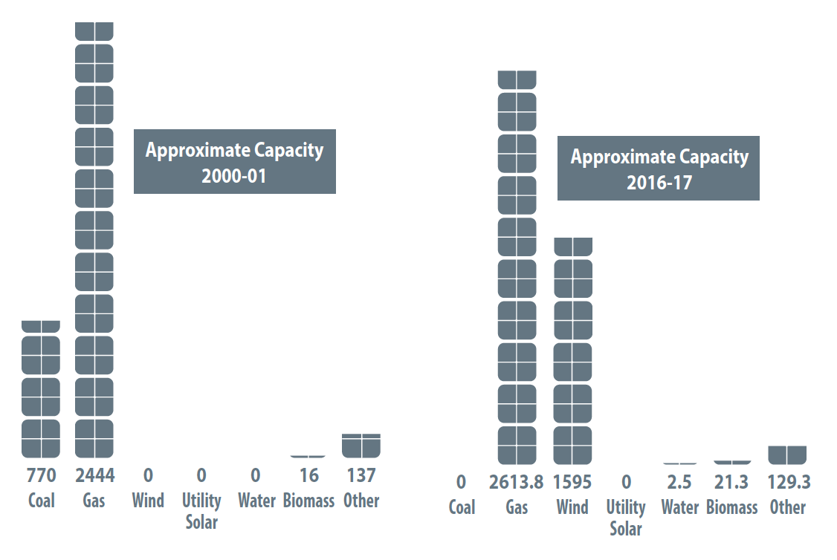
The graph below was published in the Commonwealth 2022-23 budget statement.
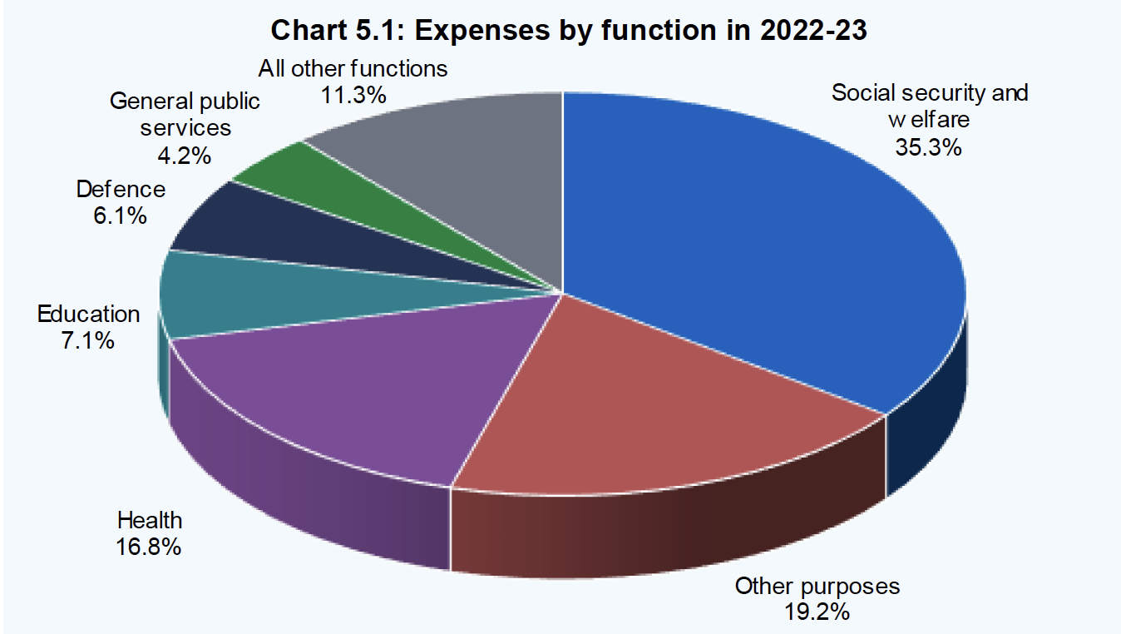

See below a table from a government report.
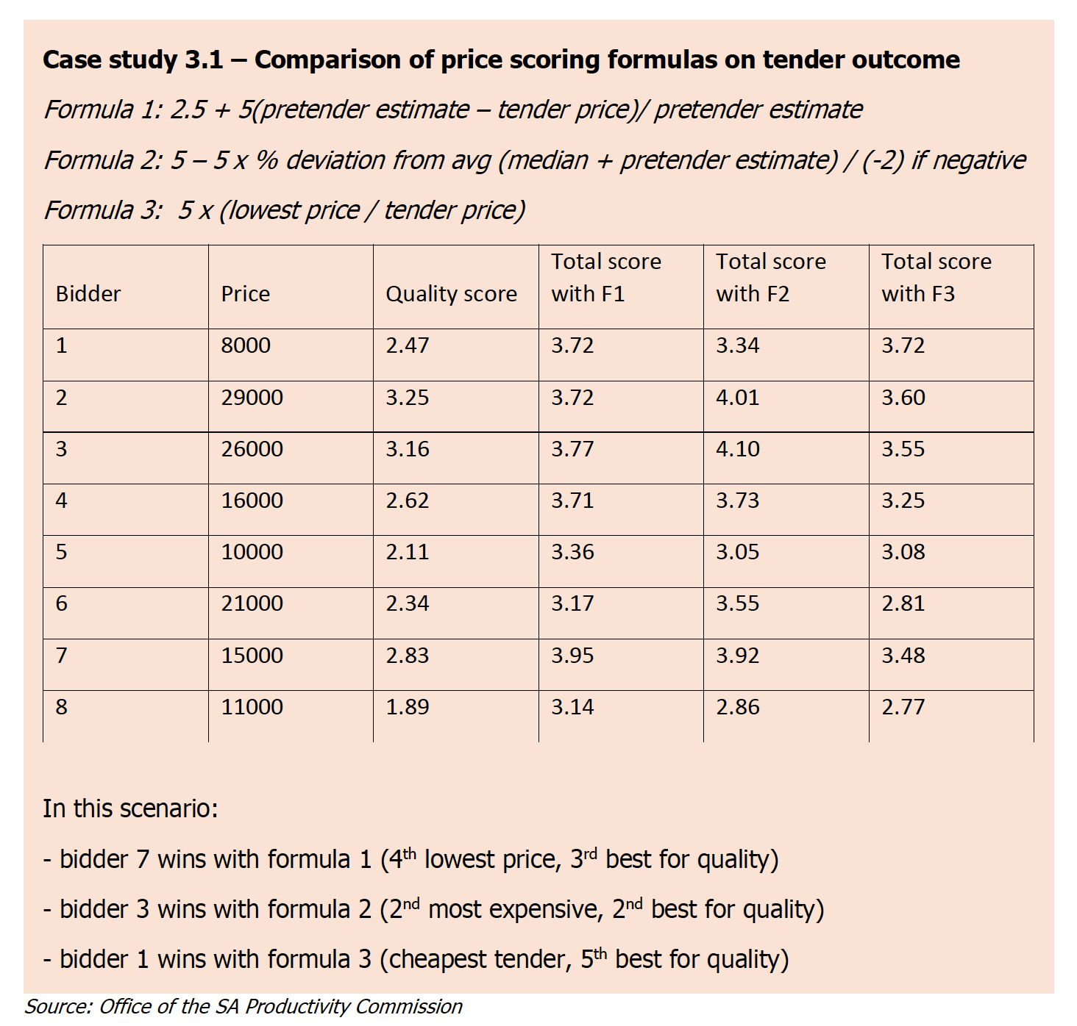

Comments?

Some observations of the graphs:
- The first graph has no units of measurement. Having no vertical axis makes it difficult to compare and understand.
- There is an inconsistency in values – the left-hand graph column for gas shows 2,444 units, but is higher than the right-hand graph column for gas, even though it shows 2,613.8 units.
- Inconsistency in the use of decimals
- It is best to have numbers comma-separated
- The second graph is presented as a 3-D pie graph. The use of 3-D distorts the values at the front of the graph relative to the values at the back of the graph.
- The use of colours can be better linked to a palette system or neutralised.
Some observations of the table
- Left justification rather than right justification of numbers
- Too many borders and inconsistent use of borders (none at the bottom)
- Borders, when used, can be lighter
- Rows are too high, leaving too much space
- Data is aligned to the top of the rows rather than centred
- Column widths leave too much space
- No comma separation of the price
- General principle – don’t use shading. For case studies and recommendations, use a border to distinguish them from the rest of the document rather than shading.

Principles of design in tables and graphs
Remove clutter and make reading as easy as possible.
Remove as much non-data ink as possible. Non-data ink is ink devoted to elements like shading, gridlines, boldness in font. When they are used, make them as light or as thin as possible.
Use fine fonts (sans serif) rather than broad fonts (serif). Be consistent in the use of fonts.
Limit the use of bold fonts to row headings, column headings and totals.
In tables:
- Right-justify numbers so they are aligned. This also creates natural space between columns.
- Only use decimal points where necessary and then minimise their use.
- Use horizontal orientation of data as much as possible.
- Use spacing to create breaks in data
In graphs:
- Maximise the data-ink ratio and minimise non-data ink – use fine fonts not bold fonts, keep gridlines light, and minimise the use of ink filling non-data spaces.
- Integrity in scales – When you set the bottom on the y-axis scale to a value greater than zero, you will either lose data or exaggerate values in the graph. Either compromises graphical integrity.
- Avoid 3D – Using three dimensions can distort the appearance of the data and exaggerate value. It should be avoided.
- Avoid Moiré effects - these come from using patterns as a means to distinguish data. These effects serve to interact with the natural tremor in our eyes to produce the distracting appearance of vibration and movement.

Use of colours
Use colour sparingly and where possible, to create contrast or attract attention to a specific piece of data. Colour from shading of cells in a table is non-data ink and should be minimised.
Colours bring with them associations. Beware of unwanted associations in the use of colours.
Most governments and organisations have brand colour and colour palette guidelines that can be used for choices of colour aligned with organisational branding.
In graphs and tables, minimise the use of bright colours or the use of colour that serves to clutter the presentation. Avoid fluorescent colours. They will create a halo effect distorting data presentation.
Also, beware of accessibility and colour blindness that may warrant the use of basic and neutral colours like black and white and shades of grey.
Applying these principles converts the bad table on the left to a better table on the right.1

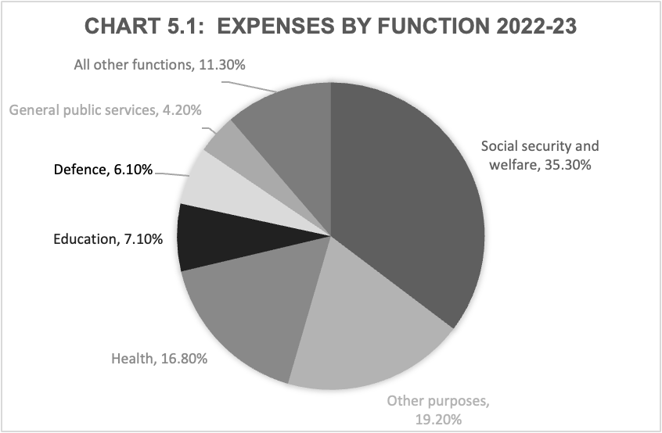
Applying these principles converts the pie graph from the original to a revised

Applying these principles converts the bad graph on the left to more straightforward graphs on the right

Casualty crashes by day of week and time of day, South Australia 2009
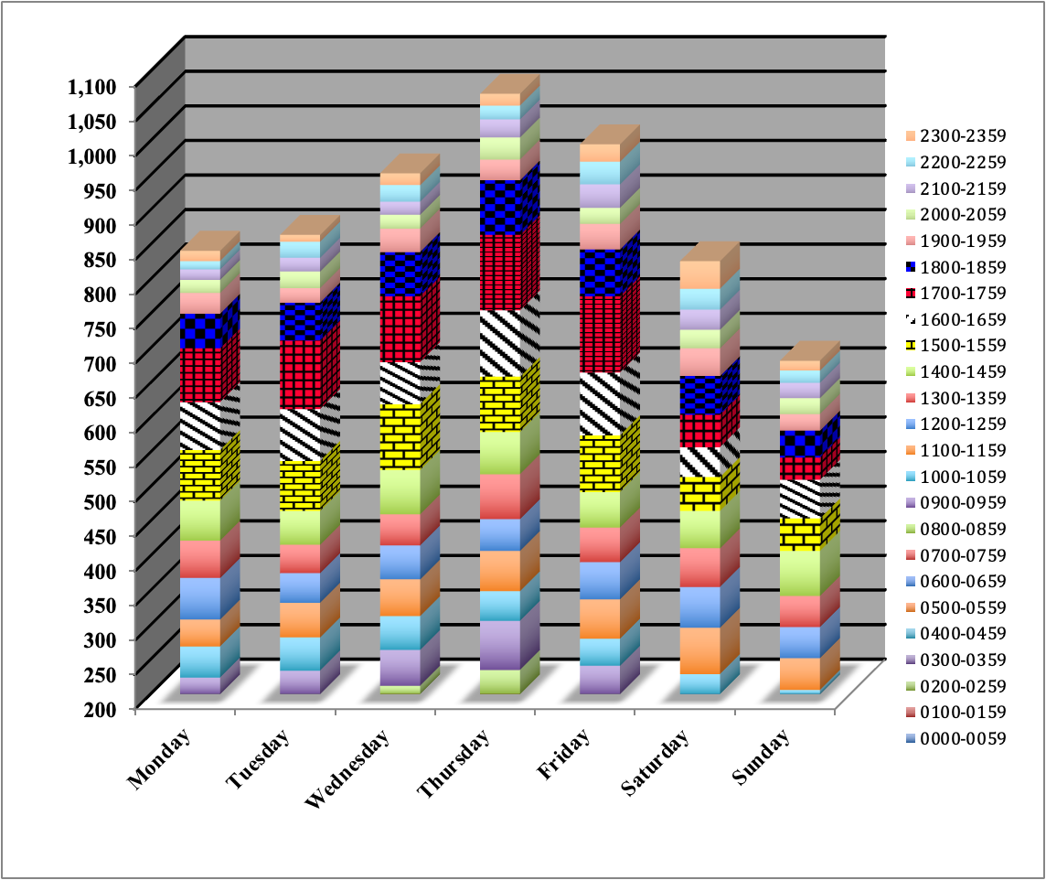

Applying these principles converts our original table on the left to a revised version on the right.

Combining text and data
It is one thing to ensure that the presentation of tables and the presentation of charts facilitates clarity in reading. However, it would be a tragedy to see excellence in tables and charts offset by the confusion created by poor linking to data in accompanying text.
When using text to discuss a table, ensure that the data referred to in the text is consistent with than included in the table.
A bad example when discussing the table above
Total government expenses have increased by over 8% per annum since 2005-06. There has been a large growth in Housing & Community Amenities (by around 19% per annum) and Health (by around 9% per annum) while expenses on agriculture, forestry and fishing have fallen by nearly 2% since 2005-06.
A good example when discussing the table above is:
Total government expenses have increased by 33.6% between 2005-06 and the 2009-10 budget. There has been a large growth in spending on housing and community amenities (77.5%), other economic affairs (61.9% growth) and Health, Education and Social Security (all around 35%) with small declines in agriculture forestry and fishing (-1.9%) and recreation and culture (-0.3%).
If you wish to discuss annual growths or dollar increases and decreases, include them in the table so the reader can quickly reconcile the data with the text. If they have to do the calculations to confirm their reading, it will slow up their reading, or at worst, stop them.
Where possible, put commentary and explanation of data with the data in the tables or charts. If this is not possible, put data explanations immediately above or below that data or chart. These suggestions are designed to stop unnecessary reading interruptions for the reader.

NOTES

Reflection
What has been my most important learning and why?

References
Australian Bureau of Statistics
Catalogue 1500.0 - A guide for using statistics for evidence-based policy, 2010
Understanding statistical language - https://www.abs.gov.au/websitedbs/D3310114.nsf/Home/Statistical+Language?OpenDocument
Moment of Clarity (2014), Christian Madsbjerg, Mikkel Vedby Rasmussen
Naked Statistics (2013), Charles Wheelan
Everybody Lies (2017), Seth Stephens-Davidowitz
I Think You’ll Find It’s a Bit More Complicated Than That (2015), Ben Goldacre
DataStory (2019), Nancy Duarte
Storytelling with Data (2015), Cole Nussbaumer Knaflic
The Data Detective (2021), Tim Harford
Style Manual, Commonwealth of Australia
Edward Tufte:
Website: www.edwardtufte.com/tufte/index
Books:
The Visual Display of Quantitative Information
Visual Explanations
Envisioning Information
Beautiful Evidence
Stephen Few
Website: www.perceptualedge.com
Books:
Show Me the Numbers
Signal
Information Dashboard Design
The Data Loom
Sally Bigwood & Melissa Spore
Website: www.plainfigures.com
Book: Presenting Numbers, Tables and Charts

Appendix 1: A basic case for infrastructure

Purpose
The Office for Case Management exists to meet legislative requirements to process cases on behalf of the Government. The processing of these cases is important to maintaining public faith in this public system (e.g. health, housing, legal). Containing waiting lists is critical to achieving good public outcomes and Government policy outcomes.
The Government has made strong policy commitments to ensuring excellence in the management of cases and to maintaining public faith in the system. There are accepted Australian benchmarks for the size of the waiting lists being managed by the Office. There are well documented standards of excellence in managing cases and there are well documented standards guiding the use and age of case management infrastructure.

Recent History
There has been significant growth in the number of cases being processed by the office, evidenced by trends in case numbers. In the last ten years, there have been policy changes that have served to further increase the number of cases. Several measures have been put into place to improve the way cases are processed through the system and they have made the growth lower than it would otherwise have been. However, the growth in the number of cases is greater than the growth in processing cases. There is a trend growth in the backlog of cases. There has been trend growth in the backlog of cases as shown in the graph below.
Infrastructure is a critical ingredient in the processing of cases. The infrastructure capacity necessary to support the processing of cases was created over 25 years ago. There has been no material growth in this infrastructure capacity over that time.

Analysis
Projections for case management growth will see South Australia performing well below benchmark with the growth in cases continuing to exceed the processing of cases. There will be a major growth in waiting lists that will materially impact the effectiveness of the system and public faith in it.
There has been an analysis of the current case management process that can improve processing times slightly but will not address the growth in waiting lists.
There has been an analysis of the utilisation of existing infrastructure assets. It is difficult to increase the utilisation of existing infrastructure given the constraints on its use. These constraints occur due to the age of the infrastructure and due to the need to ensure basic quality standards in the processing of cases.
Alternate methods (e.g. 24-hour use of infrastructure and 24-hour processing of cases) have been considered but are not feasible.
Projected growth in the waiting list compared to the benchmark is presented in the graph below.

Insights
To meet waiting list targets there needs to be an increase in the number of cases processed. Changes of policy and changes of practice have been implemented but have not addressed backlogs. Alternate ways of increasing case processing have been explored but they will not address backlogs.
Increased infrastructure capacity and a commensurate increase in staff to process cases are required to achieve the goal of reducing the backlog and maintaining public faith in the system.

Solution
Modelling has been done of the growth in cases and the growth in the number of facilities (e.g. operating theatres, beds, rooms, offices) required. This modelling has estimated that to increase the number of cases processed to eliminate the waiting list gap from the benchmark, three additional facilities are required, along with extra staff to operate and process cases in these facilities.
There are options for increasing the processing capacity
- Build the capacity (new building)
- Renovate existing assets to create capacity
- Rent or lease capacity.
Each of these options has been evaluated based on cost, timeliness, feasibility and risk. The recommended option is for a new building, near the existing infrastructure, with three new rooms.

Execution (proceeding with our project)
A major infrastructure project is proposed with the outcomes detailed in the previous section. To ensure continuity of service, it is proposed that a separate project team be established within the agency to undertake these works.
The immediate work of the project team will be to:
- Procure more detailed designs and costings
- Navigate a range of government approval processes (Cabinet, Parliamentary Works)
- Seek specific planning approval for this initiative.

Appendix 2: What makes a good story?
In short, we need to bring to the reader or audience’s attention:
- Unresolved tension or conflict
- Resolution and the promise of an ever-after
- That they are involved in the story.
The fundamental pattern of many stories is tension and resolution. Good stories explore tensions and usually include what are known as tension-resolution pairs.
Tension is used to describe conflict, trouble, torment, anxiety, instability, inadequacy and threat. Resolution is used to describe solutions, answers, assurance, insight, relief and salvation. It is the tension and the quest for resolution that make life and stories interesting. Tensions create interest and can motivate us to improve. Tensions can also cause conflict and stress.
At the heart of an interesting story will be conflict or unresolved tension that we want to resolve or we want to see how it is resolved.
A good narrative will also draw the reader or audience into the story by making it relevant to them or by making characters someone they associate with. They help the target audience see themselves as part of the story.

Unresolved Tension
There are two ingredients to unresolved tensions:
- a quest and
- a reality that confronts the quest (an issue or opportunity).
Tensions necessarily involve some form of ideal or aspiration that meets obstacles or roadblocks. The ideal will need to be explicitly stated against which we contrast reality to show the tension of unmet goals.
In organisational narratives, a quest will be a goal or standard of excellence that the organisation seeks to achieve. The reality will reflect actual performance or an opportunity that can be taken up. Evidence of problems, issues and opportunities will reveal gaps from ideals and create tension that seeks to be resolved.

Resolution and the promise of an ever-after
The narrative will also include some resolution of this tension. This can occur through:
- Turning points
- Revealing a mystery
- A breakthrough
- A diagnosis or understanding
- A great idea.
Some authors on presentation and business narratives refer to the concept of the ‘big idea’ being at the heart of the narrative. The big idea will be the means to resolving the tension that has been brought to the attention of the audience.
The resolution will often be the target or pivot point for the plot of a narrative. It is the point towards which early parts of the narrative will lead to and from which the latter parts are derived ‘ever-after”.
For most narratives, this leads to the promise of an ever after, in most cases, the promise of a better ever after or a happy ending. In fiction, the ever-after is usually imagined by the reader or audience, with the story usually finishing on a note to enable this.
In contrast to this, business narratives will need to give the reader more detail so they can be involved in the follow-up. We will want to have the reader energised and positive – either to make a commitment or to invest time, money and effort into the enterprise, project or initiative.
These elements of narrative need to be supported by detail.
This is where numbers are used to provide vivid detail and compelling evidence to help highlight tensions or establish resolutions.

Involving the reader
We want to see ourselves as part of the story – that is why we get emotionally involved in stories.
This is particularly relevant to how we construct our narratives. We want to have thought about our target audience and ensure that they are part of the story we recount. Many strategic narratives seem to focus on new parts of a business or to change and ignore large swathes of work involving large numbers of staff that will continue to be delivered.
To involve the reader in the narrative, we may want to:
- Outline a quest, challenge or outcome that we share
- Craft conflict or tension as something they are experiencing and can associate with
- We will want them to be reminded of events that they have seen and observed so we align with their reality
- To confirm a truth that we find that is relevant to them.

Syd Field’s three-act structure
- Set up - context
- Confrontation/tension
- Resolution
Act I contains the setup. It is approximately the first quarter of a screenplay, and reveals the main character, premise, and situation of the story.
Act II contains the confrontation. It lasts for the next two quarters of the screenplay and clearly defines the main goal of the protagonist.
Act III contains the resolution. This is the final quarter of the screenplay. This answers the question as to whether or not the main character succeeded in his or her goal.

The importance of context in storytelling
The set-up in Field’s structure emphasises the importance of context in storytelling. Context is the setting within which our work, our data, our report is situated. For non-fiction stories at work, context could include:
- Strategic context – how the subject we are working on or with relates to the broader goals and aspirations of our organisation and decision maker(s).
- Historical context – the circumstances and events that have led to the work that is being done.

Appendix 3: Presenting cost and activity analysis
I was asked to help a team of scientists who had been asked to deliver their services with less money. They were part of a government department and had been given a savings target by the Government.
There is a range of scientific services that operate across State and Federal Governments. In the State Government examples include pathology and radiology services within the Health and Human Services Department, Forensic sciences within the Justice Portfolio, and food, plant and biosecurity services within the environment and primary industries sectors. In the federal government, examples include the CSIRO, the Bureau of Meteorology and aspects of customs.
The initial reaction from the scientists was that they could not achieve their savings targets through efficiencies. Improving their services was an ongoing task and they were continually finding ways to deliver their services more efficiently.
They were confused by the allocation of a savings target without regard for the services they delivered. They had not been consulted on the amount of savings or their implications. My assistance was sought to help them work through this task. In the first instance, I made it clear to them, that all parts of government have savings targets allocated to them. It is a reasonable thing for the leaders of an organisation to expect ongoing improvement and efficiencies as well as governments making decisions to reallocate money due to changing demographics or economic realities like lower taxation income.
My first piece of advice is not to get caught up in why they had been allocated savings or the politics of their savings target. Our goal was to achieve a line of sight between the financial parameters of their business and the service parameters of their business so the implications of the savings targets would be clear to them, to their department and the Government. I wanted to understand the full cost for the delivery of their services and the relationship between these costs, the revenues of the business and the activity of the business.
We started by viewing their business as a series of functions or services. Most businesses do this naturally and the result of this can be seen from organisational structures.
All organisations of any size can be distilled down into two functions:
- Function One: Produces and delivers the outputs of the business (e.g. Laboratory services, tests, freight to deliver)
- Function Two: Supports function one (e.g. Finance, HR, ICT)
The first function incurs direct costs and the second function incurs indirect costs. The second function is often described as an overhead. Both functions are necessary in any business.
We started by understanding the structure of their business and how the finances were allocated across the various functions of their business. It was important to be able to have both a historical view of their finances by function and to have a forward-looking view of their finances by function. The second area is often not that well understood.
I wanted to develop a representation or a financial exhibit of their overall business showing the revenues and expenses of each function.
We developed an initial financial graphic of the business that looked as follows:
The graphic showed the total expenses for the business as the sum of the expenses across each team (from left to right) and the sum of expenses across the different categories of expenses (from top to bottom).
The scientists had structured their business and their finances in this way and we were able to construct the above table quite easily.
To get a better line of sight, we needed to understand the full cost of delivering the services from each of the teams. To do this, we need to allocate or attribute the corporate costs across each of the teams. Attributing ICT expenses can be done by identifying the ICT requirement of each team (number of computers, machines or data usage from each team). Other corporate costs are often attributed to teams based on the number of FTEs in each team as a % of the total of the four service delivery teams. I wanted to develop a second financial exhibit that looked like the one below.

We now had a display of the total expenses associated with each team in the business.
My next request for an improved line of sight was to include some measures of activity or output for each of the teams. For the scientists, the measures of activity could have included:
- The number of tests performed
- reports produced
- cases managed
- investigations conducted.
The scientists did have measures of their activity, although they were nervous about how well these captured some of the subtleties of their work. For instance, those who performed tests would comment that they had simple tests and more complex tests. They should not be counted as the same. We could address this by establishing the concept of a standard test and then estimating that complex tests were the equivalent of three standard tests. Now we could combine the different tests into one meaningful measure of the number of standard tests performed. This activity data can be included in our graphic and can be used to calculate the average cost per item. This is shown in the graphic over the page.

We are now establishing a line of sight between the expenses of the business and the activity of the business. With this line of sight, the scientists were now able to demonstrate the impact of the budget savings on their activity levels. A reduction in the budget for team one will translate into that team performing fewer tests or managing fewer cases which will likely impact the waiting time for tests or cases.
Another benefit of this line of sight is that the scientists have developed parameters for their business that can be benchmarked. As a minimum, they can benchmark their current and future performance against their past performance. They can also benchmark their performance against that of other enterprises to find and identify opportunities for improvement or to identify where they have achieved high standards of efficiency or effectiveness. The main benefit of external benchmarking is that it acts as a trigger to evaluate performance and to find ways to improve, from the examples of comparable businesses.
The scientists modelled these impacts and provided a submission back to the Government to demonstrate the impact of the budget reductions. They modelled the impact on the number of tests performed and estimated the increased waiting times arising from the reduced activity. There are functions of government where the speed and waiting times for scientific tests will impact other services. Examples will include the speed of pathology tests in moving patients through hospitals, and DNA tests in progressing police investigations and court trials.
An example of the outcome of this work is provided in the following graphic.

This final graphic provides a line of sight between expenses and their relationship with activity and their relationship with a performance indicator like waiting times.
In the case of the scientists, the Government received their submission and feedback from other agencies was such that they wanted to avoid the impact of increased waiting times in one of the services. The increase in waiting times in other services was not ideal but deemed tolerable.
The Government then reinstated some of the savings requirements, seeking to quarantine some key functions from the impact of savings.
The example shows the value of having a line of sight between finances, activity and outcomes and increases the financial clarity for the business. The example also shows business model clarity and financial clarity at work. In this case, the financial clarity served as a defence against budget cuts for one team in the business. For other teams in the business, the financial clarity serves to help manage expectations about service levels, demonstrating that the savings would impact service volumes and waiting times.

Appendix 4: Some thoughts on dashboards
Another variant in presenting numbers is to present a range of data in different forms in close proximity using a dashboard.
“A dashboard is a business tool that displays a set of PIs (performance indicators), KPIs (key performance indicators), and any other relevant information to a business user. Dashboard data is often displayed in real-time after retrieval from one or more data sources in a business. Dashboards are interactive, allowing an executive to drill into particular aspects of the display or switch between facets or views of the data.”
Dashboards are typically software tools that are used online but can also be translated into the presentation of reports for decision-makers.
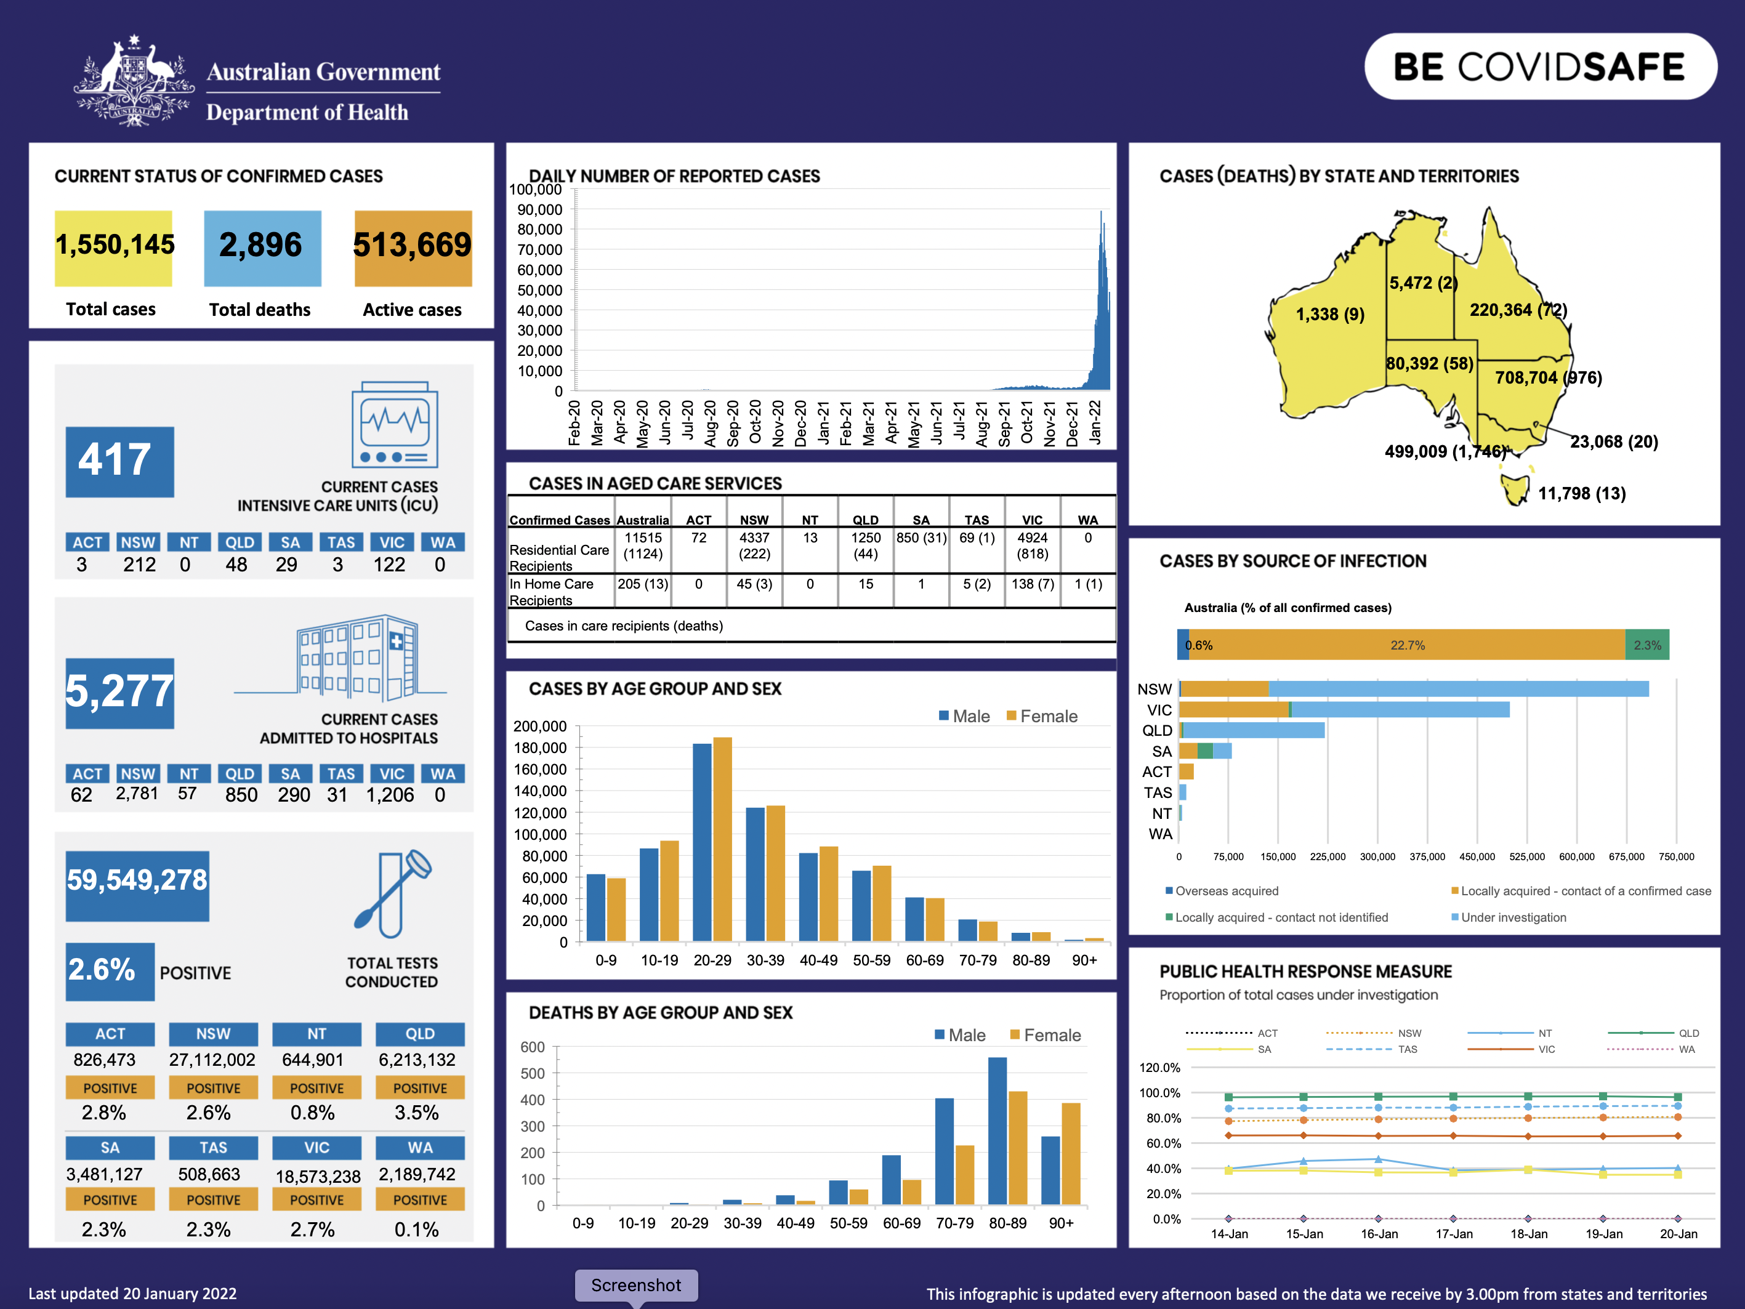
Above is an example sourced from: https://www.health.gov.au/sites/default/files/documents/2021/01/coronavirus-covid-19-at-a-glance-20-january-2022.pdf
There is a risk that dashboards can put the flashy presentation ahead of the data and distract the readers. There is a high risk of chartjunk with this form of data presentation.
“Chartjunk refers to all visual elements in charts and graphs that are not necessary to comprehend the information represented on the graph, or that distract the viewer from this information.” Tufte, Edward R. (1983). The Visual Display of Quantitative Information.
When I present examples of dashboards to participants, common feedback includes:
- I don’t know where to start looking
- It is overwhelming
- It feels cluttered.
At their worst, a dashboard can appear to be a data dump or data ‘vomit’. Someone has used the dashboard to empty their analysis into one place but without regard for how the reader will navigate or understand it.
With bad design, readers will be turned off of our dashboards and turn away or, if they try and look, they will feel lost. We would rather they feel welcomed to our display and enjoy a smooth journey through what the data is saying.
The same thought process is used by people designing physical environments and buildings. They want people to feel welcome to the place and to find it easy to navigate and find their way around. These professionals (urban planners, architects and graphic designers) use the term wayfinding.
Wayfinding can be defined as spatial problem-solving. It is knowing where you are in a building or environment, knowing where your desired destination is, and knowing how to get there from your present location. (source: Wayfound Victoria)
I believe the term can also be applied to spatial problem-solving with graphic displays. In the definition above, we can include among ‘environment’, dashboards or data displays.
Some thoughts to help our readers navigate:
- It is important for the reader to be given a guide as to where to commence by the use of signals like ‘You are here’ or ‘Start here’.
- The use of text boxes to help describe the data and to guide the reader through the dashboard. More advanced tools like Power BI and Tableau enable ‘hover points’ that provide more detailed text for a reader when their mouse hovers over a label or data point. The use of hover points is more limited in Excel.
- Use a specific design that will help the reader follow a path. Some examples include:
- Academic design (in columns)
- Comic book design (in rows)
- Hub and spoke design

Academic design (working in columns)

Start here

Finish here

Comic book Design (working in rows)
Start here

Finish here

Hub and spoke design

Appendix 5: Bullet graphs
Bullet graphs support the comparison of the featured measure to one or more related measures (for example, a target or the same measure at some point in the past, such as a year ago) and relate the featured measure to defined quantitative ranges that declare its qualitative state.
They were developed by Stephen Few to replace the meters and gauges that are often used on dashboards
The bullet graph consists of five primary components:
- Text label
- A quantitative scale along a single linear axis
- The featured measure
- One or two comparative measures (optional)
- From two to five ranges along the quantitative scale to declare the featured measure’s qualitative state (optional).
The example below is a bullet graph for an employee satisfaction survey result over three years.
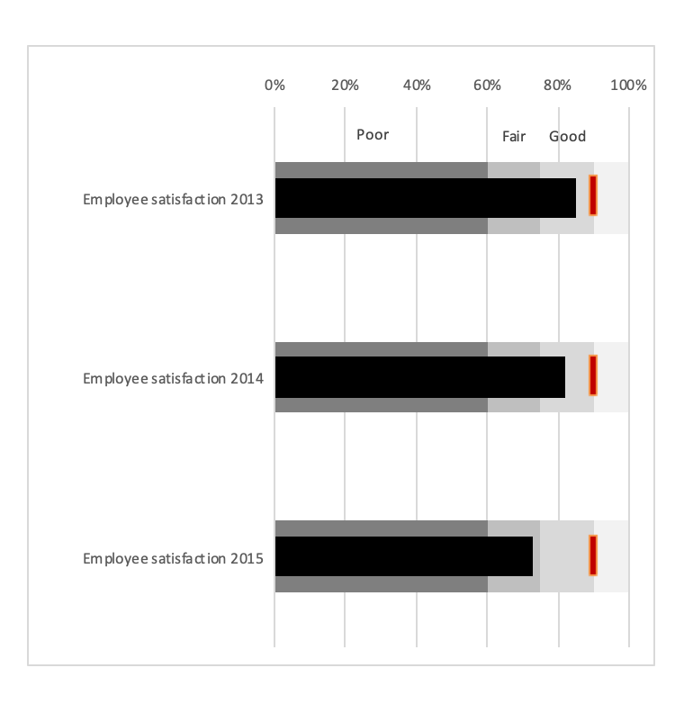
The graph shows the result (the featured measure in black) compared to a target (red line at 90%) and scales poor, fair and good.

Source: 5512.0 Government Finance Statistics, Australia, 2018-19

